Progress Report

PROJECT TITLE: Food Grade Distillers Dried Grains
PROJECT NUMBER:
REPORTING PERIOD: October 2018
PRINCIPAL INVESTIGATOR: Padu Krishnan
ORGANIZATION: South Dakota State University
PHONE NUMBER: 574-440-9215
EMAIL: Padmanaban.krishnan@sdstate.edu

1.) PROJECT ACTIVITIES COMPLETED DURING THE REPORTING PERIOD. (Describe project progress specific to goals, objectives, and deliverables identified in the project workplan.)

4 MS Graduate students have worked on separate Food DDG projects
Tanvee Despande - Quality Standards for Food Grade DDG
Kara Konst - Glycemic Response study for FDDG Fortified Asian Noodles
Brady Bury – Recovery of value added constituents from DDGS (Phytonutrients and Zein).
Patra Akaya – Effects of particle size on the rheology of DDG Flour.

A second Glycemic Response Study is currently in progress. The study duplicates FDDG effects in a second food model, namely Asian Noodles using FDDG as a fortifying agent.

Three journal articles were published in peer reviewed journals in 2018. All three relate to use of FDD in food extrusion and bread baking.

- Krishnan, P., Singha, P., Singh, S. K., Muthukumarappan, K. (2018). Physicochemical and nutritional properties of extrudates from food grade distiller’s dried grains, garbanzo flour and corn grits. Wiley Publishing. https://onlinelibrary.wiley.com/doi/abs/10.1002/fsn3.769

- P. Singha, Krishnan, P., Muthukumarappan, K., Singha, P. (2018). Influence of processing conditions on apparent viscosity and system parameters during extrusion of distillers' dried grains-based snacks. Food Science and Nutrition (DOI:10.1002/fsn3.534).
Extrusion parameters for different ingredients (chickpea, corn grits, Distillers dried grains combined in specific proportions were evaluated to determine the most optimal processing conditions for the production of a "Cheetos-like" snack food containing distillers dried grains as a fiber and protein source. Chickpea was used as a protein modifier and taste improvement ingredient.

- Pourafshar, S, Krishnan, P. and K. Rosentrater. Production of Barbari Bread (Traditional Iranian Bread) Using Different Levels of Distillers Dried Grains with Solubles (DDGS) and Sodium Stearoyl Lactate (SSL). Foods, 6, 31. Accepted: 27 February 2018; Published: 1 March 2018

Three additional manuscripts are being submitted for the next reporting cycle.

We have developed protocols for in house monitoring of aflatoxins and fumonisin to screen our raw materials used for DDG production.

A bench scale-up apparatus for mycotoxin spiking studies was acquired.
This apparatus will also be used in the automated recovery of nutraceuticals from Corn and DDG.

2.) IDENTIFY ANY SIGNIFICANT FINDINGS AND RESULTS OF THE PROJECT TO DATE.

A wholesome food ingredient with high content of dietary fiber and protein for use by the food industry and for international feeding programs.
FDDG will be shelf-stable, color-neutral, odor-neutral, flavor-neutral and a gluten-free product.
FDDG will be free from mycotoxins following quality check and rigorous processing.
The food grade DDG (FDDG) is ground to a fine particle size and heat-sterilized.
Solvent treatment helps in oil and pigment removal yielding FDDG with L, a & b values of 88.00, -0.58 & 17.43, respectively, and oil content of 2%. More than 90.64% of FDDG is within 75-400µm particle size range. Mycotoxin screening using LC-MS in the raw unprocessed material shows Fumonisin B1 (FB1) at a level of 0.3ppm which was reduced to levels below detection limits by employing processing techniques. A consistent quality FDDG will be odor-neutral, color-neutral, flavor-neutral, gluten-free and with minimal oil content with consistent particle size for quality control. FDDG will be free from mycotoxins following quality check and rigorous processing. A wholesome FDDG food ingredient will contain high levels of dietary fiber(40%TDF) and protein (39%) for use by the food industry and for international feeding programs.

3.) CHALLENGES ENCOUNTERED. (Describe any challenges that you encountered related to project progress specific to goals, objectives, and deliverables identified in the project workplan.)

We have received notification of non-action on our patent for a food grade DDG. The Technology Transfer Officer at SDSU assures me that this is a common response by the patent office and several exchanges are typical in the patent application process. We are submitting further documentation to continue the patent protection application.

4.) FINANCIAL INFORMATION (Describe any budget challenges and provide specific reasons for deviations from the projected project spending.)

No budget challenges are anticipated.

5.) EDUCATION AND OUTREACH ACTIVITES. (Describe any conferences, workshops, field days, etc attended, number of contacts at each event, and/or publications developed to disseminate project results.)

FDDG Cookies were distributed at MN Farm Fest 2018 in June 2018.

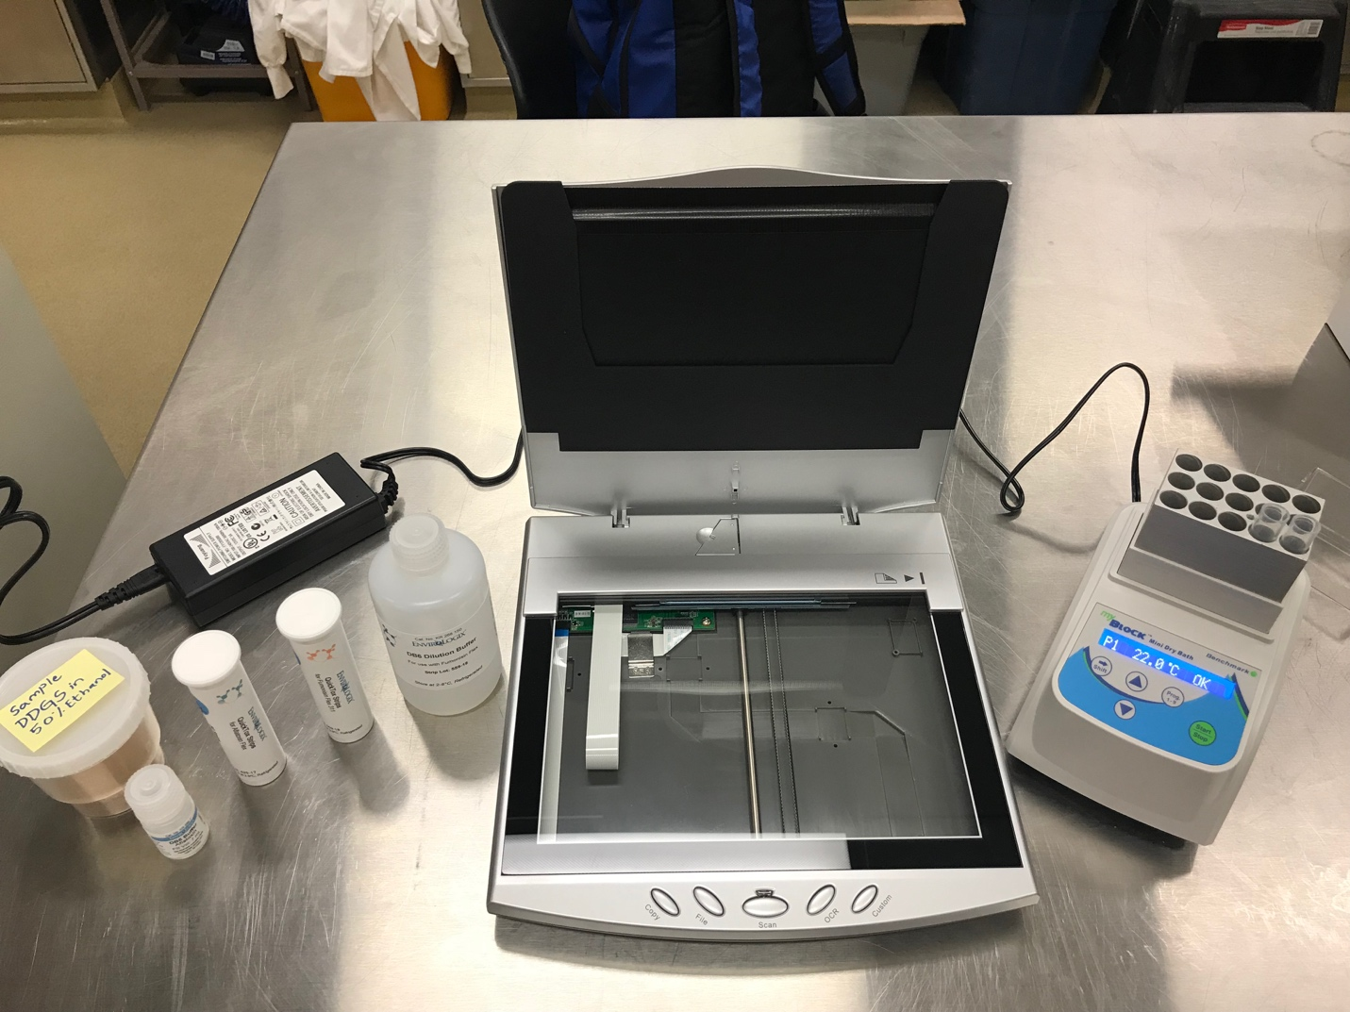

Fig 1. Mycotoxin analysis system
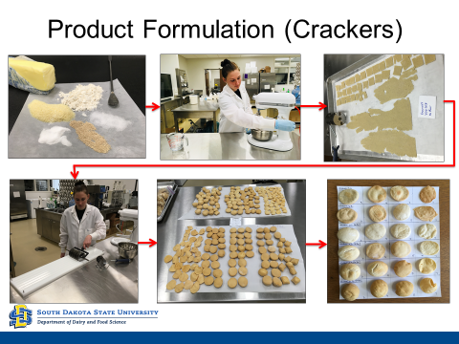

Fig 2. DDG food product - crackers

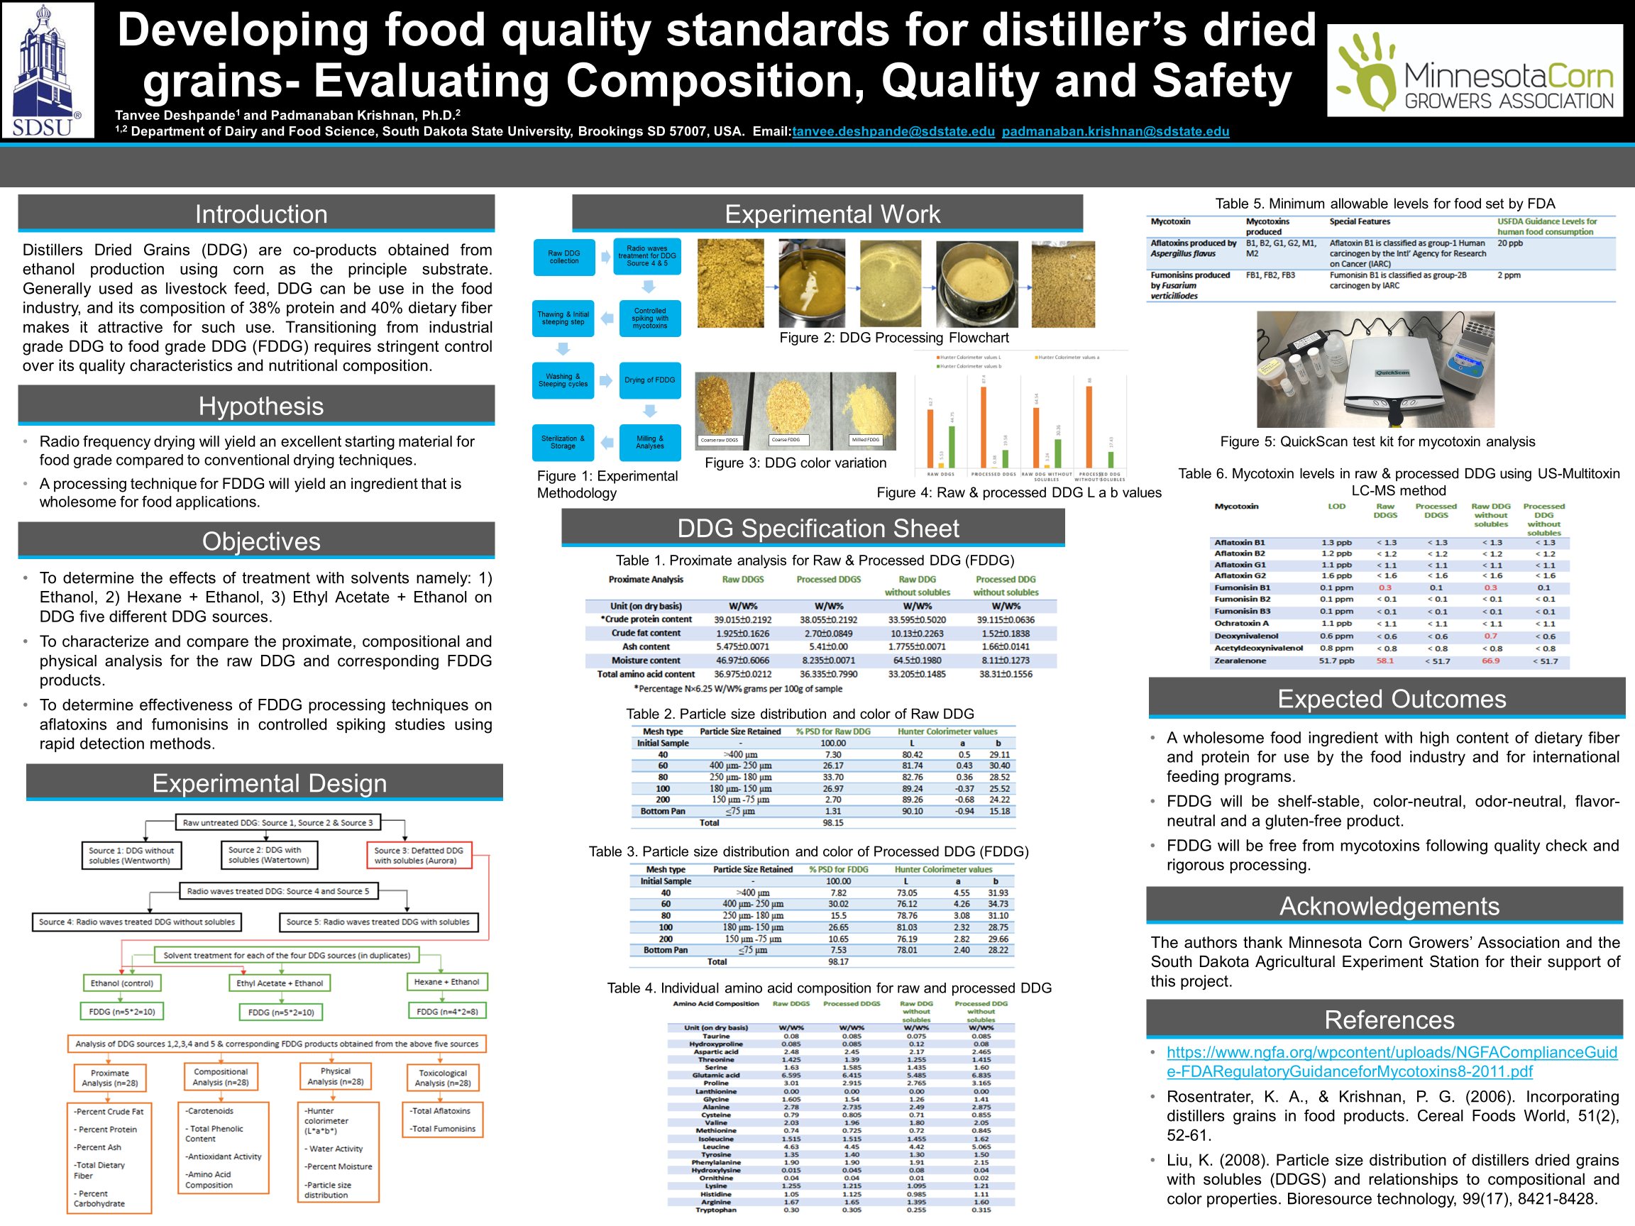

Figure 3. CUTC Presentation (Second Place Graduate Student Poster Award).

