Progress Report

PROJECT TITLE: Hydrous Ethanol Reforming for Reducing NOx Emissions from Diesel Engines
PROJECT NUMBER: 1078-16EU
REPORTING PERIOD: 10/1/2016-12/31/2016
PRINCIPAL INVESTIGATOR: William Northrop
ORGANIZATION: University of Minnesota
PHONE NUMBER: (612) 625 6854
EMAIL: wnorthro@umn.edu

1.) PROJECT ACTIVITIES COMPLETED DURING THE REPORTING PERIOD. (Describe project progress specific to goals, objectives, and deliverables identified in the project work plan.)

From Work Plan:
This project will develop an aftermarket hydrous ethanol reforming system for diesel engines that can meet CARB in-use standards for both PM and NOx, an achievement that has not been achieved by any dual fuel ethanol systems to date. To meet this goal, we will develop a thermally integrated system that uses exhaust heat to reform hydrous ethanol into a mixture of hydrogen and carbon monoxide to reduce combustion temperatures and thus reduce NOx formation in the engine. The system will be designed, built and demonstrated at the UMN TE Murphy Engine Research Laboratory.

The specific objectives of this project are: 1) To design and fabricate a hydrous ethanol reforming system that can be coupled to a John Deere 4045 Tier 2 diesel engine without modification to the engine control system. 2) To characterize the hydrous ethanol reforming system experimentally over a modified eight-mode off-highway test cycle. 3) To prove that the designed system can enable similar fumigant energy fraction (FEF) levels as the previously developed port-injected hydrous ethanol system while achieving lower NO_{X} and unburned EtOH emissions. 4) To prove that the designed system can achieve CARB in-use verification classification for retrofit emissions control systems over the eight-mode test cycle.

Update:
Objective 1 is near completion as a custom exhaust manifold incorporating an integrated heat recuperation reformation reactor tube was designed and manufacturing has begun. Figure 1 depicts an isometric view of the custom manifold. In addition, a custom vaporizer, which will be used to evaporate hydrous ethanol prior to entering the catalyst tube was designed and tested on a separate bench testing apparatus. The project overall is behind schedule due to issues sourcing components for the integrated heat exchanger reactor. The manifold is under construction and the inner reactor is out for quoting. It is hoped that a fully functioning reactor will be ready by the summer of 2017.

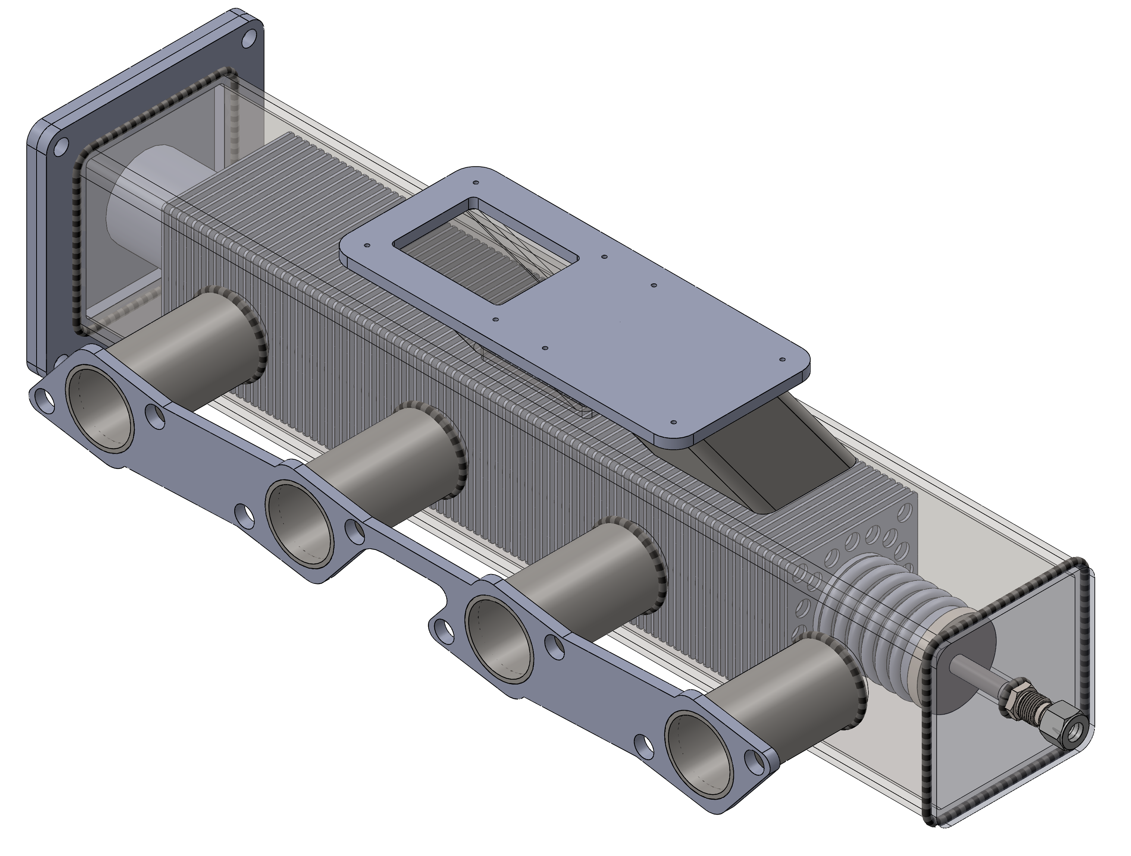
Figure 1: Isometric view of custom exhaust manifold

2.) IDENTIFY ANY SIGNIFICANT FINDINGS AND RESULTS OF THE PROJECT TO DATE.

Through engineering analysis of the heat transfer in the reactor, we determined that preheating the hydrous ethanol stream prior to entering the vaporizer and catalyst tube would be necessary in order to ensure complete vaporization. This is due to hydrous ethanol’s large latent heat of vaporization. In order to achieve this, we will integrate a liquid to air heat exchanger to extract heat from exhaust gases after the turbocharger. Preheating, coupled with a high power cartridge heater vaporizer will be adequate to vaporize high water content hydrous ethanol.

3.) CHALLENGES ENCOUNTERED. (Describe any challenges that you encountered related to project progress specific to goals, objectives, and deliverables identified in the project workplan.)

Progress to catalyst tube manufacturing with perforated fins has been stalled due to little response from previously reliable monolith company. We are looking for a backup company to use in the meantime.

4.) FINANCIAL INFORMATION (Describe any budget challenges and provide specific reasons for deviations from the projected project spending.)

No budget challenges have been encountered on the project to date.

5.) EDUCATION AND OUTREACH ACTIVITES. (Describe any conferences, workshops, field days, etc attended, number of contacts at each event, and/or publications developed to disseminate project results.)

As part of the project, a test reactor was developed and built for diesel reforming and integrated with a light-duty diesel engine. The results of this preliminary study will be presented in April at the 2017 Society of Automotive Engineers World Congress in Detroit MI.

