

**Progress Report**

PROJECT TITLE: Value added materials from corn

PROJECT NUMBER: 1084-17EU

REPORTING PERIOD: October 31 – December 31, 2018

PRINCIPAL INVESTIGATOR: Marc Hillmyer

ORGANIZATION: University of Minnesota

PHONE NUMBER: 612-625-7834

EMAIL: hillmyer@umn.edu

1.) PROJECT ACTIVITIES COMPLETED DURING THE REPORTING PERIOD. (*Describe project progress specific to goals, objectives, and deliverables identified in the project workplan.*)

Since the last report the Tonks and Hillmyer groups have been wrapping up our work with the polymerization of HMS and trying to apply the lessons that we’ve learned towards the polymerization of other monomer systems. In addition to the side reactions identified in our previous report, we have also found that alcohol acetylation as well as hydroxycarbonylation play significant roles in the hydroesterification of styrene with benzyl alcohol (Figure 1), and thus are expected to be key side reactions in the polymerization of HMS as well. Fortunately, both of these side reactions can be mitigated by proper selection of catalyst reagents.

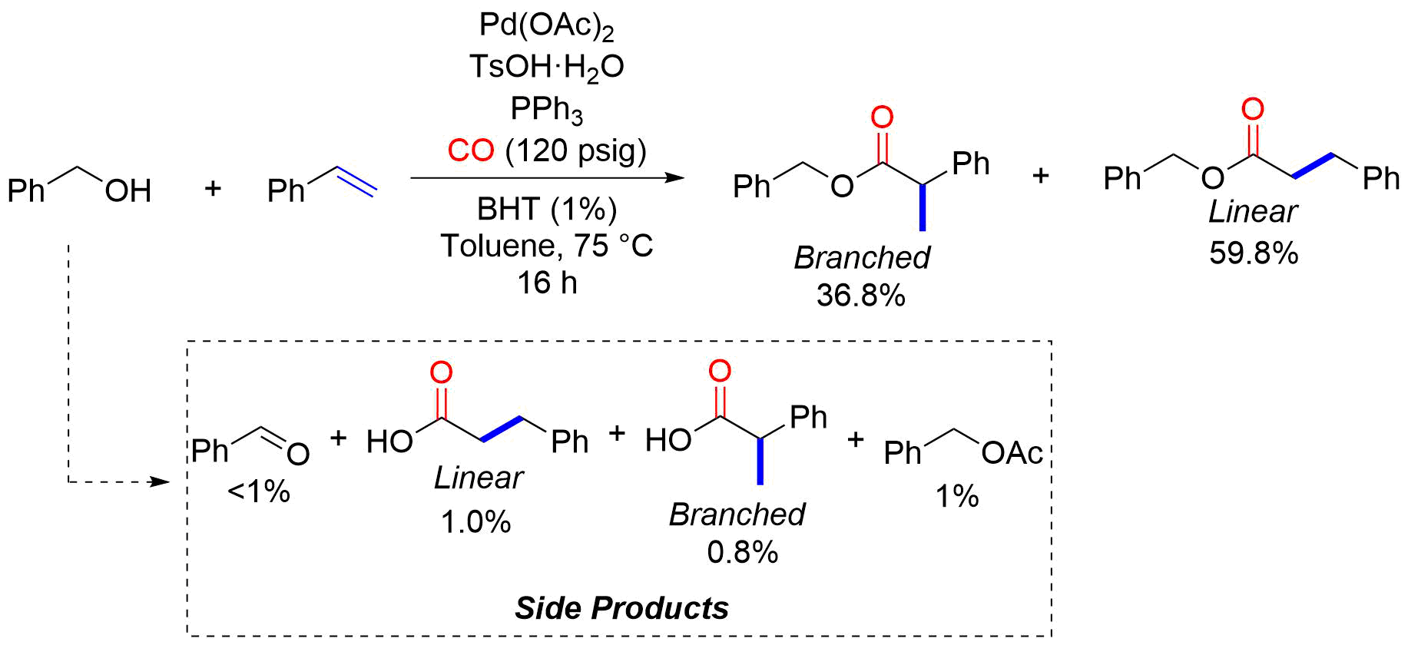

**Figure 1**. Hydroesterification of styrene with benzyl alcohol, showing the key side products formed which are also expected to be present in the reaction with HMS.

Having a clearer picture of the predominant side reactions involved with hydroesterificative polymerization, we turned to a substrate which we hypothesized would be more inert to the identified side chemistries, namely 10-undecenol (Figure 2, left). Under our normal catalytic conditions, we found that conversions of 10-undecenol to poly(dodecyloate) were low, but after some catalyst optimization, we found that 1) increased substrate concentrations (1.67 M) 2) increased reaction temperatures (100 °C) and 3) increased loadings of acid (4%) and ligand (8%) led to high monomer conversions within 16 h. The isolated polymer was found to have *M*n ~ 14.5 kg/mol, significantly higher than what was observed for HMS. Increased reaction times (72 h) resulted in slight increases in *M*n to ~16 kg/mol. Thus, these findings suggest that functional group longevity is higher with 10-undecenol compared to HMS, and that with a more judicious choice of substrate, palladium catalyzed hydroesterification has the potential to deliver polyester in moderate molecular weight ranges. We are continuing to probe whether conditions can be further optimized to lead to even higher *M*n values. In regard to this latter point, one way we have attempted to achieve this is through the use of a Pd0 starting material. Starting from Pd0 vs. PdII should in theory totally mitigate the formation of any aldehyde end-groups due to alcohol oxidation, and thus help maintain functional group longevity over the course of the reaction. Using the conditions described in Figure 2 (right), we were successful in synthesizing poly(dodecyloate) in *M*n ~ 8 kg/mol within 16 h. This is a first pass, and we are hopeful that extended reaction times with this catalyst system will lead to higher molar masses.

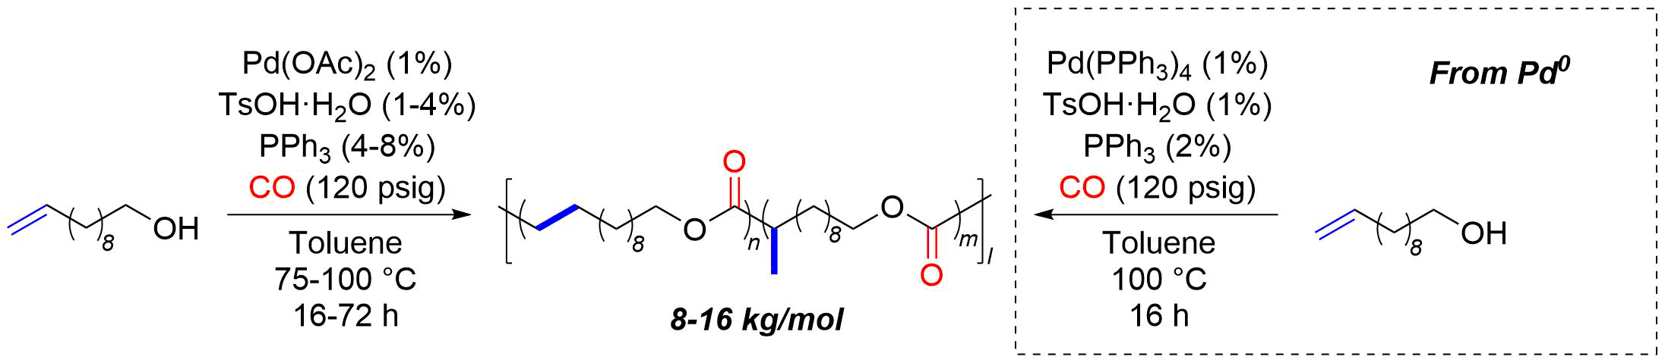

**Figure 2**. Co-polymerization of 10-undecenol with CO to give poly(dodecyloate).

Additionally, we have been seeking to expand the repertoire of this chemistry by looking into other AB type monomers (Figure 3). Specifically, we have made both lactate derived monomers as well as those based on isosorbide, a bicyclic diol which can ultimately be derived from glucose. Preliminary 1H NMR data suggest that these monomers will be more challenging to work with, presumably due to the reduced nucleophilicity of the corresponding alcohol functionalities and we are currently looking into various strategies to address these issues. On paper however, they should be robust with respect to the identified side chemistries observed with HMS.

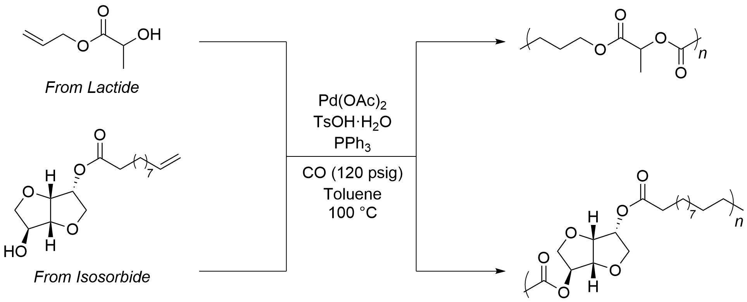

**Figure 3**. Hydroesterificative polymerization of new AB type monomers derived from lactide (top) and isosorbide (bottom).

The Tonks group has also continued exploration of new catalyst frameworks for promoting hydroesterification reactions. A key feature of these catalysts is the incorporation of hydrogen bonding appendages to aid in the proton transfer step of hydroesterification. We have synthesized a new ligand framework (Figure 4) and examined its use in ethylene polymerization, as a first step before testing it for productive alkene hydroesterification. Satisfyingly, these new catalyst frameworks are highly active for alkene polymerization, reaching up to 5,000 kg of polymer per mole of Ni per hour.



|  |  |  |  |  |
| --- | --- | --- | --- | --- |
| Equiv. ZnEt2 | Polymer Yield (g) | Activity  (kg*mol-1*h-1) | PDI | Mn  (g*mol-1 * 10-5) |
| 0 | 0.333 | 3330 | 1.67 | 14.9 |
| 100 | 0.502 | 5020 | 1.70 | 15.3 |
| 500 | 0.374 | 3740 | 1.35 | 6.10 |

**Figure 4.** Ethylene polymerization activity of new hydrogen bonding appended Ni polymerization catalysts.

2.) IDENTIFY ANY SIGNIFICANT FINDINGS AND RESULTS OF THE PROJECT TO DATE.

In the Hillmyer/Tonks project researchers have identified key side reactions/products in the hydroesterificative polymerization of HMS, namely aceylation, hydroxycarbonylation, and benzyl alcohol oxidation. This knowledge informed our choice of other substrate targets, and we were able to successfully demonstrate the application of hydroesterificative polymerization towards the synthesis of poly(dodecyloate) from 10-undecenol and CO in moderate molar masses (*M*n ~ 16 kg/mol) and branched to linear ratios of 20:80. We were also able to demonstrate the use of Pd0 as a suitable precatalyst for this chemistry, which we hope will lead to further mitigation of side chemistries. We are very close to submitting this work for publication. In pursuit of other substrates for this chemistry, namely those derived from lactide and isosorbide, we have preliminarily shown that ester formation occurs, but reactions are slow and give low conversions thus far.

The Hoye group has continued to study the polymerization of the novel monomer 4-ketovalerolactone (**KVL**) prepared from levulinic acid, in turn readily available from six-carbon sugars such as glucose. The product poly(ketovalerolactone) (**PKVL**) is prepared by ring-opening transesterification polymerization (ROTEP) (Figure 5). These polymerization reactions are carried out in the melt state of neat **KVL**, using an alcohol initiator and an acidic catalyst, until complete solidification of the reaction mixture is observed. The resulting powdery samples of **PKVL** have relatively high melting temperatures (ca. 130 °C) and low glass transition temperatures (ca. 5 °C). The absence of significant phase transitions across a temperature range between ambient and the boiling point of water suggests the potential for promising application of **PKVL**. We are beginning to explore the copolymerization of **KVL** with valerolactone and 3-methylvalerolactone (also, from glucose) to further modify the properties of the resulting polymers.



**Figure 5.** Synthesis of **PKVL** from **KVL** by ring-opening transesterification (ROTEP).

Using strategies to those used to synthesize **KVL** from levulinic acid (Figure 6a), we can also produce 3-acetylpropiolactone (**APL**) (Figure 6b) via the isomeric brominated intermediate 3-bromolevulinic acid (**3-BLA)**. In this bromination reaction, we have observed high selectivity for formation of **3-BLA** instead of **5-BLA**, a process controlled by the choice of reaction solvent and basic reagent. The ring closing step to form **APL** can proceed with a minimal amount of unfavorable side reactions (such as elimination of HBr to 3-acetyl acrylic acid) by using weak bases such as sodium bicarbonate. We intend to study the polymerization of **APL** to obtain **PAPL**, a backbone isomer of **PKVL**. .



**Figure 6. a.** Review of the levulinic acid (**LA**) route to the novel monomer 4-ketovalerolactone (**KVL**). **b.** The synthesis of the isomeric, -lactone **APL** from levulinic acid via **3-BLA** and the structure of the anticipated ROTEP polymer **PAPL**.

3.) CHALLENGES ENCOUNTERED. (*Describe any challenges that you encountered related to project progress specific to goals, objectives, and deliverables identified in the project workplan.*)

Side reactions have proven to be the biggest difficulty associated with achieving high molecular weights of polyester in the Hillmyer/Tonks collaborative project. However, with the lessons learned from our work thus far, we hope that our devised strategies for side reaction mitigation will lead to a significant advancement in the applicability of this polymerization method, and specifically towards monomer units derived from corn products.

The challenges in the Hoye group project remain of how to obtain samples of **APL** that are sufficiently pure and dry to allow for meaningful and efficient ROTEP studies

4.) FINANCIAL INFORMATION (*Describe any budget challenges and provide specific reasons for deviations from the projected project spending.*)

Nothing to report.

5.) EDUCATION AND OUTREACH ACTIVITES. *(Describe any conferences, workshops, field days, etc attended, number of contacts at each event, and/or publications developed to disseminate project results.)*

Nothing to report.