

**Progress Report**

PROJECT TITLE: Ethanol reformer for on-board octane control in spark ignition engines

PROJECT NUMBER: 1089-17EU

REPORTING PERIOD: 4/1/2018-9/30/2018

PRINCIPAL INVESTIGATOR: William Northrop

ORGANIZATION: University of Minnesota

PHONE NUMBER: (612) 625 6854

EMAIL: wnorthro@umn.edu

1.) PROJECT ACTIVITIES COMPLETED DURING THE REPORTING PERIOD. (*Describe project progress specific to goals, objectives, and deliverables identified in the project work-plan.*)

This preliminary investigative project will design and construct a small reactor for partially reforming ethanol and ethanol blends at high thermal efficiency. The design is based on fundamental research that we have done under an NSF grant entitled, “High Equivalence Ratio Partial Oxidation of Liquid Fuels by Reactive Volatilization”. In the prior research, we have investigated the use of non-premixed short contact time reactor architectures for partially reforming liquid fuels. A reactor will be constructed where air is sent through a porous catalytic substrate coated with reforming catalyst. Initially the air is preheated to allow reactions to begin. Once lit, the heating element will no longer be needed to sustain the reforming reactions. Fuel is atomized and sprayed directly onto the opposite side of the hot catalyst. The two react at short contact time and ethanol is partially converted to reformed gas species like hydrogen, methane and carbon monoxide. The gas mixture can then be sent to the intake of a SI engine. Ethanol is an ideal fuel for reforming as it decomposes at a lower temperature than gasoline on typical reforming catalysts and has a low sooting tendency in low oxygen environments.

In this project, we intend to expand our efforts in reforming for engines by developing a simple and efficient reforming reactor for ethanol and ethanol blends to enable real-time octane control for SI engines used in light-duty transportation applications.

Update:

The final reactor has been completed and testing has been completed with ethanol. Additional experiments are planned in the next quarter with ethanol and gasoline/ethanol blends according to the system diagram shown in Figure 1. The final reactor was designed and constructed to conduct the reforming experiments as shown in Figure 2 and uses an alumina foam catalyst substrate coated by Johnson Matthey also shown in Figure 2. The internal design of the reactor is shown in Figure 3. Sourcing the foam material and shipping it to the UK for processing delayed the experiments, which started in May of 2018.

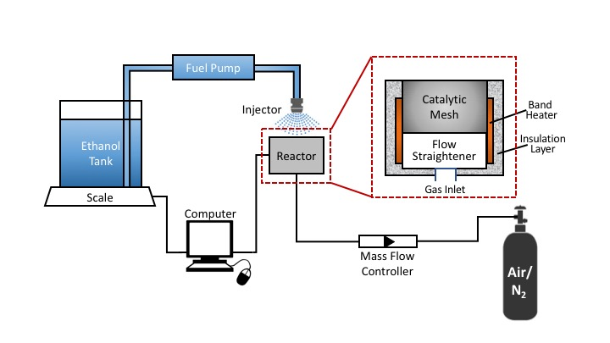

Figure 1. Test bench for testing hydrous ethanol spray vaporization and reforming

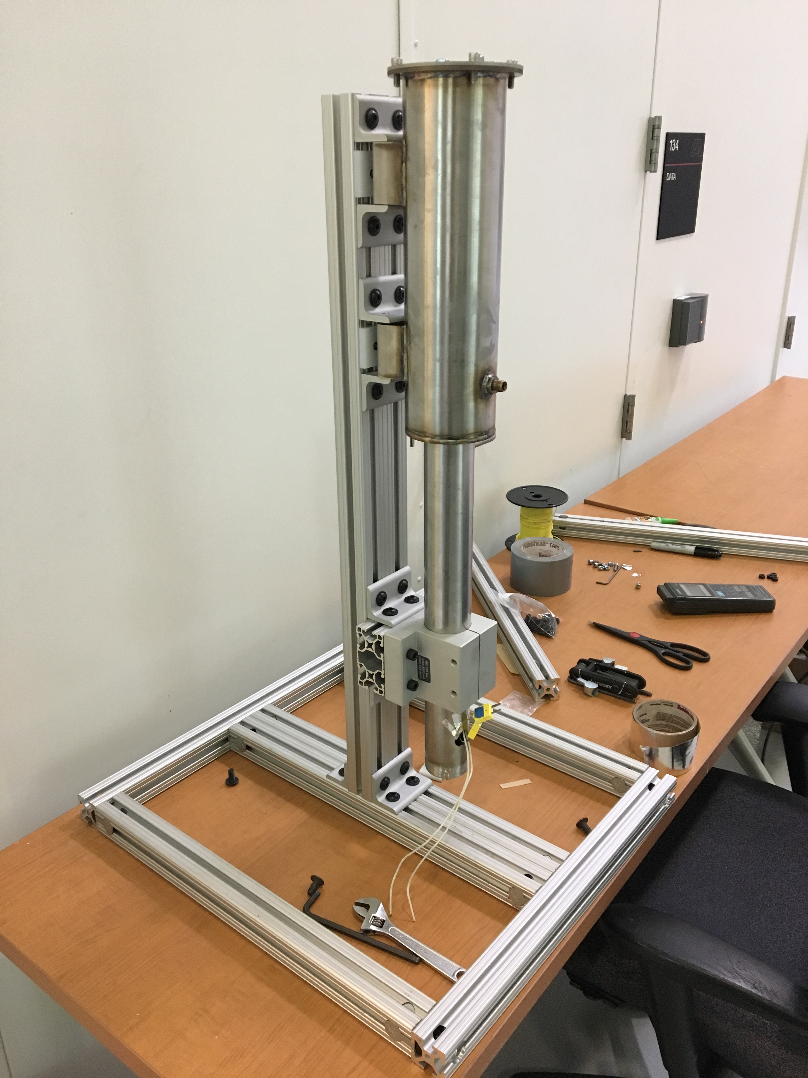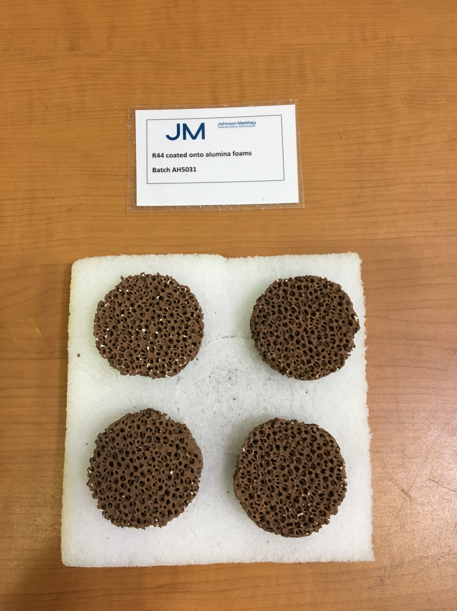

Figure 2. Photos of the reactor developed for the final testing and the catalyst foams coated by Johnson Matthey.



Figure 3. Internal configuration of the opposed flow reactor used for ethanol experiments.

Experiments with the reactor were conducted with results shown in Figure 4. The figure shows that syngas (H2 and CO combined) concentration increased with increasing equivalence ratio (the ratio of fuel to air flow divided by the stoichiometric air to fuel ratio), but with low overall concentrations. Remaining experiments in the project will be focused on increasing the yield of syngas components and on identifying how much ethanol converts to methane in the reactor.



Figure 4. Ethanol partial oxidation syngas production as a function of global equivalence ratio

2.) IDENTIFY ANY SIGNIFICANT FINDINGS AND RESULTS OF THE PROJECT TO DATE.

To date, the project has shown that opposed flow reforming of sprayed ethanol is a viable technique. Opposed flow spray reforming of ethanol against air emerging through a metal monolith showed activity and could sustain reforming reactions at moderate temperature. Closed reactor testing shows that ethanol conversion is low, though it may be sufficient to alter reactivity of overall fuel and air mixtures of engines.

3.) CHALLENGES ENCOUNTERED. (*Describe any challenges that you encountered related to project progress specific to goals, objectives, and deliverables identified in the project workplan.*)

One challenge encountered in the project has been a difficulty to obtain appropriate catalysts. To conduct the experiments outlined previously, a metal monolith catalyst section was used from a prior study. It is expected that the used catalyst will be suitable for the proof-of-concept work to be conducted in this work but that an alumina foam substrate would be more appropriate. A significant lead time for obtaining the foam and wash-coating catalyst on it has delayed the project timing.

A technical challenge encountered in the project has been mild formation of carbon residue on the catalyst surface. This residue deactivates the catalyst and reduces the conversion of ethanol to syngas. To remedy the situation, a higher injection pressure will be used, resulting in smaller fuel droplets and better vaporization. The increased vapor fraction will be advantageous for better mixing and less liquid contact on the catalyst surface.

4.) FINANCIAL INFORMATION (*Describe any budget challenges and provide specific reasons for deviations from the projected project spending.*)

No budget challenges have been encountered on the project to date.

5.) EDUCATION AND OUTREACH ACTIVITES. *(Describe any conferences, workshops, field days, etc attended, number of contacts at each event, and/or publications developed to disseminate project results.)*

Project results were presented at the spring 2018 Central States Section of the Combustion Institute meeting held in Minneapolis, MN in May. Three students including two female undergraduate mechanical engineering students and one Ph.D. student are currently working on the project. It is expected that one peer-reviewed journal paper will result from the work conducted in this project.