Progress Report

PROJECT TITLE: Quantifying hydrologic impacts of drainage under corn production systems in the upper Midwest
PROJECT NUMBER: 4116-14SP
REPORTING PERIOD: October 1, 2016 to January 31, 2017
PRINCIPAL INVESTIGATOR: Jeff Strock
ORGANIZATION: University of Minnesota
PHONE NUMBER: 507-752-7768
EMAIL: jstrock@umn.edu

1.) PROJECT ACTIVITIES COMPLETED DURING THE REPORTING PERIOD. (Describe project progress specific to goals, objectives, and deliverables identified in the project workplan.)
Objective 1: Determine how the presence of subsurface drainage changes the comprehensive water budget of corn production systems.

Task 1. Physical quantification of soil water balance. Minnesota: Drain flow has been continuously monitored and during 2016, flow was nearly continuous once flow began after soils thawed in spring. Water samples for water quality have been analyzed. The Tracy site recorded about 38 inches of precipitation whereas the normal is about 26 inches. Mean annual precipitation at the Waseca site is 36 inches, however, during 2016 a record 56 inches of precipitation was recorded. Soil water content and temperature sensors (4, 8, 16, 24 and 39 inches) were continuously monitored. Soil water potential sensors (Tensiometers and 229 matric potential sensors) have been continuously monitored. Climate data are being continuously downloaded from both sites. Root samples were collected from the two Minnesota sites and have been cleaned and prepared for scanning. They are currently being scanned for length and mean diameter plus weighed for total biomass. Soybean was planted at the Tracy site and corn at the Waseca site in 2016. Yield data was collected from the management zones at the Tracy site as well as the Waseca site however the raw data have not been completely processed at this time. South Dakota: Drain flow has continuously been monitored every 15 minutes based on flow over V-notch weirs in drainage control structures. Water table depth at 5-ft midway between drain lines in the middle of each plot was also been measured and logged every 60 minutes. Soil water content was collected every 15 minutes at 6, 18, 30, and 42 inch depths. Micrometeorological data (temperature, relative humidity, wind speed and direction, solar radiation, and precipitation) were also collected continuously from the South Dakota Mesonet station, located on the research farm near Beresford that and operated by the South Dakota State Climate Office. We continue to collect annually crop yield data for soybean-corn rotation. Soybean was planted in 2013 and 2015, and corn in 2014 and 2016.

Task 2. Source, flow path and residence time of root zone water and shallow ground water. Minnesota: Deep and shallow wells along with suction cup lysimeters were installed at all sites monitored during 2016. Precipitation, drainage water, well water and soil pore water was periodically collected for isotopic analysis. Samples have been delivered for isotopic analysis. South Dakota: Shallow wells were installed and water table data are collected every 60 minutes. A deep well (35-ft deep) at the Beresford site was also installed and monitored for isotope analysis. The well is an artesian well with continuous flowing water. Isotope samples have been collected two to three times per year.

Local meteoric water lines (LMWL) were established for Tracy, Waseca, and South Dakota sites. Equations are as following:
$$Tracy: y=7.2727x+2.5171, R^{2}=0.9499$$
$$Waseca: y=8.0179x+12.461, R^{2}=0.9643$$
$$Beresford: y=6.5256x-10.748, R^{2}=0.9643$$

The difference in the slopes is likely due to the temperature difference/gradient among the locations. Well samples also plot at different locations relative to the LMWL. The groundwater seems to be more enriched near Beresford than the other two locations.

Tracy site and Waseca site have isotope time series plots from March 2016 to October 2016 and January 2017. Both sites are close to be ready for a prelim analysis of the residence time for each water body. This will be completed the first quarter of 2017. Residence time information will aid in the SWAT modeling.

Figure 1. Tracy site δ¹⁸O plot against time.
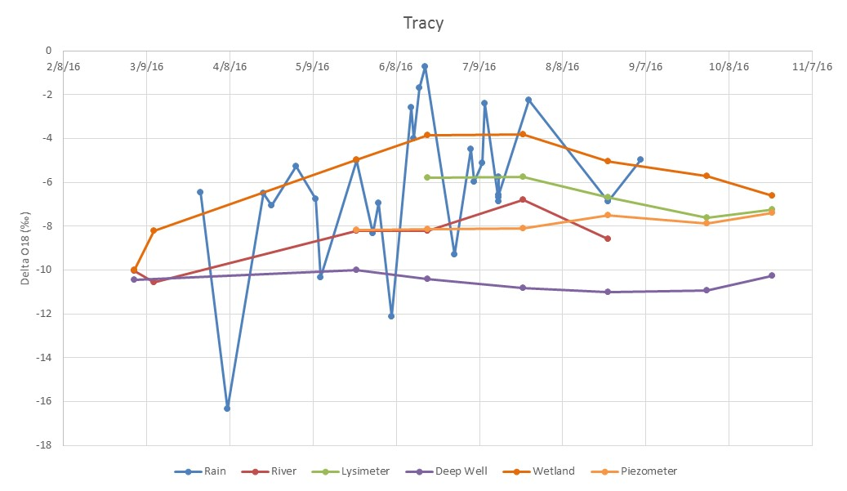

Figure 2. Waseca site δ¹⁸O plot against time.
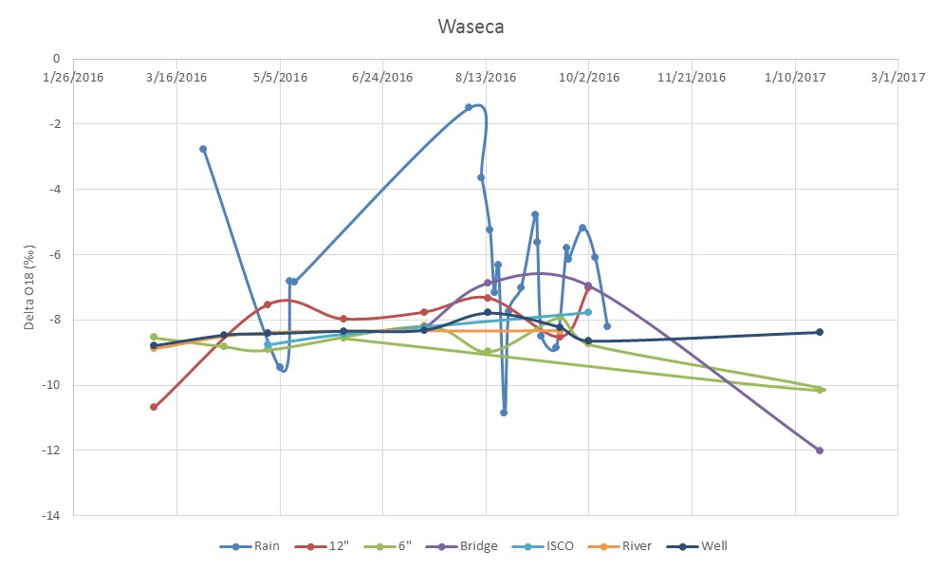

Objective 2: Quantify how the different components of field-scale water budgets may influence watershed-scale hydrology and predict how these systems may change under scenarios of variable weather and changing climate.
Task 1. Computer simulation modeling using the SWAT model. South Dakota: A SWAT model of the Vermillion River Watershed has been built and hydrologic calibration has begun. Preliminary results show good agreement between observed and predicted daily flow values with the notable exception of 2013, during which the model is over-predicting flow when compared against the observed record. Current calibration efforts for the Vermillion River SWAT model are focused on ensuring that two upstream reservoirs are parameterized correctly along with numerous wetlands that are common features in the northern portion of the watershed.

Additional notable progress with modeling efforts are centered on developing methods to partition daily modeled flow values into their respective source components (e.g., surface water vs. ground water). We are now able to visualize water yields for individual flow components on a daily basis (e.g., Fig. 1) to determine how various sources of water are combining to make up total flow from the watershed. This is an important advancement for evaluating the simulated hydrology data against measured water age values to assess whether or not the watershed model is doing a realistic job of simulating key components of the watershed hydrologic budget. Information gained from this analysis of model results (and complemented by field observations) will lead to a more robust understanding of the relative importance of different water sources during various watershed conditions.

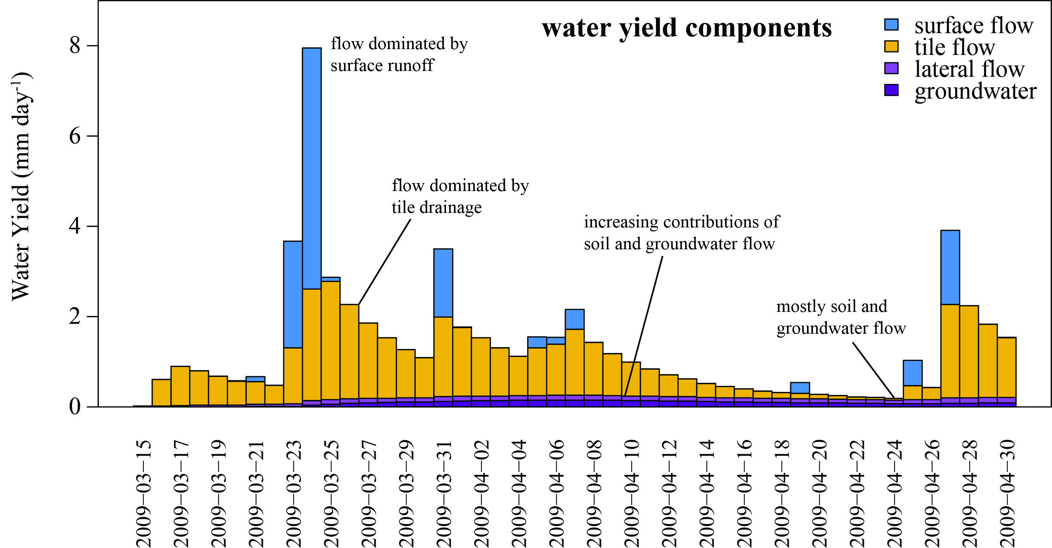

Figure 1. Key source water contributions to daily water yield in the LeSueur River Watershed simulated by the SWAT model. Modeled estimates of the source and relative importance of different water sources will be compared against measured water age estimates determined via isotopic techniques in order to determine key mechanisms responsible for flow generation in the study watersheds and link them back to field-scale processes.

2.) IDENTIFY ANY SIGNIFICANT FINDINGS AND RESULTS OF THE PROJECT TO DATE.
Considerable work has been done in synthesizing data collected since the beginning of the project. This data was presented at the ASA-CSSA-SSSA annual meeting in Phoenix, AZ. The graduate student, Lu Zhang, spent time working with the seasonal isotope data and the data look promising. Based on Tritium analysis, the Tracy groundwater is more than 60 years old and Waseca more than 40 years old. There are plans for coupling the results of the isotope analysis with the modeling in order to improve the model output.

3.) CHALLENGES ENCOUNTERED. (Describe any challenges that you encountered related to project progress specific to goals, objectives, and deliverables identified in the project workplan.)
We have encountered some delays in isotope analysis but we have been assured that the lab will get caught up with sample analysis in early 2017.

4.) FINANCIAL INFORMATION (Describe any budget challenges and provide specific reasons for deviations from the projected project spending.)
Spending has been progressing as expected.

5.) EDUCATION AND OUTREACH ACTIVITES. (Describe any conferences, workshops, field days, etc attended, number of contacts at each event, and/or publications developed to disseminate project results.)
- Department of Soil, Water and Climate – Departmental Seminar Lightning Presentation. – 26 October, 2016. St. Paul. Presenter. Topic: Research and Outreach Overview. Number of participants: 42.

- Soil Science Society of America Annual Meeting. 9 November, 2016. Phoenix, AZ. Presenter. Topic: Drainage water management to mitigate nitrogen leaching from a tile drained agricultural landscape. Number of participants: 35.

- Soil Science Society of America Annual Meeting. 9 November, 2016. Phoenix, AZ. Co-author with post-doc advisee. Topic: Effect of drainage water management on drain flow. Number of participants: 36.

- Minnesota Groundwater Working group on Tile Drainage. 15 November, 2016. St. Paul, MN. Presenter. Topic: Impact of tile drainage on groundwater age and recharge. Number of participants: 10.

Personal contacts with some attendees after the presentations were strongly positive about the project.

