Progress Report

PROJECT TITLE: Impact of Cover Crop Strategies on Productivity of Corn
PROJECT NUMBER: 4123-16SP
REPORTING PERIOD: Oct 1 – Dec 31, 2017
PRINCIPAL INVESTIGATOR: Axel Garcia y Garcia
ORGANIZATION: University of Minnesota
PHONE NUMBER: 507-752-5080
EMAIL: axel@umn.edu

1.) PROJECT ACTIVITIES COMPLETED DURING THE REPORTING PERIOD. (Describe project progress specific to goals, objectives, and deliverables identified in the project workplan)

The objectives of the project are to a) assess the viability of cover crop strategies on corn-soybean rotation under different tillage practices and b) determine the effect of cover crop strategies on growth and yield of corn and soybean produced across multiple environments. Experiments for objective (a) are conducted within the Long-Term Tillage Trial platform (LTTT) located in Lamberton and Waseca. Experiments for objective (b) are conducted within the Long-Term Agricultural Research Network (LTARN) located in Grand Rapids, Lamberton, and Waseca.

Both graduate students did well; activities included field data collection and lab processing (Fig. 1), data analysis, and presentation of preliminary results by one of them at the Agronomy meeting in Tampa, FL.

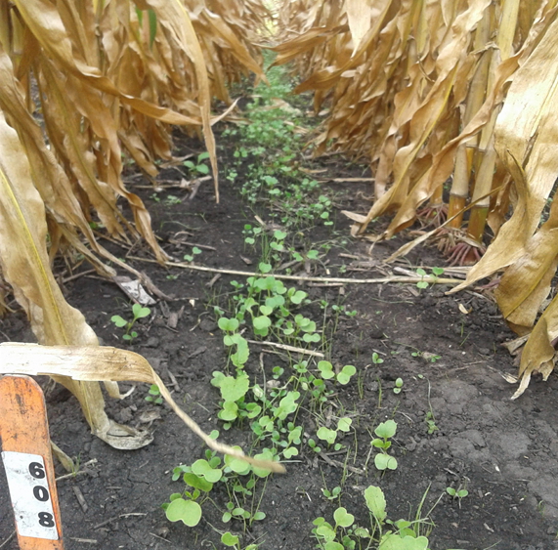 | 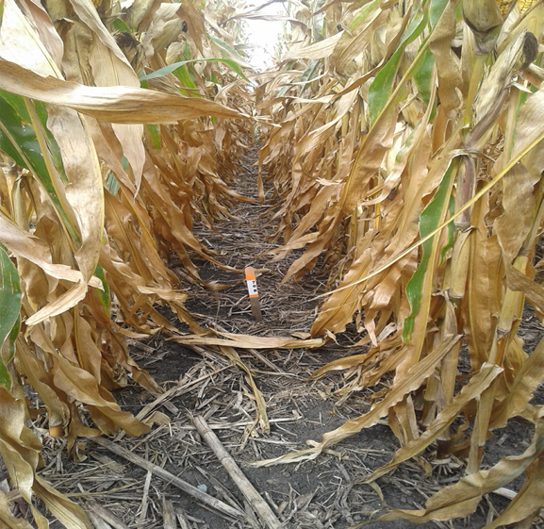 | 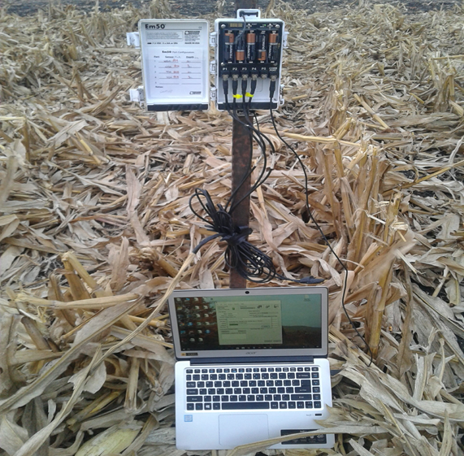 | 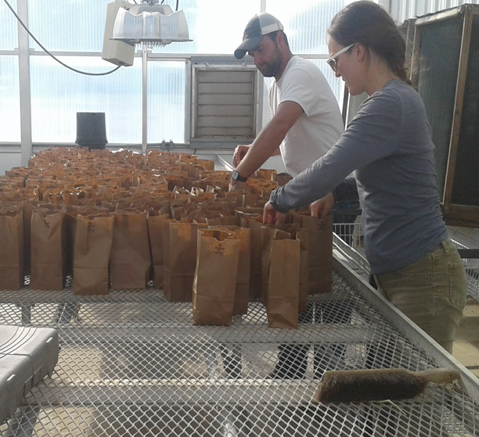 | 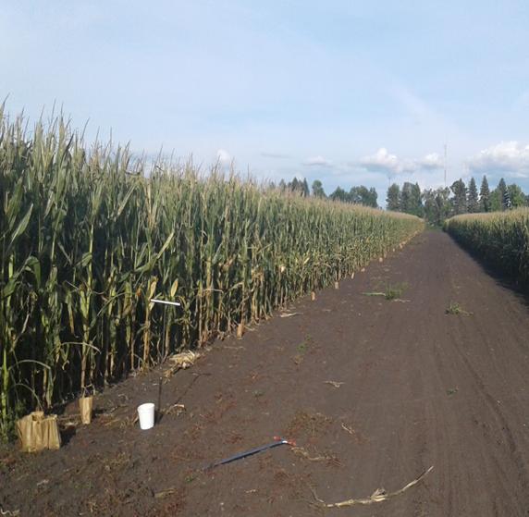
a | b | c | d | e
Figure 1 – a) Cover crops at corn physiological maturity; b) crop residue from last season in NT plots; c) EM50 datalogger: downloading soil moisture and temperature data; d) preparing plant samples for lab analysis; and e) collecting soil samples for lab analysis.
Cover crops and tillage practices (objective a)

Soil moisture and soil Temperature
Soil moisture and soil temperature were monitored simultaneously at a depth of around 2-3 inches. A close up of early-season data collected is shown in Fig. 2. Further analysis is needed to determine potential differences due to cover crops.

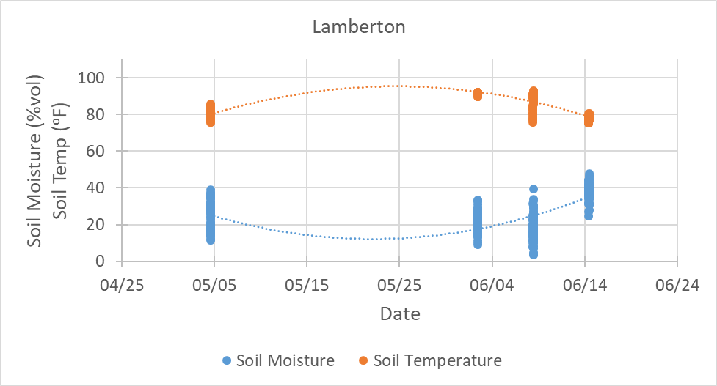
Figure 2 – Early-season soil moisture and soil temperature from corn and soybean grown under different tillage practices (CT = conventional till; ST = strip till, and NT = no till) in Lamberton. The data presented are pooled averages from both primary crops, tillage practices and cover crop practices.

Cover crop ground cover and grain yield of corn
Fall ground coverage was marginal. Regardless of the location, cover crops seeded into standing corn had more ground covered than those seeded into standing soybean (Fig. 3a). Within location and tillage practice, yield differences were not statistically significant (Fig. 3b)

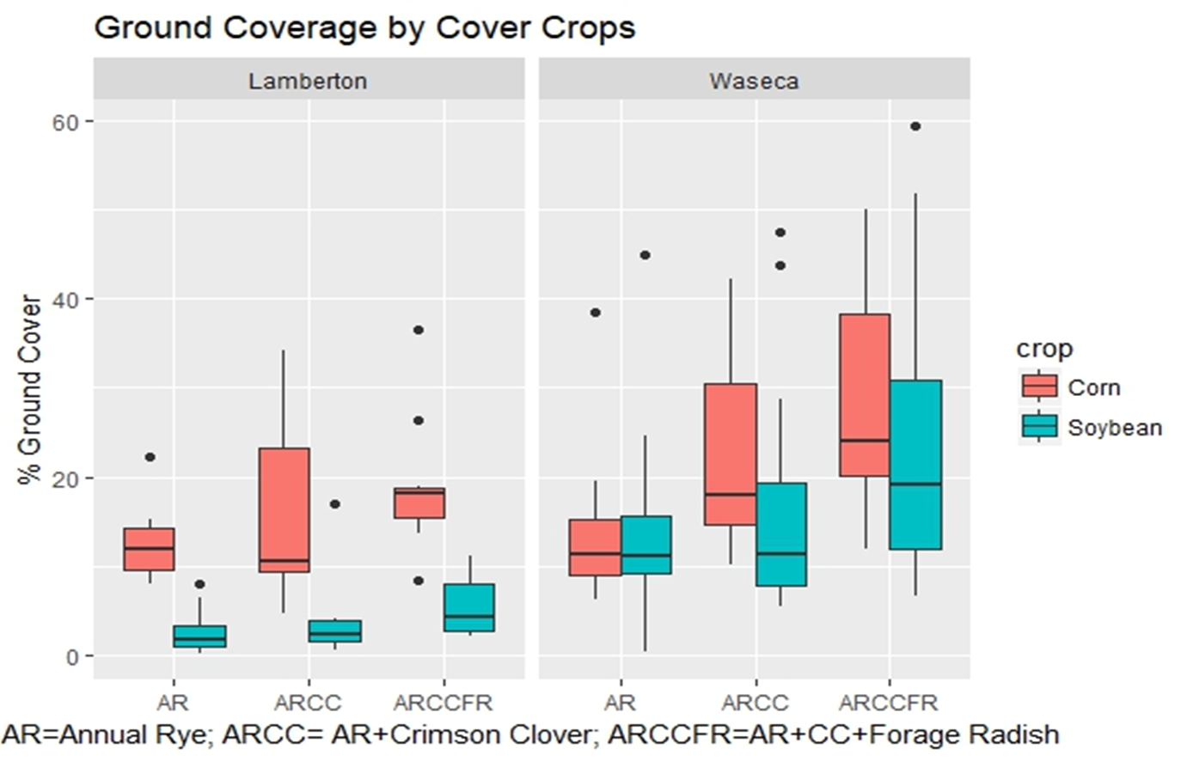 | 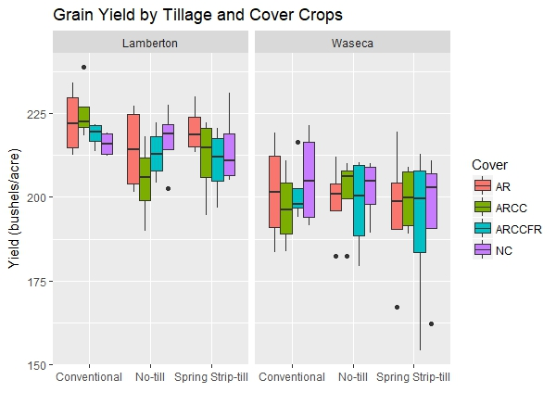
(a) | (b)
Figure 3 – Fall ground cover (%) and corn grain yield under different tillage practices (CT = conventional till; ST = strip till, and NT = no till) in Lamberton and Waseca.
Nitrate in the leachate

The ceramic cup lysimeters were installed late in June of 2017. Overall, and regardless of the crop and tillage practice, NO₃-N in the leachate was higher at the end of the season. In corn, NO₃-N in the leachate was higher in conventional tillage and lower in no till. In soybean, however, lower NO3-N were found under strip till and higher under no till (Fig. 4). Further analysis is needed to determine potential differences due to cover crops.

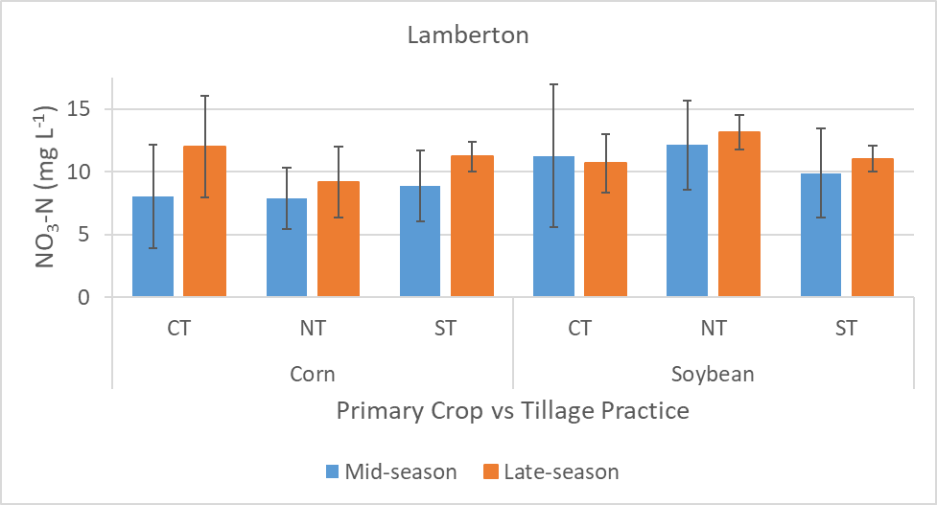
Figure 4 – Fall ground cover (%) and corn grain yield under different tillage practices (CT = conventional till; ST = strip till, and NT = no till) in Lamberton and Waseca.

Cover crops in multiple locations (objective b)

Soil moisture

Soil moisture was successfully monitored at all locations. In average, data was collected every 7-10 days at six fixed depths, including 10, 20, 30, 40, 60, and 100 cm. The dynamics of soil moisture was similar among locations: soil moisture varied the least at the beginning and at the end of the season while high variation was in mid-season. This coincides with period of low (start- and end-season) and high (mid-season) water requirements by both crops. Results from Lamberton are shown in Fig. 5.

Corn | Soybean
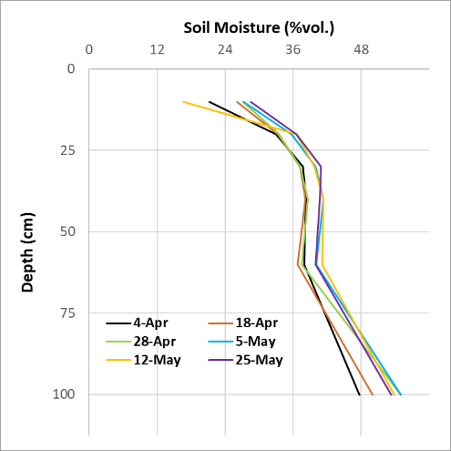 | 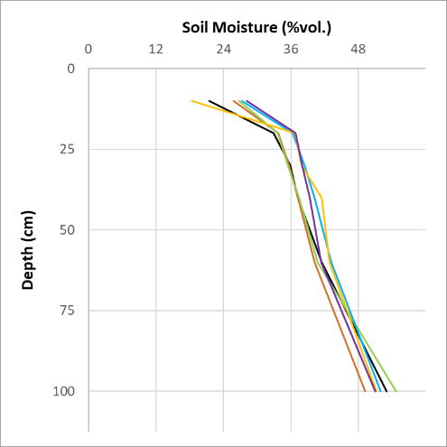
(A)
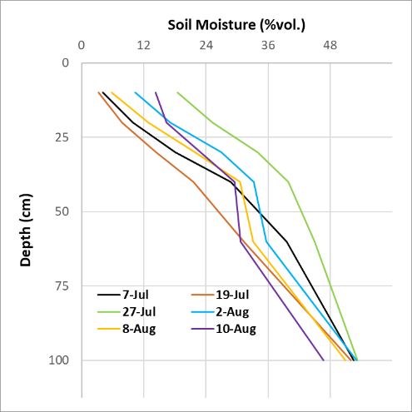 | 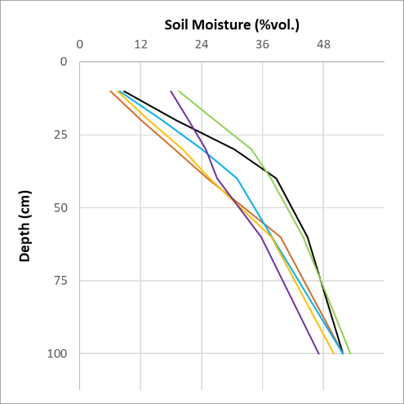
(B)
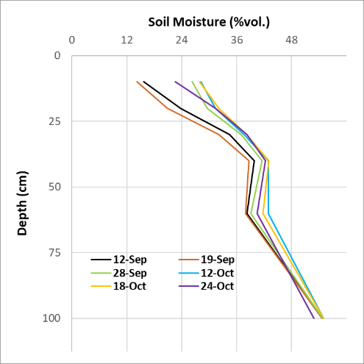 | 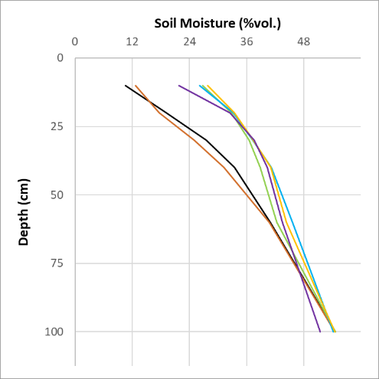
(C)
Figure 5 - Soil moisture variation at (A) beginning-, (B) mid, and (C) end-season in corn and soybean for conditions in Lamberton during the 2017 growing season.

Grain yield of primary crops

Grain yield of corn and soybean vary among locations; higher and lower corn yields were obtained in Waseca and Grand Rapids, respectively and higher and low soybean yields were obtained in Lamberton and Grand Rapids, respectively. Within a location, yield of corn in Grand Rapids and Lamberton was not affected by cover crop mixes with annual and cereal rye. In Waseca, however, significant differences (p < 0.05) on corn yield were observed between annual rye mixes. Within a location, yield of soybean in all locations was not affected by annual rye- or cereal rye-based mixes (Fig. 6).

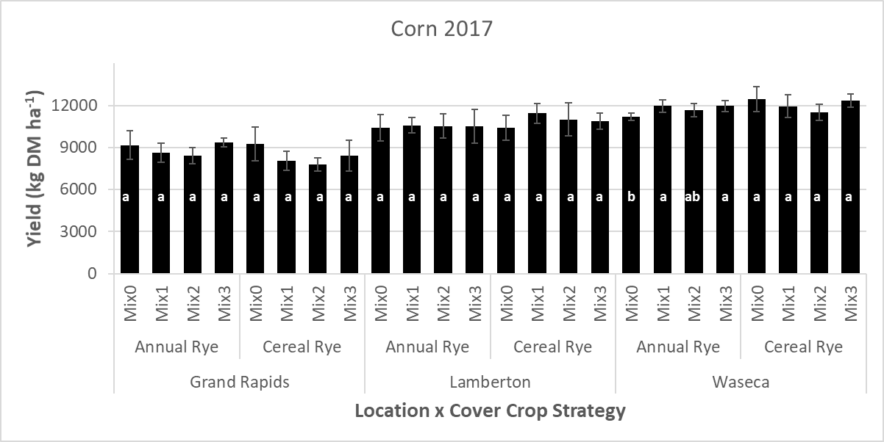
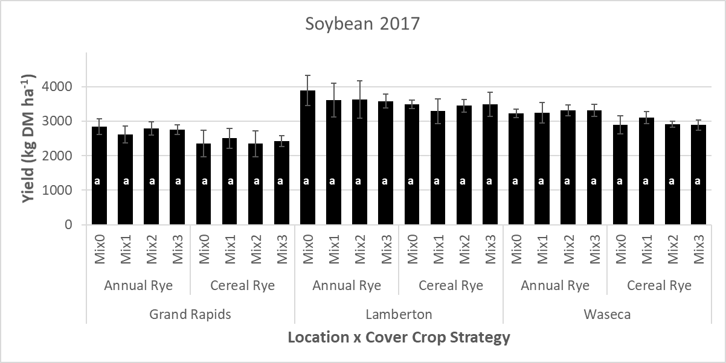

Figure 6 – Yield of corn and soybean as affected by location and cover crop strategy. 2017 growing season. Mix0 = no cover; Mix1 = rye cover, only; Mix2 = blend of rye + crimson clover (CC); and Mix3 = blend of rye + CC + forage radish. Within a location and rye strategy, means yield with the same letter are not significantly different at alpha = 0.05. Vertical lines correspond to ± one standard deviation.

Corn yield in southern and southwestern Minnesota produced lower yields when cover crops were seeded early (V4 corn stage) in the growing season. In north central Minnesota, however, corn yielded less when cover crops were seeded late (R5 corn stage) in the season (Fig. 7).

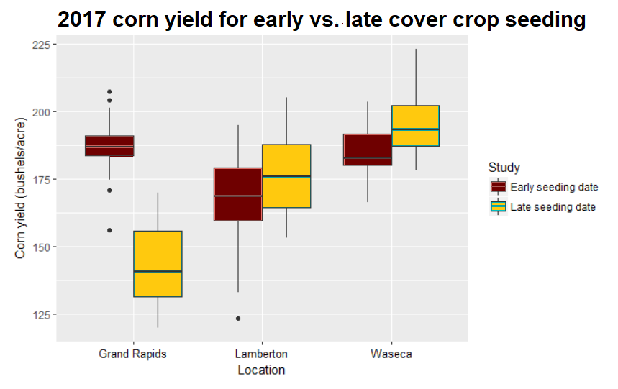

Figure 7 – Effect of early- and late-season cover crop seeding on grain yield of corn.

Nitrate in the leachate

Among locations, NO₃-N in the leachate was higher at the beginning of the season in Grand Rapids, followed by Lamberton and Waseca. Overall, however, the potential for NO₃-N loss was higher in Lamberton and lower in Waseca. Except in Grand Rapids, NO₃-N losses tend to be higher in corn than in soybean. Ortho-P in the leachate were marginal among locations and crops; yet, its concentration in the leachate was slightly higher in Lamberton (Fig. 8).
Differences on NO₃-N in the leachate due to cover crop strategy were observed in all three locations but further analysis is needed before a conclusion is provided. In general, however, slightly higher NO₃-N in the leachate was observed in the no cover (Mix0) treatments. On the other hand, ortho-P in the leachate was very low to marginal in in all locations (Fig. 8).

NO₃-N vs Cover Crops | Ortho-P vs Cover Crops
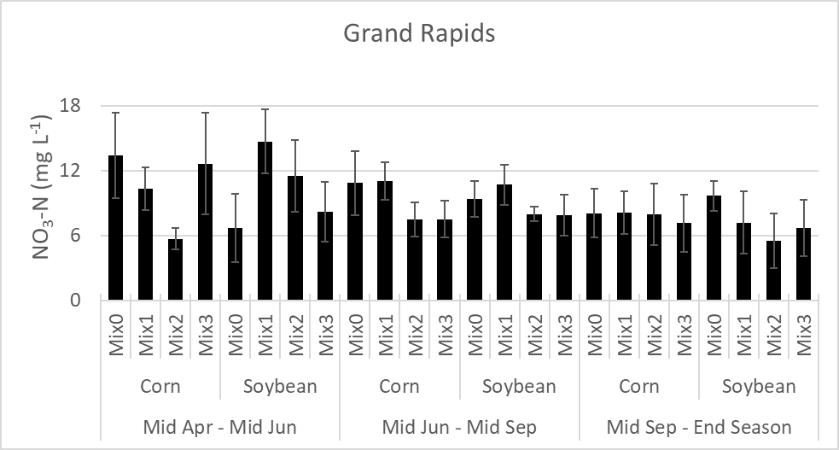 | 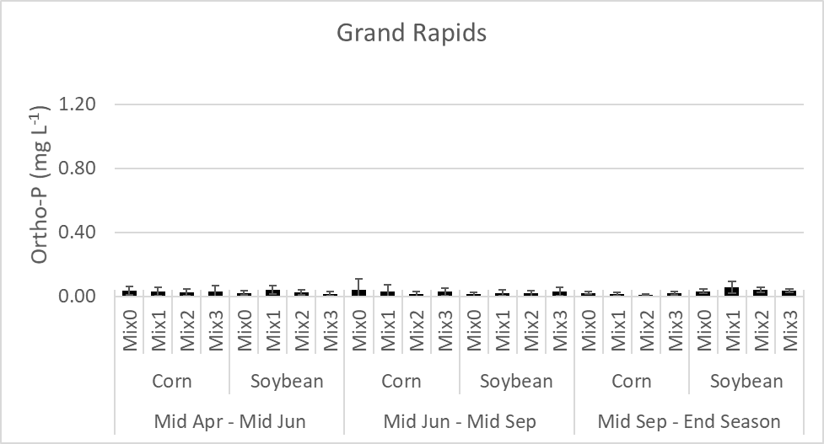
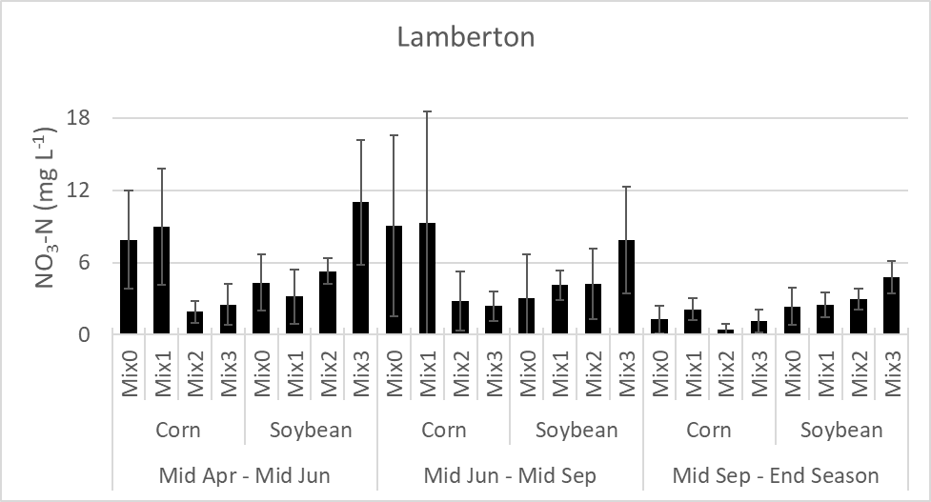 | 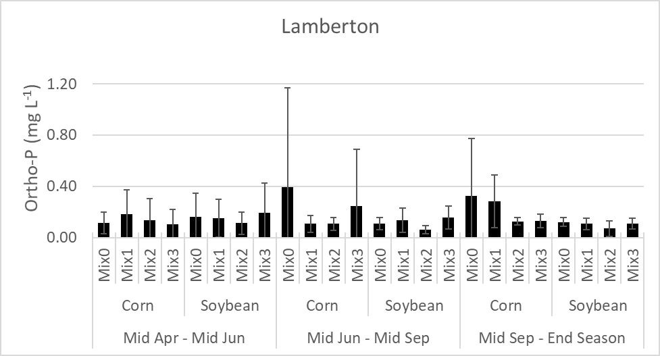
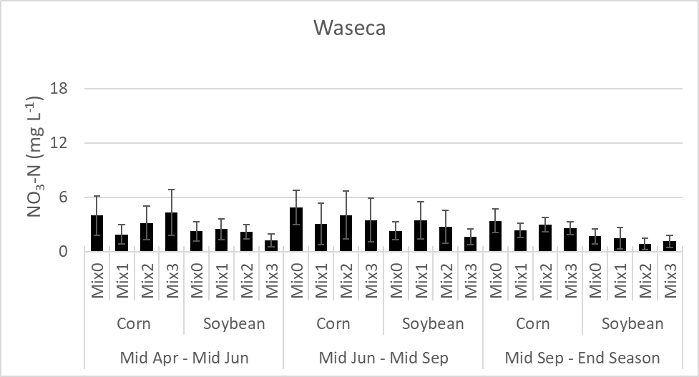 | 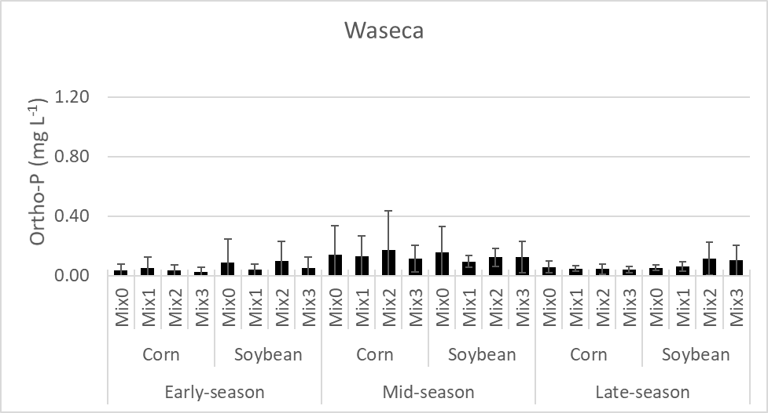
Figure 8 – NO₃-N and Ortho-P in corn and soybean following different cover crop strategies during early (mid-Apr to mid-Jun), mid (mid-Jun to mid-Sep), and late (mid-Sep to end season) season in 2017. Mix0 = no cover; Mix1 = rye cover, only; Mix2 = blend of rye + crimson clover (CC); and Mix3 = blend of rye + CC + forage radish

Weather conditions in all locations

Weather conditions from the beginning of October delayed harvest. This situation was more evident in Lamberton, where the 141 mm of rainfall in the first seven days more than tripled the long-term average of 41 mm of the month (Fig. 9). Consequently, harvest of grain and biomass yield of crops and cover crops was delayed. This, however, did not affect the end-season activities of the project.

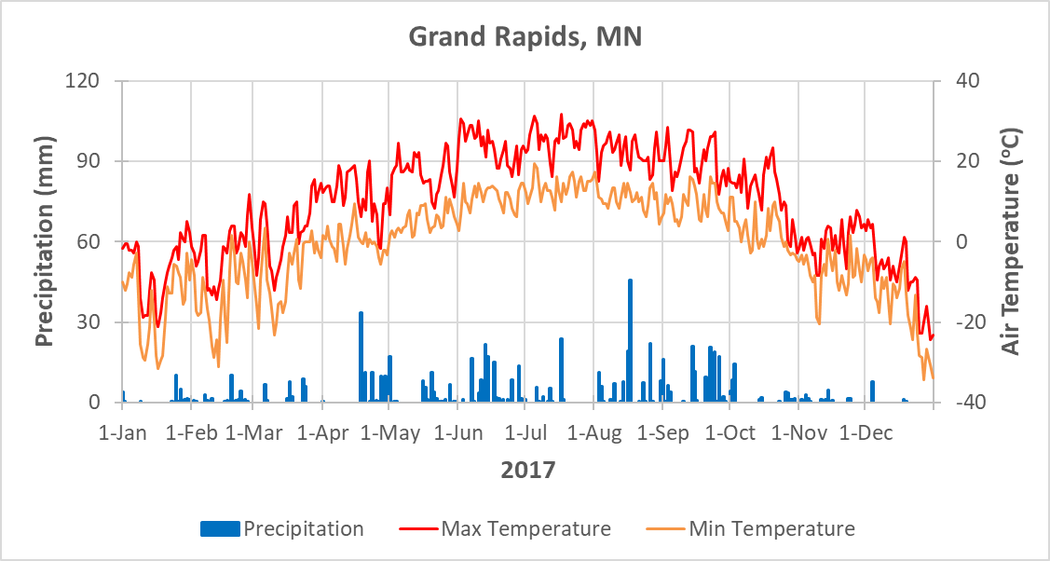
(A)
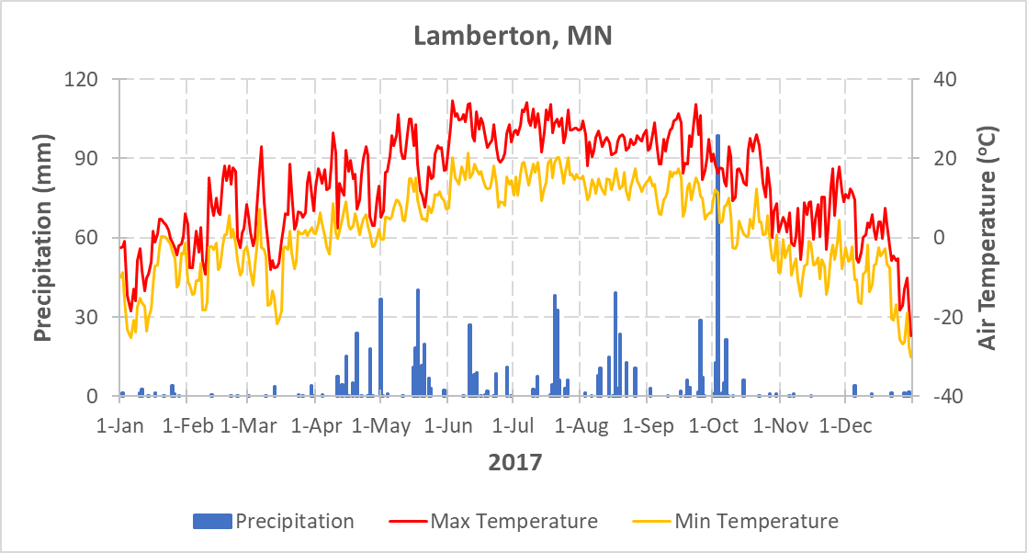
(B)
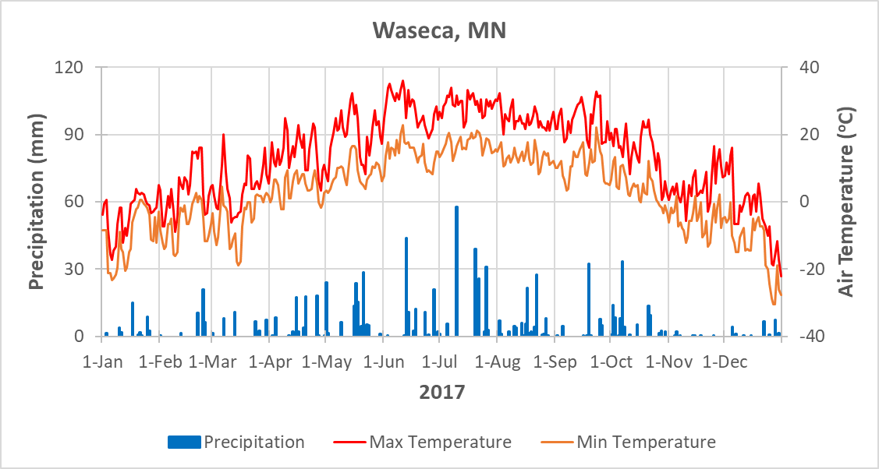
(C)

Fig. 9 – Weather conditions during the 2017 growing season at (a) Grand Rapids, (b) Lamberton, and (c) Waseca.

2.) IDENTIFY ANY SIGNIFICANT FINDINGS AND RESULTS OF THE PROJECT TO DATE.

Although no significant differences, our preliminary analysis shows that corn and soybean following annual rye perform slightly better than corn following cereal rye. Further analysis is needed to determine the causes of this.

3.) CHALLENGES ENCOUNTERED. (Describe any challenges that you encountered related to project progress specific to goals, objectives, and deliverables identified in the project workplan.)

As usual, weather conditions are the main concern. A wet end-of-the-season delayed harvest of primary crops but our data collection was not affected.
We experienced some issues with several ceramic cup lysimeters in Lamberton; some cups were damaged with field equipment and some others were not holding the vacuum needed to extract the water solution. The issues were resolved.
Bacterial disease in corn showed up again at the LTTT at the Lamberton location. Similar to 2016, the issue was isolated and it seems not to have affected the performance corn.

4.) FINANCIAL INFORMATION (Describe any budget challenges and provide specific reasons for deviations from the projected project spending.)

No budgetary challenges to report.

5.) EDUCATION AND OUTREACH ACTIVITES. (Describe any conferences, workshops, field days, etc attended, number of contacts at each event, and/or publications developed to disseminate project results.)

- Garcia y Garcia, A. G. Johnson, J. Strock, and R. Liu. 2017. The Nexus of Cover Crops, Water, and Nitrogen: Impact on Corn and Soybean Productivity and the Environment. ASA-CSSA-SSSA. Oct 22-25, Tampa, FL.
- Rusch, H., J. Coulter, and Garcia y Garcia. 2017. Cover Crop Strategies to Balance Corn Production and Environmental Stewardship. ASA-CSSA-SSSA. Oct 22-25, Tampa, FL.
- Garcia y Garcia, A., J. Strock, B. Potter, J. Johnson, J. Vescht, W. Sadok. 2018. Impact of Cover Crop Strategies on Productivity of Corn. 2018 AgExpo, Verizon Center, Jan 24, 2018 - Mankato, MN.
- KC, R. and Garcia y Garcia. 2018. Assessing Cover Crop Strategies in Corn Production under Different Tillage Practices. 2018 AgExpo, Verizon Center, Jan 24, 2018 - Mankato, MN.
- Rusch, H., J. Coulter, and Garcia y Garcia. 2018. Advancing sustainable corn production with cover crops. 2018 AgExpo, Verizon Center, Jan 24, 2018 - Mankato, MN.

