Progress Report

PROJECT TITLE: Impact of Cover Crop Strategies on Productivity of Corn
PROJECT NUMBER: 4123-16SP
REPORTING PERIOD: Apr 1 – Jun 30, 2018
PRINCIPAL INVESTIGATOR: Axel Garcia y Garcia
ORGANIZATION: University of Minnesota
PHONE NUMBER: 507-752-5080
EMAIL: axel@umn.edu

1.) PROJECT ACTIVITIES COMPLETED DURING THE REPORTING PERIOD. (Describe project progress specific to goals, objectives, and deliverables identified in the project workplan)

The objectives of the project are to a) assess the viability of cover crop strategies on corn-soybean rotation under different tillage practices and b) determine the effect of cover crop strategies on growth and yield of corn and soybean produced across multiple environments. Experiments for objective (a) are conducted within the Long-Term Tillage Trial platform (LTTT) located in Lamberton and Waseca. Experiments for objective (b) are conducted within the Long-Term Agricultural Research Network (LTARN) located in Grand Rapids, Lamberton, and Waseca.

Both graduate students have processed almost all of the remaining samples from 2017 as well as presented partial results at local and regional events. Their preliminary results have yet to be revised and statistically analyzed; still, a summary of some of those results follows.

Cover crops and tillage practices (objective a)

Soil moisture and soil temperature

We are measure soil moisture and soil temperature at the depth of 5 inches every week in both locations. Our preliminary results taken at different dates at each location show that soil moisture is higher under no till, followed by strip till, and conventional till (Fig. 1).

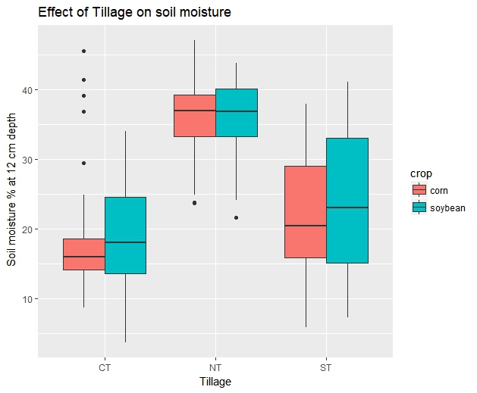 | 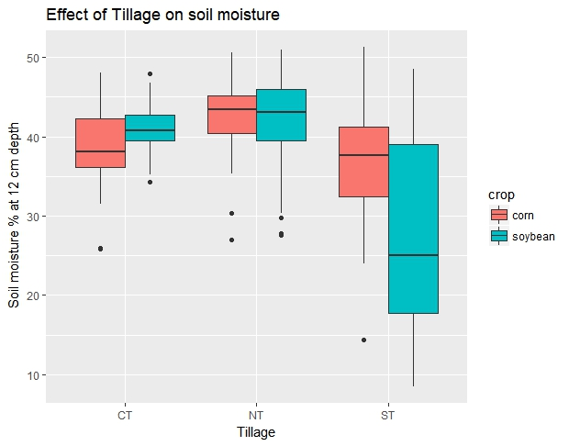
(a) | (b)
Figure 1 – Effect of tillage on soil moisture at a) Lamberton and b) Waseca. Results were averaged over treatments; measurements were taken on May 25 in Lamberton and May 7 in Waseca.

We had to re-install some dataloggers for the continuous recording of soil moisture and soil temperature in Waseca (Fig. 2). This was performed quickly so, the experiment was not compromised.

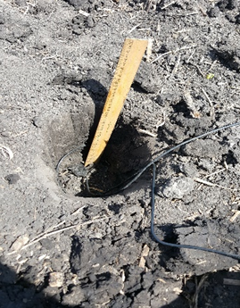 | 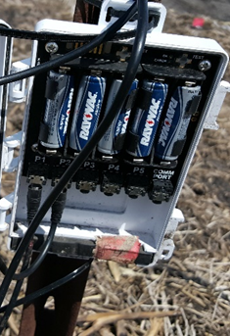 | 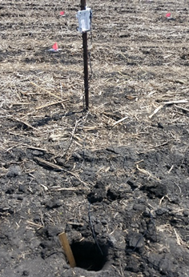
Figure 2 – Installation of dataloggers in Waseca.

Other data collection activities, such as leaf area index, biomass (Fig. 3a), NO₃-N in the leachate, and N mineralization (Fig. 3b; activity added to the project this year), are progressing according to our work plan.

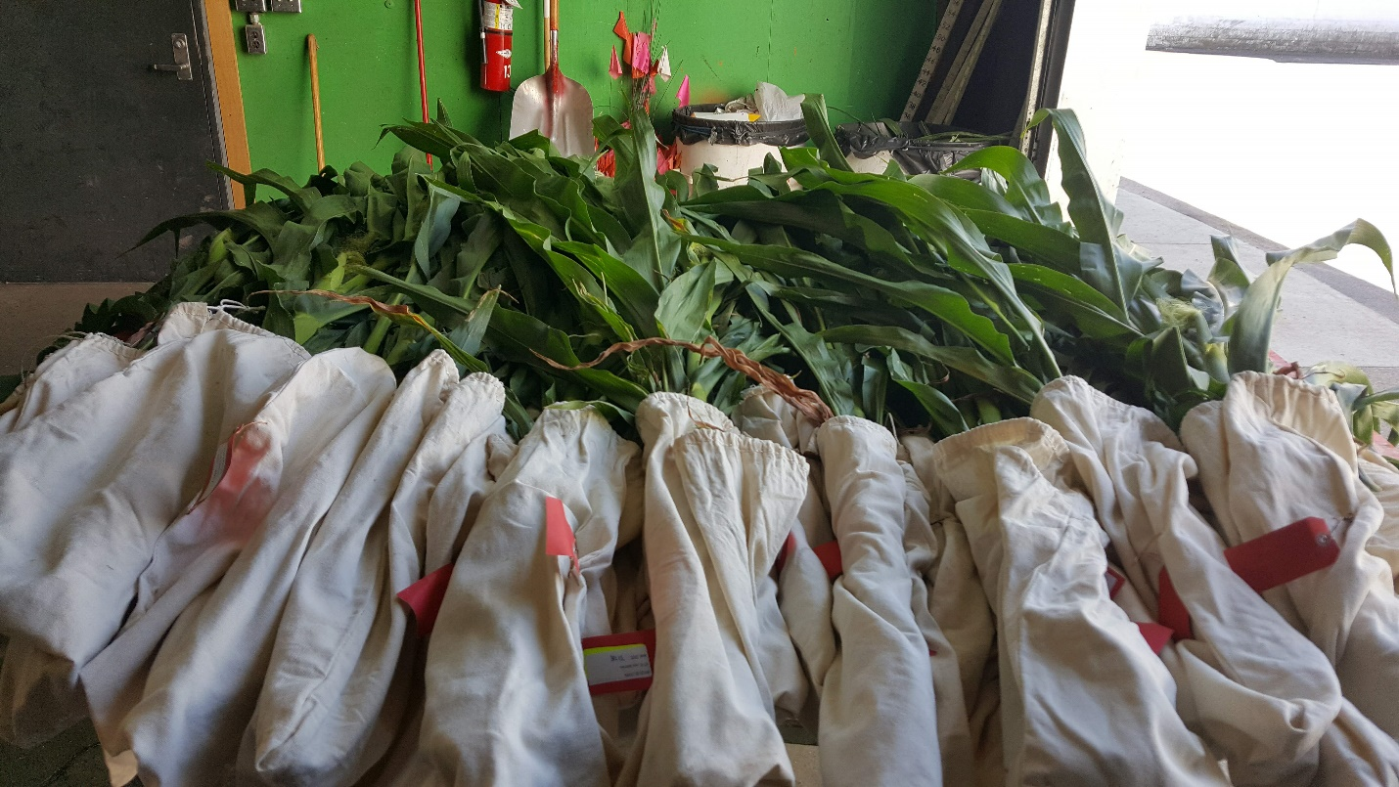 | 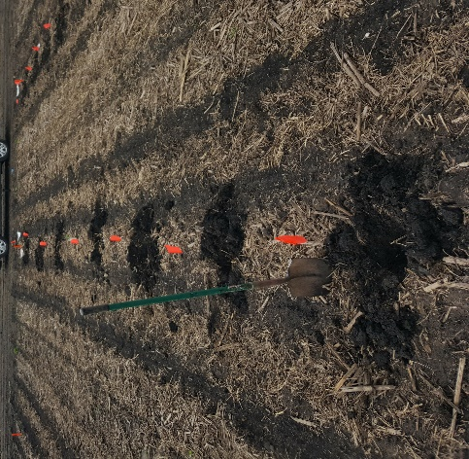
(a) | (b)
Figure 3 – a) Corn biomass weighing in Waseca, and b) preparing for N mineralization study.

Cover crops in multiple locations (objective b)

Early seeding cover crops
Cover crops were interseeded on June 14 and 15, 2018 into corn at V4-V6 leaf collar stage at Waseca (Fig. 4) and Lamberton, respectively. Due to the later planting of crops at Grand Rapids, MN, cover crops were interseeded on June 28, 2018. Percent living cover and cover crop biomass will be collected approximately one month after seeding and again at the end of the growing season.

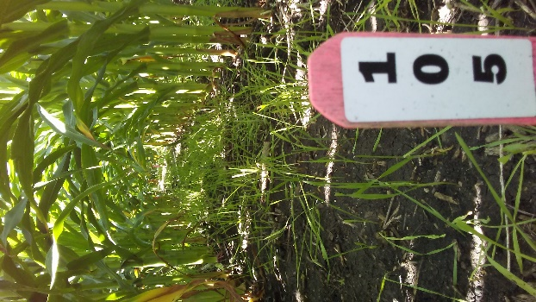 | 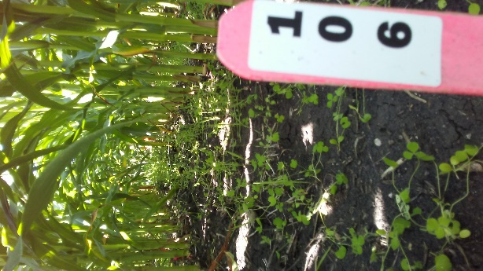 | 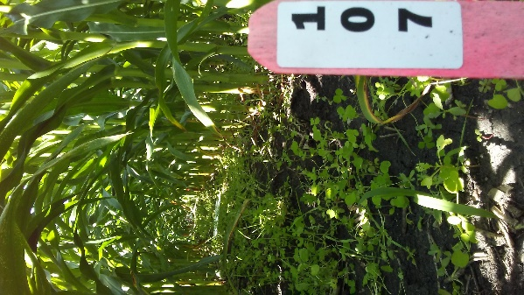
(a) | (b) | (c)
Figure 4 – Examples of early seeded cover crop establishment several weeks after seeding (a) cereal rye (CR), (b) CR + crimson clover (CC), and (c) CR+CC+ Forage radish cover crop treatments at Waseca, MN.
Insect traps

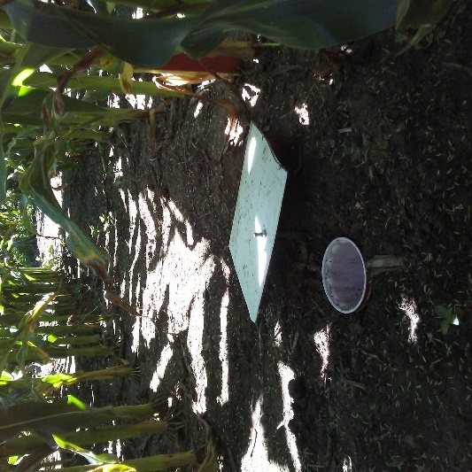
Two types of insect traps are being used this growing season. Sticky traps (which were used in 2017) to trap flying insect (e.g. lacewings and corn root borers) will be placed once every-other-week near the corn canopy in the early seeded cover crop (timing) study. Additionally, pitfall traps were installed in the ground to capture crawling insects (e.g. ground beetles and caterpillars) (Fig. 5). Samples will be collected every-other-week. Due to heavy rainfall and wet soils, entry into the plots has been limited to avoid ripping out the cover crops with foot traffic. Thus, the sticky and pitfall trap dates in June were delayed to the first week of July.
Figure 5 –Pitfall trap installation. An 18-ounce plastic red cup was installed in the middle of the center row of each plot in the early seeded cover crop (timing) study. Every-other-week soapy water is placed in the cup and 24-hours later insects that have fallen into the trap are collected and stored in small glass vials for identification.

Weather conditions in all locations

The second quarter of 2018 started cold and wet, limiting cover crops growth. From the beginning of April, air temperature was highly variable, with peaks and lows through May. From mid-Apr through mid-May, a key period for growth and for the termination of cover crops, Grand Rapids was dry while Lamberton and Waseca were wet. At termination of cover crops, which occurred 8-15 of May, the aboveground biomass of winter rye following both corn and soybean was low. The number of days with rainfall events that exceeded 13 mm (half inch) between April and June 2018 amounted to seven at Grand Rapids, six at Lamberton, and nine at Waseca. May and June had the most days with heavy rainfall. Of the three locations, Lamberton experienced the highest rainfall amount for a single event (49 mm in June as compared to 41 mm at Waseca in May and 39 mm at Grand Rapids in May). At both Lamberton and Waseca, more than half of the total number of days in May and June received rainfall. We did compare the 2018 weather conditions with a long-term series (1990-2015; data not shown) and found that April was drier that the long-term average in Grand Rapids and Lamberton, and cooler at all three locations. In all three locations, May and June tended to be both warmer and wetter than the long-term average.

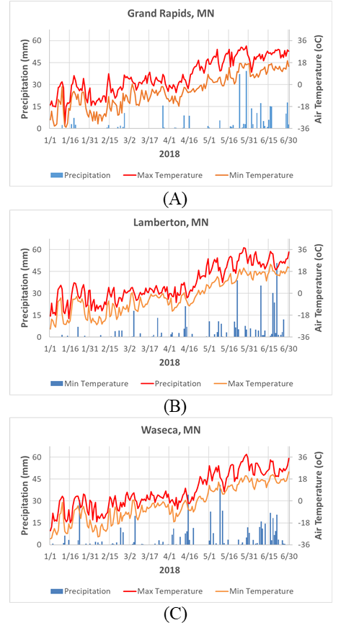
Fig. 6 – Weather conditions during the second quarter of 2018 at A) Grand Rapids, B) Lamberton, and C) Waseca.

2.) IDENTIFY ANY SIGNIFICANT FINDINGS AND RESULTS OF THE PROJECT TO DATE.

The percent living canopy cover of the 2017 season is being determined (Fig. 7). Preliminary results show robust cover crop establishment of early seeded (V4-V6 stage corn) cover crops, especially at Grand Rapids and Waseca (Fig. 8). Late seeded cover crops (R5-R6 corn and R7-R8 soybean) showed better establishment under corn as opposed to soybean (Fig. 9).

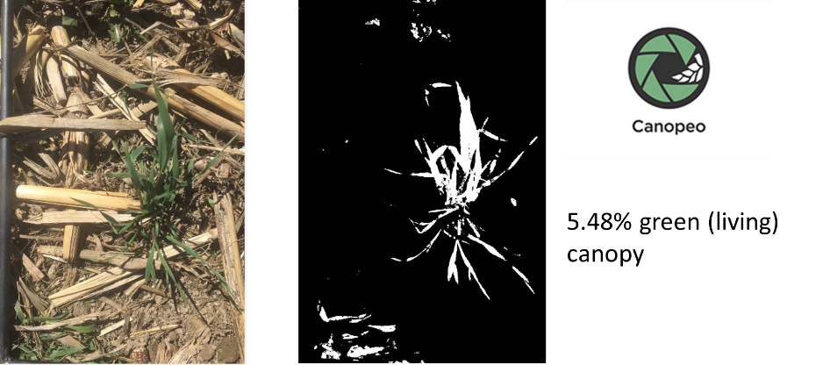
Figure 7 – Obtaining percent leaving canopy cover.

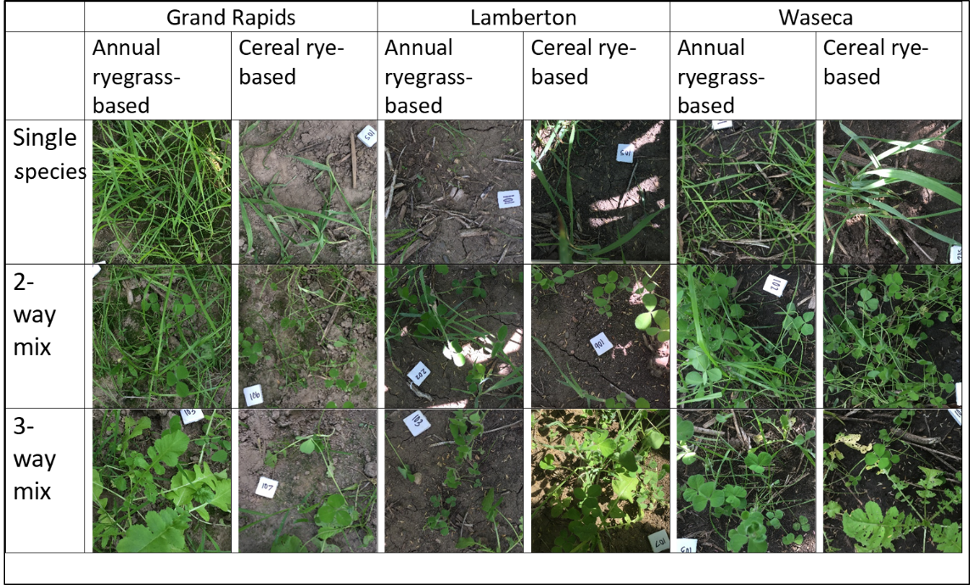
Figure 8 – Leaving canopy cover of cover crops seeded at V4-V6 corn. Photos taken on July 17, 2017, one month after interseeding cover crops into standing corn in Grand Rapids, Lamberton, and Waseca.

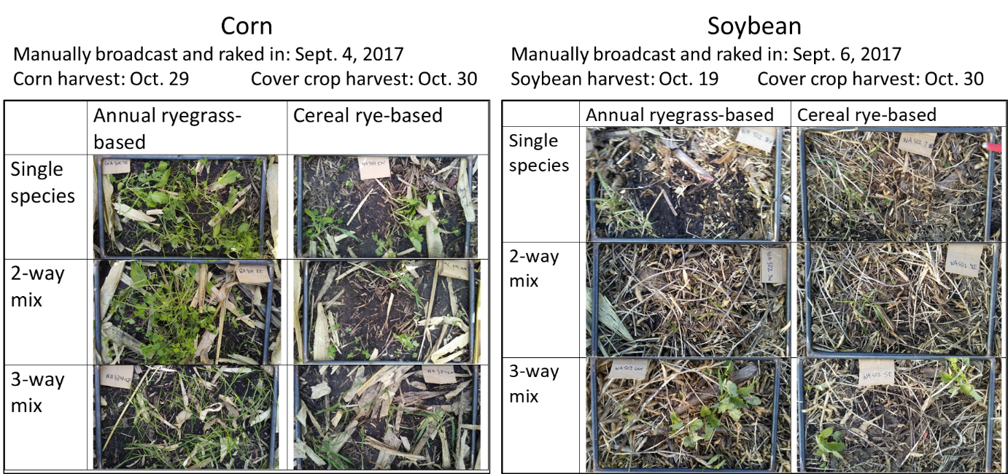
Figure 9 – Leaving canopy cover of cover crops seeded at R5-R6 corn and R7-R8 soybean at Waseca in fall of 2017.
Also, our preliminary analysis of the NO₃-N in the leachate during fall 2016 and the 2017 growing season shows variability based on location (likely related to soil type), crop (corn vs. soybean), and cover crop treatment.

3.) CHALLENGES ENCOUNTERED. (Describe any challenges that you encountered related to project progress specific to goals, objectives, and deliverables identified in the project workplan.)

The window of opportunity in which to perform spring field activities was tight this spring. A late snow storm in mid-April was largely responsible for the delay in preparing the seed bed and planting. Corn was planted on May 7th and soybean on May 18th at Waseca, approximately 10 days after the planned planting dates. Similarly, at Lamberton, corn and soybean were planted on May 16th - 19th, approximately 12 days after the planned planting dates. At Grand Rapids, corn and soybean were planted May 22, a delay of around 8-10 days.

The wet conditions made it challenging sidedress fertilization and weed control. Consistent rainfall reduced the effectiveness of herbicide and fertilizer. As a result, more weeds and less even growth of crops was observed. We found volunteer annual rye this spring in the tillage trial in Lamberton during the critical weed free period of primary crops. Our herbicide program controlled the problem. In the case of cover crops, some plots, especially at Lamberton, showed poor establishment, likely as a result of seeds being washed away by rainfall.

4.) FINANCIAL INFORMATION (Describe any budget challenges and provide specific reasons for deviations from the projected project spending.)

No budgetary challenges to report.

5.) EDUCATION AND OUTREACH ACTIVITES. (Describe any conferences, workshops, field days, etc attended, number of contacts at each event, and/or publications developed to disseminate project results.)

Rusch, H.L. 2018. Southern Research and Outreach Center Advisory Board meeting. Project presentation. Waseca, MN. July 23, 2018. (participants: around 16)
Garcia y Garcia, A. Integrating cover crops into corn-soybean rotations in Sothern MN. SROC Agronomy Tour. Waseca. June 19, 2018. (participants: around 60)

