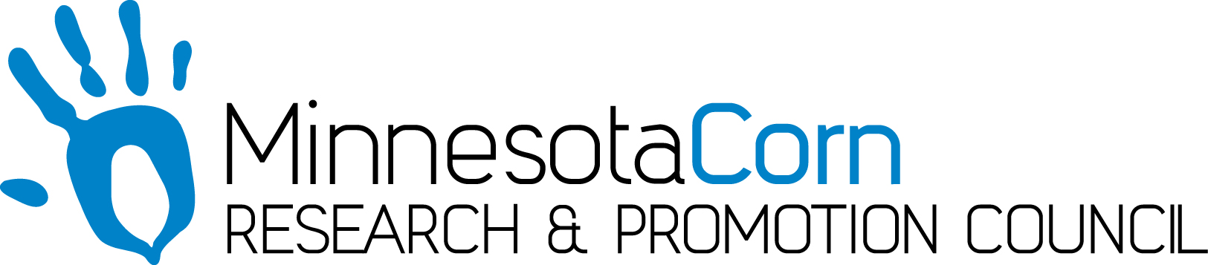

Progress Report

PROJECT TITLE: Maximizing Soil Warming and Health under Different Tillage Practices in a Corn-Soybean Rotation
PROJECT NUMBER: 4110-14SP
REPORTING PERIOD: February 1, 2018 to April 30, 2018
PRINCIPAL INVESTIGATOR(S): Jodi DeJong-Hughes, Aaron Daigh, Abbey Wick
ORGANIZATION: University of Minnesota Regents, North Dakota State University Extension
PHONE NUMBER: 320-235-0726 x 2006
EMAIL: dejon003@umn.edu

1.) PROJECT ACTIVITIES COMPLETED DURING THE REPORTING PERIOD. (Describe project progress specific to goals, objectives, and deliverables identified in the project workplan.)
Presenting data at winter meetings across Minnesota.

2.) IDENTIFY ANY SIGNIFICANT FINDINGS AND RESULTS OF THE PROJECT TO DATE.
There has been no new activity during this reporting period.

3.) CHALLENGES ENCOUNTERED. (Describe any challenges that you encountered related to project progress specific to goals, objectives, and deliverables identified in the project workplan.)
The weather will be challenging as we need to get in a few of the tillage treatments before planting.
Video production prices has risen since I wrote the grants. I’ll need to ask for an amendment.

4.) FINANCIAL INFORMATION (Describe any budget challenges and provide specific reasons for deviations from the projected project spending.)
There were no budget challenges during this project period.

5.) EDUCATION AND OUTREACH ACTIVITES. (Describe any conferences, workshops, field days, etc attended, number of contacts at each event, and/or publications developed to disseminate project results.)
A full list will be included on the final report.

