Final Report

PROJECT TITLE: Nutritional improvement of corn ethanol coproducts via yeast engineering
PROJECT NUMBER: 1081-16EU
PRINCIPAL INVESTIGATOR AND CO-INVESTIGATOR(S): Bo Hu

ABSTRACT
Coproducts generated from a corn ethanol biorefinery, for instance, Distiller's Dried Grains with Solubles (DDGS), are very attractive in animal feeds as partial replacement of some of the more expensive and traditional feeding materials for energy (corn), protein (soybean meal), and phosphorus (mono-or dicalcium phosphate). However, variability in nutrient content and digestibility has been observed, especially the lower digestibility of most amino acids compared to corn and soybean meal. Extra undigested nutrients are then excreted to the manure, causing environmental concerns. The project focuses on improving the nutritional value of corn ethanol coproducts by increasing the level of several key amino acids, such as lysine and arginine. We improved the lysine content by 2% in DDGS via genetic engineering of the lysine synthetic pathway of the yeast Saccharomyces cerevisiae to accumulate a higher content of lysine in the cell biomass during the ethanol fermentation, thereby increasing lysine in the final coproducts. We also increased the arginine content in DDGS by 11% via overexpressing a heterologous arginine rich peptide, KR,. We are now combining these traits together by marker switching. We also attempted to fortify the protein content of DDGS through growing edible filamentous fungi on Wet Distillers Grains (WDG). Protein content was increased in WDG by 59% in the best performing trial and protein concentration increased by 50% in a separate well performing trial.
DDGS produced from the proposed method, with increased nutritional value, will meet animal feed requirements and increase its value in the global animal feed market. The more nutritionally balanced coproducts will reduce total dietary cost by reducing the content of supplementary synthetic amino acids. With better digestibility, the proposed new DDGS will also minimize nitrogen excretion and ammonia emissions from animal manure, which benefits the ecosystem by protecting agricultural land and water and improving quality of life in Minnesota. Approximately 3 million metric tons of DDGS are produced annually in Minnesota from 21 ethanol plants. Since 10 of these 21 ethanol plants are farmer owned, these combined benefits will directly enhance returns per bushel of corn to Minnesota corn farmers. These treatment methods could increase revenue for corn ethanol plants by providing a higher protein DDGS product enriched in the much-needed amino acids.

INTRODUCTION
Bioethanol is by far the dominant biofuel, accounting for more than 90% of total biofuel production. Currently around 25 billion gallons of bioethanol are being produced annually, with the majority (14 billion gallons) being produced in the United States with corn as the major feedstock (Industry Statistics from Renewable Fuels Association). DDGS are the major coproduct in this process. The U.S. ethanol industry consumes around 37% of corn/maize produced in the country and generates around 35 million metric tons of DDGS annually over the past several years (U.S. Bioenergy Statistics from USDA Economic Research Service). DDGS are a rich source of significant amounts of protein, amino acids, phosphorous, and other nutrients for animal feed and has long been substituted for corn and soybean meal in livestock, poultry and aquaculture diets. As a global commodity for inclusion in animal diets, DDGS has become an important share of profit opportunities for ethanol producers [1]. Since marketability and suitable uses of DDGS are keys to the profitability of dry grind ethanol production, factors that affect the quality of DDGS can impact its market value. One of the drawbacks of DDGS is that the protein quality (amino acid profile) of DDGS is considered to be incomplete in terms of animal requirements due to amino acid deficiencies (such as lysine and arginine) and the low digestibility of amino acids in DGGS[2], as compared to some other feed ingredients, such as soybean meal. Historically these amino acids have been supplemented by external addition of feed grade amino acids to rations.
The digestibility of most amino acids in DDGS is approximately 10 percentage units lower than in corn. Lysine digestibility is the most variable compared with all other essential amino acids because lysine has high susceptibility to heat damage [3-6]. Thus, lysine is the first limiting amino acid and its content and digestibility are the major concerns in the use of DDGS as a feed component. Sources of DDGS that have a low lysine digestibility often have low lysine content, which is the reason why the ratio of lysine to crude protein provides a general estimate of the relative lysine digestibility. The concentration of lysine should be measured before using DDGS in diets fed to swine, and if the concentration of lysine expressed as a percentage of crude protein is less than 2.80%, the DDGS should not be used [7, 8]. Supplementation of crystalline lysine is the current approach to balance the amino acid profile and has been proven to be effective in improving nutrient efficiency.
L-arginine (Arg) is utilized via multiple pathways to synthesize protein and low-molecular-weight bioactive substances (e.g., nitric oxide, creatine, and polyamines) with enormous physiological importance. In human, Arg regulates cell signaling pathways and gene expression to improve cardiovascular function, augment insulin sensitivity, enhance lean tissue mass, and reduce obesity. It is beneficial for improving whole-body metabolic profile, fetal growth and development, insulin sensitivity, and lean tissue mass, as well as reducing white fat mass and concentrations of ammonia, free fatty acids, triglyceride, and cholesterol in the plasma. [9] Arg supplementation increased (P<0.05) the live weight and feed conversion ratio without increasing the feed intake of the broiler.[10]
It is widely accepted that DDGS proteins are coming from two sources, corn and yeast. As yeast protein was reported to contribute 20% of DDGS protein [11], it may be possible to increase the lysine content in DDGS via improvement of lysine concentration in yeast biomass. While genetic engineering of Saccharomyces cerevisiae has been the research focus for decades to increase the ethanol yield, tolerance, and utilization of different substrate materials [12, 13], no genetic engineering research has been specifically focused on the animal feed improvement for the corn ethanol coproducts. In addition, using genetic manipulation to engineer yeast strains is considerably easier than engineered plants for producing better animal feed coproducts, while the engineered yeast is also significantly easier to be adopted by industry.
The project also utilized filamentous fungal growth in addition to the genetic engineering of yeast. Mucor indicus and Rhizopus oryzae have been used in human food since antiquity. The strains have been used in tempeh production in the Philippines to enhance the flavor and nutritional properties of soybeans[14]. Soybeans are cooked slightly and inoculated with fungal starter cultures then wrapped in banana leaves and left to grow. The fungi break down the fibers and sugars present and transform them into fungal biomass which is rich in protein and has a pleasant taste. We apply these same principles in WDG to breakdown indigestible carbohydrates and convert them to highly nutritious fungal biomass. The fungal biomass is rich in key amino acids such as lysine, tryptophan, threonine, and methionine[15]. The amino acid ratios are comparable to a corn-soy diet except that methionine is found in even greater amounts. In addition to attractive protein profiles filamentous fungi are able to produce phytase and many enzymes that break down difficult to digest carbohydrates[16]. With the conversion of phytaste to phosphorus and the breakdown of cellulose and hemicellulose these fungi could allow higher feeding regimens of DDGS to monogastric livestock which are typically not well equipped to digest DDGS. The advantages of positive protein profiles and production of beneficial enzymes make filamentous fungi a good treatment of DDGS to improve their feeding value and open up new markets.
In our study:
In order to improve lysine accumulation in yeast biomass, the lysine biosynthesis pathway was genetically modified based on system-wide analysis (Figure 1). This specific objective was to modify lysine biosynthesis pathway in S. cerevisiae to produce more lysine in the yeast cells, to evaluate fermentation properties of these engineered strains, and the nutritional value of DDGS recovered from the dry grind corn ethanol fermentation.
In order to improve arginine accumulation in yeast biomass, an arginine rich peptide (KR) was genetically overexpressed in yeast. This specific objective was to induce KR expression in S. cerevisiae to store more arginine rich peptides in the yeast cells, to evaluate fermentation properties of these engineered strains, and the nutritional value of DDGS recovered from the dry grind corn ethanol fermentation.
When filamentous fungi are cultured on WDG the fungi consumes carbohydrates, which are unavailable to livestock, and converts the carbohydrates to proteinaceous biomass, which serves to close the amino acid gap in corn ethanol co-products. The fungi used are Generally Regarded as Safe (GRAS) and have been used to produce feed ingredients historically. Because of the research, more sustainable forms of animal feed will be produced due to the improved feeding value of the co-products.

OBJECTIVE AND GOAL STATEMENTS
The overall goal is to significantly increase the feeding value of corn ethanol co-products through genetically engineering the yeast strain to enrich several key amino acids (lysine, tryptophan, and arginine) during the fermentation so that the modified yeast biomass will significantly improve the nutritional value of DDGS. Specifically, the metabolic pathway of lysine, arginine, and tryptophan in S. cerevisiae will be genetically engineered to generate yeast cell biomass with more of these amino acids. The extra amino acids will be primarily produced during the cell growth stage without significantly affecting the ethanol fermentation. The enriched yeast biomass with more lysine, tryptophan, and arginine will be present in the thin stillage (TS) will then be combined with wet distillers grains (WDG) to generate the improved DDGS after drying. Lysine is one of the most important amino acids in animal feed and currently the industry is relying on supplementation due to its limitation in the DDGS. Tryptophan and arginine are also available, but it is cost prohibitive to be commercially used in the animal feed industry. Solid state fermentation with edible filmentous fungal strains will achieve similar goals of fortifying protein content but will also break down indigestible fibers. The genetic modification of yeast strains and solid state fermentation is expected to increase the overall digestibility of the corn-coproducts and decrease the nutrient excretion to manure and its odor. Quite different from the current mainstream emphasis on ethanol production for yeast, this proposed research focuses on improving animal feeds generated from the corn ethanol industry and will benefit all players involved in the industry. Improvements will be realized through the animal feeds to the corn farmers and potentially decrease the environmental impacts of the whole corn ethanol industry.

MATERIALS AND METHODS
Strains and media
The CEN.PK113-7D strain of S. cerevisiae, obtained from Euroscarf (European Saccharomyces cerevisiae archive for functional analysis; University of Frankfurt, Germany) collection, was used as reference strain from which engineered strains was constructed (Table 1).
Table 1. Strains of S. cerevisiae used in this study
Strain name | Genotype
CEN.PK113-7D (WT) | MATa; URA3, HIS3, LEU2, TRP1, MAL2-8c, SUC2
OLYS20 | LYS20pr::KanMX-TPI1pr
OLYS14 | LYS14pr::KanMX-TEF1pr
ΔLYS80 | lys80Δ::KanMX
ΔLYS80:O20 | lys80Δ::KanMX-TPI1p-LYS20
ΔLYS80:O14 | lys80Δ::KanMX-TEF1p-LYS14
ΔLYS80:O14/20 | lys80Δ::KanMX-TEF1p-LYS14-TPI1p-LYS20
PDA1-KR | YPR::PDA1p-1xKR-KanMX
RPL4-KR | YPR::RPL4p-1xKR-KanMX
TDH3-KR | YPR::TDH3p-1xKR-KanMX
SSA1-KR | YPR::SSA1p-1xKR-KanMX
HSP26-KR | YPR::HSP26p-1xKR-KanMX

S. cerevisiae strains were routinely grown in YPD media (yeast extract 10 g/l, peptone 20 g/l, glucose 20 g/l). The screening of transformants with the KanMX marker was done in solid YPD media supplemented with 200 µg/ml of G418 (Calbiochem, EMD MILLIPORE). For fermentation using YP media (yeast extract 10 g/l, peptone 20 g/l), 150 g/L glucose was added. The dry grind corn ethanol fermentation was performed in liquefied corn mash provided by Absolute Energy. Amyloglucosidase from Aspergillus niger was used for saccharification (525mg/L) and 0.45 g/L urea was used as nitrogen source to support yeast growth during fermentation. Penicillin and streptomycin was added to inhibit bacterial contamination during fermentation.
Determination of yeast cell growth
Yeast cells were grown in YPD media at 30ºC and 200 rpm and initial exponential cell growth was used for calculation of a specific growth rate. The cell number was counted automatically using Cellometer Auto M10 (Nexcelom) plating on solid medium. For dry cell weight determination, a 2 ml culture sample was filtered through a pre-weighed 0.2 μm cellulose nitrate membrane filter (Whatman) and washed twice with deionized water. After drying at 70ºC for 16 h, the dry cell weight was determined. The dry cell weight was measured at designated time points for which optical density (OD₆₀₀) was also measured. All measurements were performed in duplicate including controls.

Metabolites extraction and amino acids profile analysis
For determination of intracellular amino acids content, cells at mid-exponential growth were used. The intracellular metabolites were quenched in cold methanol and extracted using boiling buffered ethanol [17]. In brief, the cell cultures from YPD were sprayed into cold methanol, kept at -40ºC, and allowed to cool for 3 minutes. The mixture was centrifuged at 5,000g for 5 min at -10ºC. The supernatant was immediately removed, then the pellet was treated with a 75% ethanol solution containing 75 mM Hepes at pH7.5 and incubated at 80°C for 3 min. After cooling down on ice, the extracts were evaporated under vacuum (120 min, 30°C, <10 mbar) using nitrogen blow evaporation. Dried residues of samples were resuspended in Type 1 water. All samples were then centrifuged (15,000g, 5 min, 4°C) to remove cell debris. The supernantants were transferred to filter caps (Ultrafree, PVDF, 0.22 μm, Millipore) and centrifuged again, and the filtrates were collected and stored at -80°C.
For the amino acids profile analysis, the samples were hydrolyzed with HCl [18]. In brief, the freeze-dried cells or DDGS were incubated with 6N HCl containing 4% thioglycolic acid at 110°C for 24 h in tubes purged with nitrogen. Then the reaction was terminated by adding 6 M NaOH. The hydrolysates were collected and stored at -20°C.
After thawing on ice and dilution, amino acids were extracted from these treated samples and derivatized using EZ:faast kit (Phenomenex Inc.) and determined by GC-FID (Agilent 2100) analysis [19]. The column was a Zebron ZBAAA 10 m * 0.25 mm capillary GC column. The column oven temperature program was set 32°C per min from 110 to 320°C. The FID detector temperature was 320°C and 2 µL was injected at an injection temperature of 250°C and a split level of 1:15. The carrier gas was He at a flow rate of 1.5 mL/min. Or the reaction mixture was diluted by 10 times and analyzed with the HPLC, the column ZORBAX Eclipse Plus 4.6 mm * 250 mm was used as manufacture’s instruction.

Yeast fermentation
To build yeast biomass for high sugar fermentation, fresh cells grown on solid YPD medium were used for pre-inoculum and liquid cultures were grown overnight in YPD. The same amount of yeast cells were inoculated into a pre-fermentation medium of YPD. After the cells were grown until saturation, pelleted by centrifugation, and washed twice with fresh YP medium, the cell densities were determined by measurement of OD₆₀₀. Thereafter, equal quantities of cells were then re-suspended in fermentation medium at 1OD per ml. All yeast pre-cultures were incubated at 30°C with agitation at 200 rpm in Erlenmeyer flasks with four times headspace. For anaerobic fermentation, the flasks were sealed with rubber stoppers with a 28G syringe needle to release CO₂. Samples were taken at designated intervals for cell growth and fermentation performance analysis.

Ethanol, glucose, acetic acid and glycerol determination
Samples taken from the fermentation cultures were centrifuged at 13,000 rpm for 5 min at 4°C and the supernatants were taken and then filtered through 0.22 µm GHP filters (Millipore, USA). The filtrates were used to determine the concentrations of ethanol, glucose, acetic acid, and glycerol using Agilent 1200 Series HPLC (Agilent, USA) equipped with an Agilent 1260 Infinity Refractive Index Detector and a Bio-Rad HPX-87H Ion Exclusion Column (Bio-Rad, USA). The column was eluted at 35°C with a 5 mM sulfuric acid mobile phase at a flow rate of 0.6 mL/min.

Preparation of wet distillers grains and fungal spores
Wet Distiller’s Grains were obtained from a dry grind corn ethanol plant, Absolute Energy, LLC, in St. Angsar, Iowa that used corn. Mucor indicus 24905 and Rhizopus oryzae were secured from the American Type Culture Collection (ATCC). Fungal spores were preserved at -70 °C in a 60% glycerol solution. Glycerol stocks were aseptically struck on potato dextrose agar plates and cultured at 30 °C for 7 days. To prepare the working spore solution, a sterile spreader was used to agitate the plates with sterile distilled water. The prepared store solution was placed in sterile 15 ml tubes. The stock spore solutions were used the same day they were prepared. To inoculate the fungal spores, a cell count of the spores was done using a 0.1 mm deep Neubauer improved haemocytometer (Hausser Scientific, USA) under microscope (National DC5-163 digital using 40x magnitude).

Solid state fermentation
25 g of WDG were placed in 250 ml Erlenmeyer flasks and autoclaved at 121 °C for 30 min and then cooled before use. Factors such as moisture content, container, carbon and nitrogen supplementation, temperature, agitation, and different nitrogen species were studied by varying one factor at a time. WDG were inoculated with 2.5X10⁶ Mucor indicus and Rhizopus oryzae spores per gram of wet substrate to prepare separate monocultures. Fermentation was carried out at 30 °C for 6 d. Weight measurements were taken once every 24 h to assess the growth rate of the flasks.
For the first set of experiments moisture contents of 60% and 70% were set by using sterilized distilled water and fermentation was carried out for 4 days at 30C. The other treatment was moisture content being controlled at levels of 57, 61, 64, and 67% with distilled sterilized water and fermentation was carried out for 14 days at 30°C. In the second set of experiments autoclaved thin stillage was used to raise the moisture content of flasks prepared to 60, 70, and 80% and fermentation was carried out for 6 days at 30 °C. The third set of experiments attempted to understand how different nitrogen species affected fungal growth. Urea (CH₄N₂O), sodium nitrate (NaNO₃), sodium nitrite (NaNO₂), ammonium nitrate (NH₄NO₃), ammonium chloride (NH₄Cl), and yeast extract were prepared in an aqueous solution and then sterile filtered through a 0.45 μm filter. Each solution was prepared in order to deliver 0.25 g of nitrogen and to bring the final moisture content to 70% in the flasks. The fermentation was carried out for 6 days at 30°C

Estimation of protein though total organic nitrogen and other analyses
In order to measure protein content at the end of fermentation, total organic nitrogen was measured using the Kjeldahl method to give total Kjeldahl nitrogen, which includes organic nitrogen and nitrogen in ammonia and ammonium. Total ammonia nitrogen was measured and subtracted from the TKN value to give the organic nitrogen present in the sample; this value was multiplied by 6.25 to give the total amount of protein found in the sample in accordance with FAO standards [20]. Weight loss overtime was measured by pre weighing the culture flasks before placing WDG inside. This value of only the flask was recorded and used as a baseline comparison. The flasks then received WDG and had any other treatments needed in the experiments and then were weighed at the beginning of the fermentation time. Weight measurements were taken every ~24h through the course of experiments. A sample of the fermentation substrate was removed at the end of the experiment and dried in a 105 °C oven overnight to obtain moisture content values. The ending moisture content along with the weight loss measurements taken allow for a calculation of biomass generated

RESULTS AND DISCUSSION
1. Increasing the lysine content of DDGS by yeast with higher lysine biosynthesis
1.1 The growth ability of the lysine-pathway-related knockout strains
In this study, CEN.PK113-7D was used as the wild type (WT) strain because it grows excellently under controlled industrially relevant conditions, and is wildly applied in metabolic engineering and system biology research in industry and academia. The high fermentation performance of CEN.PK113-7D using corn mash was confirmed in the lab scale first. All the mutant strains were constructed based on CEN.PK113-7D. According to the lysine synthesis pathway in yeast (Figure 1), three mutation loci were selected including homocitrate synthase (LYS20), pathway specific transcriptional factor (LYS14), and multiple kinase repressor (LYS80). The homocitrate synthases Lys20 and Lys21 catalyze the condensation of 2-oxoglutarate and acetyl-CoA, the first committed step of the lysine biosynthesis pathway. The non-cooperative and weakly-inhibited Lys20 isoform was shown to exert most of the flux control over the lysine synthesis [21, 22]. Thus, the LYS20 was overexpressed aiming to increase the lysine flux. The pathway specific transcriptional factor Lys14, could regulate at least six LYS genes coding for enzymes of the fungi specific a-amino adipate (AAA) pathway which requires the metabolic intermediate a-aminoadipate semialdehyde (aAASA) as the co-inducer to bind at nonameric core sequence in promoter regions of the target LYS genes [23]. Then we overexpressed LYS14 to upregulate LYS genes to further increase the lysine flux. The multiple kinase repressor Lys80, now known as Mks1, is a negative regulator of the RTG pathway, in which the responsive genes are involved in early steps of the TCA cycle to produce 2-oxoglutarate [24, 25]. The supply of the precursor 2-oxoglutarate was reported to exert predominant control on the lysine synthesis flux in S. cerevisiae and enhance the supply of 2-oxoglutarate may contribute to more lysine production [26]. Thus, Lys80 is characterized to negatively regulate lysine biosynthesis through limiting 2-oxoglutarate supply. To produce more precursor 2-oxoglutarate, LYS80 was deleted. The mutants ΔLYS80, OLYS20 and OLYS14 showed similar specific growth rate (µ) as compared to WT, while the growth rate was retarded in mutants ΔLYS80:O20, ΔLYS80:O14 and ΔLYS80:O14/20 (Table 2).

Table 2. The growth rate of lysine mutants
Strain name | µ (h⁻¹)
CEN.PK113-7D (WT) | 0.253±0.009
OLYS20 | 0.255±0.003
OLYS14 | 0.251±0.006
ΔLYS80 | 0.241±0.009
ΔLYS80:O20 | 0.210±0.003
ΔLYS80:O14 | 0.191±0.001
ΔLYS80:O14/20 | 0.211±0.007
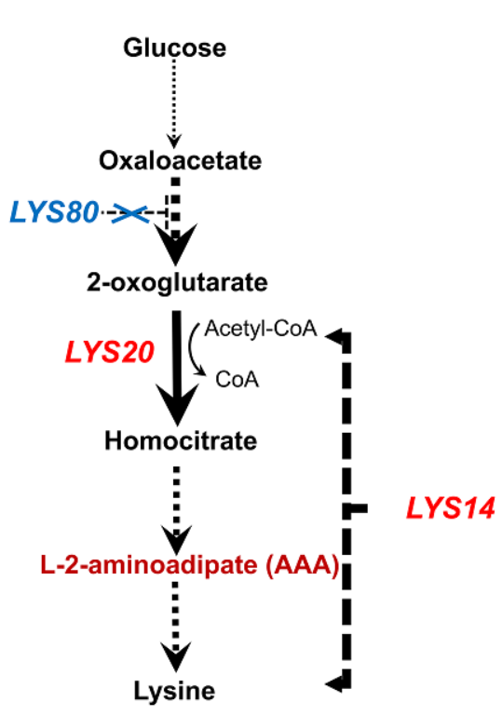

Figure 1. The lysine synthesis pathway

1.2 The intracellular lysine pool was increased
To test whether lysine biosynthesis was increased in the mutants, the total intracellular free lysine pool of these strains was measured. The cells were cultured in YPD medium and harvested at mid-exponential growth phase. Compared with the control WT strain, overexpression of the LYS20 gene slightly increased the free lysine pool by 15%. The free lysine concentration was increased by 65% through overexpression of LYS14, which indicates the overexpression of LYS14 was functional. Deletion of LYS80 led to a 40% increase in the free lysine content. In contrast with the small enhancement observed in a single mutant, the free lysine pool was increased nearly four times compared with WT in mutants: ΔLYS80:O20, ΔLYS80:O14 and ΔLYS80:O14/20, respectively. This indicates the carbon flux was redirected to lysine biosynthesis more efficiently and the lysine synthesis pathway is more active than that in the WT strain. These results inspired us to attempt fermenting in an industrial corm mash medium with the mutant strains. Test the strains capability to increase lysine content the next step.

1.3 The fermentation capacity of the lysine-pathway-related knockout strains and amino acid profile
In order to verify if the lysine ratio of the total amino acids is improved after the corn mash fermentation, the simultaneous saccharification and fermentation of the engineered strains using raw corn mash was performed. The glucose can be utilized in 48 h by the wild type strain, but there is still residual sugar left after 96 h in the mutants (Figure2). Therefore, the ethanol titer was lower in the mutants at the end of the fermentation (Figure 3).

Figure 2. The time curve of glucose Figure 3. The time curve of ethanol

Figure 4. The amino acid profile of DDGS from lysine pathway mutants

Taken together, the single mutant strains show similar fermentation capacity to WT strains and their intracellular free lysine content increased slightly. In contrast, the double mutants showed much slower glucose consumption ability. However, the double mutants (ΔLYS80:O20, ΔLYS80:O14) could accumulate much higher free lysine intracellularly. These results implied that the accumulation of a high concentration of intracellular free lysine could be a metabolic burden to the host cell and impair their growth and fitness ability. The impact could be due to feedback inhibition of lysine or the cell membrane functions could be negatively affected by the positive charges of free lysine.
Finally, the fermented corn mash from the mutants was freeze dried, and the resultant “DDGS” was used for amino acid profile analysis (Figure 4). The lysine ratio of the total amino acids increased by 2% and 1.5% in OLYS20 and OLYS14. As amino acids in the DDGS are comprised by corn and yeast. The yeast biomass accumulation was less in the DDGS from the double mutants so the yeast proteins contributes less to the DDGS protein profile. Although lysine production increased in yeast cells, the lysine ratio in the DDGS protein did not show much increase as yeast protein was suppressed.

2. Increasing the arginine content of DDGS by yeast strain with overexpressing arginine-rich peptide

2.1 The arginine-rich peptide selection
In the previous section, we found that the enhancement of the lysine synthesis pathway is not related with high lysine content/ratio due to the free amino acid accumulation inside of the cells, even leading to a diminishing of ethanol production. So we thought that we could express a peptide would work as an amino acid reservoir to store arginine in a peptide form (polymer) to avoid the accumulation of free amino acids.
Upon reviewing the literature, we found a lysine/arginine-rich cationic peptide (ZY13) (VKRWKKWRWKWKKWV-NH2) with antimicrobial activity [27].Based on the sequence of ZY13,we designed WR and WH (Figure 5), which were predicted without antimicrobial activity due to the loss of charge polarity. Meanwhile, we used the sequence of WR to search its homologue via BLAST[28]. A peptide (KR) of uncharacterized protein CDQ88819 (aa599-748) from rainbow trout was identified. The amino acid composition is listed in table 3.
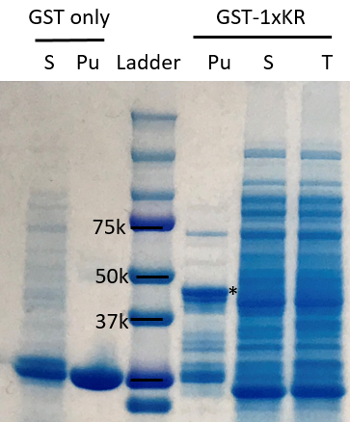
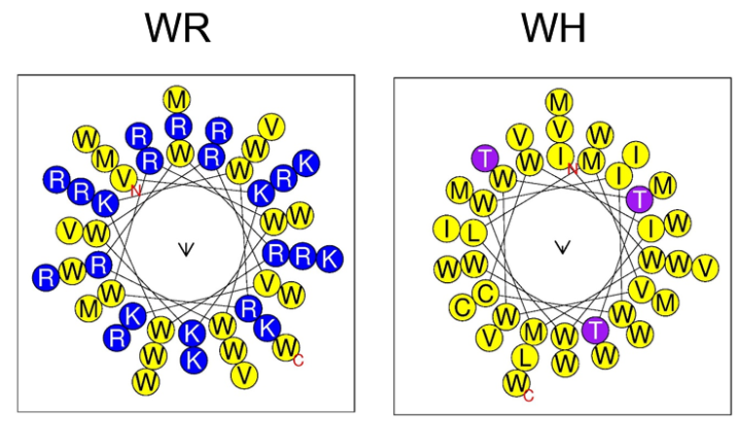
Figure 6. SDS/PAGE of 1xKR
Pu: Purified protein
S:Supernatant
T: Total protein
*:The full-length fusion protein
Figure 5. The Helix map of WR and WH

Table 3. The composition of WR, WH and KR.

Name | Length(aa) | Arginine (wt%) | Lysine (wt%) | Tryptophan (wt%) | Methionine(wt%)
WR | 46 | 30.8% | 14.8% | 41.3% | 5.7%
WH | 39 | 0% | 0% | 52.1% | 14.3
KR | 150 | 32.5% | 8% | 11.2% | 0%

2.2 Expressibility Test in E.coli
The genes for 4xWR, 4xWH and 1xKR were synthesized from IDT. Then, to make sure the peptide is feasible to express in vivo, we fused the glutathione S-transferase (GST) gene with the peptides and expressed them in E. coli. We found that only 1xKR could be expressed well in E. coli (Figure 6). So we selected 1xKR for the follow up study.

2.3 Construction of 1xKR expressing yeast strains
To achieve a stabled and optimized expression level of KR and to avoid compromised ethanol fermentation ability, we constructed an integration vector with 5 promoters (PDA1, RPL3, SSA1, HSP26, and TDH3) [29, 30] for integrative expression of KR in yeast. Then, the constructed vectors were integrated into our WT yeast strain, CEN.PK 113-7D. The genomic DNA of transformants was extracted and used for PCR with designed primers to make sure the integration is correct and the expression cassette is intact after the integration process. The screened transformants (PDA1-KR, RPL4-KR,TDH3-KR,SSA1-KR, and HSP26-KR) will be used for fermentation in corn mash medium.

Figure 7. The growth curve of KR expression yeast strains

Then, a mock fermentation was performed to test the growth ability of PDA1-KR, RPL4-KR,TDH3-KR,SSA1-KR, and HSP26-KR in YPD medium with 150g/L glucose feeding. The growth assay results showed that all the strains have a similar growth ability to WT strain (Figure 7). In these transformants all the glucose in the medium was consumed by 48h for all strains. This indicated that the heterologous expression of KR in yeast does not affect the growth and glucose fermentation ability of yeast strain.

2.4 The fermentation capacity of KR-expression strains and their amino acid profile
In order to verify if the expression of KR in yeast could increase the arginine content in the total amino acids of DDGS, the strains PDA1-KR, RPL4-KR, TDH3-KR,SSA1-KR, and HSP26-KR were used for the fermentation in the raw corn mash medium. Glucose could be utilized within 96 by all the strains. The ethanol titer of all strains were similar except HSP26-KR which was slightly lower than others (Figure 8.)
Then, the fermented corn mash from the KR expression strains was freeze dried, and the resultant DDGS was used for amino acid profile analysis, the results of total amino acids (Figure 9) and amino acid profile (Figure 10) are shown below. For the total amino acids, the amount of SSA1-KR and PDA1-KR was increased by 10.3% and 6.2%, respectively, comparing with the WT strain. For the arginine content of PDA1-KR, RPL4-KR,TDH3-KR,SSA1-KR, and HSP26-KR was increased by 6.5%, 0.5%, 4.7%, 11.3% and 4.6%,respectively, comparing with that of the WT strain. These results implied that the overexpression of KR in yeast could increase the arginine content and the total amino acid amount without obvious adverse effects on ethanol fermentation. Among the strains, SSA1-KR (1xKR) showed the best performance in arginine content improvement. The chaperonin SSA1 gene was up-regulated significantly during growth in the presence of ethanol, making the SSA1 promoter a candidate that is automatically induced during the ethanol consumption phase in glucose batch cultivation [31, 32]. P_{SSA1} was about ~5-fold higher relative on ethanol to 20 g/L glucose and the increase in GFP expression from the SSA1 promoters began at 8 h, and peaked at 48 h, which is induced by ethanol[29]. Taken together, our results indicate that using ethanol-induced promoter SSA1 could improve the arginine content well due to the early stage low expression, which will lower the metabolic burden of the host yeast cells and help faster biomass accumulation at the initial stage.

3. Combination of SSA1-KR and OLYS20
Due to the positive effect of SSA1-KR and OLYS20 strain in increasing the arginine and lysine content in the DDGS. We were planning to combine the beneficial traits of both strains together. Due to the fact that the two strains were using the same G418 marker, we have to change the antibiotic selection marker of SSA1-KR from G418 to hygromycin B. Now, we are working in this project to finish the strain LYS20pr::KanMX-TPI1pr and YPR::SSA1p-1xKR-KanMX. After the strain construction, we would use this strain for the next round of raw corn mash fermentation and DDGS amino acid profile analysis.
In the future, more peptides that are rich in lysine, arginine, or tryptophan could be discovered and utilized. More precise up-regulation of the amino acid synthesis pathway could be applied in this field and would help increase the feeding value of DDGS and lower the feeding cost.

Figure 8. The Ethanol titer of KR-strains Figure 9. The total amino acids of
KR-strains

Figure 10. The amino acid profile of KR-strains
4. Solid state fermentation and moisture content
As base levels of moisture in the WDGs were insufficient to support fungal growth in the shake flasks, higher levels and a wide range of moisture were tested. Moisture contents of 54% and 60% were initially tested in a set of small batch experiments allowing only 4 days of fermentation time. Upon finding improved growth and visible fungal mycelia, a wider range of moisture content was evaluated. It is important to note mycelial growth appeared in the flasks but did not permeate throughout the entire substrate; this indicated that something was limiting in the fermentation. Upon protein analysis, Mucor indicus yielded minimal increases in protein at 60% moisture content (3505 mg protein) or actually lowered the protein content in 70% moisture content, 3336 mg protein, as compared to uninoculated WDG, 3488 mg of protein. Rhizopus oryzae had a larger disparity in its protein yields. Under 60% moisture content protein was 3260 mg and under 70% moisture content protein rose to 4305 mg, representing a 23% increase in protein. These interesting results led the researcher to test a wider range of moisture contents and to see if an increase in fermentation time would aid overall protein production.
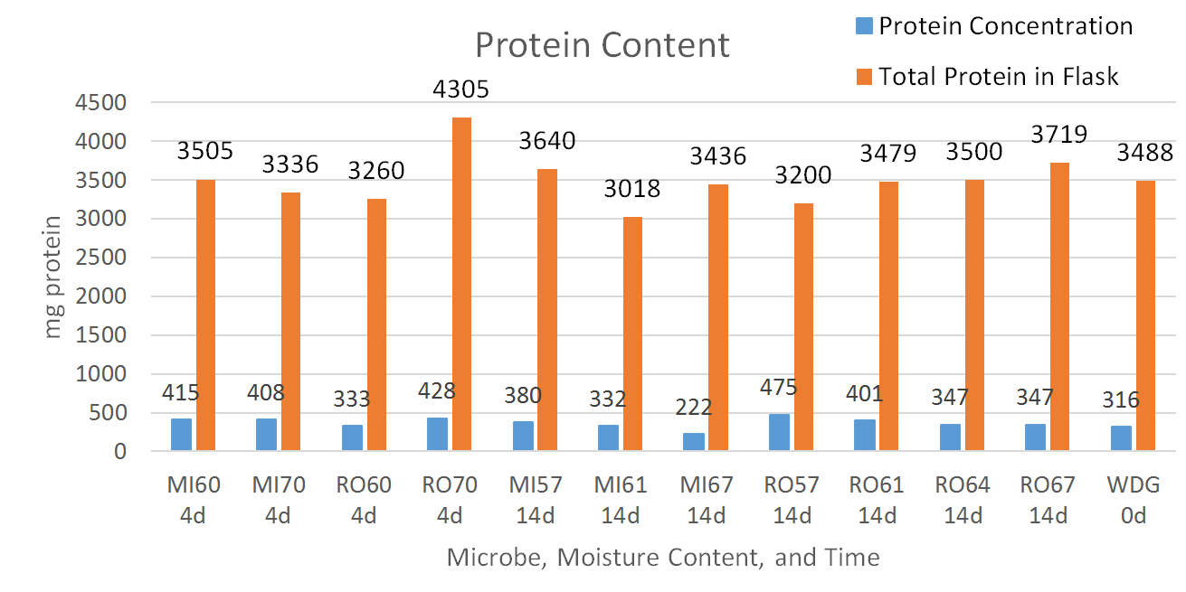
Figure 11 Protein Concentration per gram of dry biomass and total protein in flask under different moisture contents and fermentation times.
The next experiment allowed 14 days of fermentation time for the fungi to grow. Moisture contents of 57, 61, 64, and 67% were tested using distilled water to control moisture in substrate identical to previous experimental runs. Rhizopus oryzae exhibited a clear increase in total protein as moisture content increased 3200, 3479, 3500, and 3719 mg of protein per flask, respectively. Initial mass of protein in each flask was 3488 mg of protein (Figure 11.) This represents a modest increase in protein of 6.2%. These yields compare favorably against those of Doctors Lio and Wang of Iowa State University who only witnessed a 4.2% increase in protein using their fungal cultures while using similar substrates[33].

5. Carbon and nitrogen effects on protein yield
The effects of carbon and nitrogen supplementation were evaluated through addition of glucose and yeast extract. It was hypothesized that by supplementing conventional sources of nutrients found in growth media, overall growth and protein production could be stimulated. These nutrient factors as well as temperature and agitation were evaluated to see what role if any they would play in protein production. Figure 12 shows that carbon supplementation did not aid protein production in any way for Mucor indicus (3204 mg protein with carbon & yeast extract and 3208 mg protein with only yeast extract) and for Rhizopus oryzae it actually inhibited protein accumulation (2914 mg protein with carbon and yeast extract compared to 3614 mg protein with only yeast extract, a 19% difference). One possible reason for carbon addition lowering protein production is that with all nutrients being equal besides free sugars this creates a nitrogen-limiting environment for the microorganisms. By shaking, the culture flask once a day protein content was increased by 16% compared to identical conditions without shaking for Mucor indicus with Rhizopus oryzae experiencing a 12% increase. Shaking the flasks once a day is likely a benefit due to allowing the substrate to have better oxygen diffusion. When no shaking is employed, the fungal biomass will grow throughout the substrate, secreting sticky exopolysaccharides and binding the substrate together. The binding of the substrate together creates air diffusion problems, as the bottom of the flask has no access to free air. The largest gains in protein of any treatment difference are between culturing at 23 °C as compared to culturing at 30 °C. Mucor indicus and Rhizopus oryzae experienced a 23% increase in protein and a 28% increase in protein under the same conditions with only the temperature being lowered. Therefore, the most optimal culture conditions for generating protein appear to be only supplementing nitrogen with no carbon addition, culturing at 23°C, and agitating flasks once a day. These findings will inform future experimental set-ups.
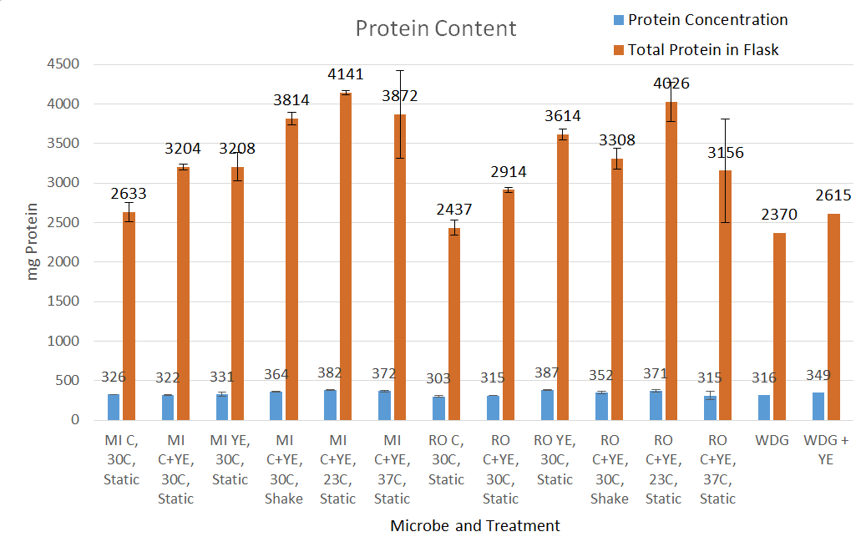
Figure 12 Protein concentration per gram of dry biomass and total protein in flask under different culture conditions.

CONCLUSIONS
Amino acid engineering
Through yeast metabolic engineering, we improved the lysine content by 2% via elevating the intracellular free lysine supply and arginine content by 11.3% via overexpressing heterologous arginine rich peptide KR. And we are now combine these traits together by marker switching.

Solid state fermentation
Wet Distiller’s Grains can serve as an effective substrate for fungal growth under the correct conditions. Adequate moisture content is important to establishing initial fungal growth and without an adequate supply, no fermentation can occur. With adequate moisture present, fungi are able to grow without any external chemical input and can increase the overall protein content significantly, 58.6% in the best performing trial. Further studies should be carried out to understand how fungal biomass contributes to protein through time. Optimizing culture length will reduce operating costs upon scale up and will in turn make the process more likely to be adapted by those companies that would benefit from the technology the most. A potentially lucrative avenue of research would involve using Thin Stillage to control moisture as corn ethanol plants have excessive amounts and it can be costly to manage. Thin Stillage could serve as a readily available carbon source for the fungi to use as its carbohydrates are not in a bound fiber form as found in WDG. By leveraging two co-product streams and readily available nitrogen fertilizer, corn ethanol plants could consistently produce a significantly more valuable feed product than is currently capable.

EDUCATION, OUTREACH, AND PUBLICATIONS

Conferences
- We attended AIChE 2017 and communicated with academic and industrial researchers about amino acid profile improvement.
- We also attended the Fuel Ethanol Workshop 2017 and communicated with industrial researchers and consulting companies that aid in yeast development. (6 contacts).
- The solid state fermentation portion of the research was presented at a University of Minnesota departmental showcase.
- The solid state fermentation project was presented at the MN Corn Growers association talk in August 2018.

Manuscripts
- The manuscript is being drafted for genetic engineering of lysine biosynthesis for improved lysine production.
- A manuscript is being drafted about expression of a arginine-rich protein in S. cerevisiae to increase the feeding value improvement of DDGS
- A manuscript is also being drafted to disseminate research findings on the corn fungal solid state fermentation.

Workshop
We hosted 3 local high school science teachers to teach them about the yeast engineering research occurring in the lab and the effects of corn ethanol in our state.

REFERENCES

1. Council, U.S.G., A GUIDE TO Distiller’s Dried Grains with Solubles (DDGS). 2012.
2. Lumpkins, B.S. and A.B. Batal, The bioavailability of lysine and phosphorus in distillers dried grains with solubles. Poult Sci, 2005. 84(4): p. 581-6.
3. Fastinger, N.D. and D.C. Mahan, Determination of the ileal amino acid and energy digestibilities of corn distillers dried grains with solubles using grower-finisher pigs. Journal of Animal Science, 2006. 84(7): p. 1722-1728.
4. Stein, H.H., et al., Amino acid and energy digestibility in ten samples of distillers dried grain with solubles fed to growing pigs. Journal of Animal Science, 2006. 84(4): p. 853-860.
5. Pahm, A.A., et al., Factors affecting the variability in ileal amino acid digestibility in corn distillers dried grains with solubles fed to growing pigs. Journal of Animal Science, 2008. 86(9): p. 2180-2189.
6. Fastinger, N.D., J.D. Latshaw, and D.C. Mahan, Amino acid availability and true metabolizable energy content of corn distillers dried grains with solubles in adult cecectomized roosters. Poult Sci, 2006. 85(7): p. 1212-6.
7. Stein, H.H., Distillers dried grainswith solubles (DDGS) in diets fed to swine. Swine Focus #001, 2007.
8. Stein, H.H. and G.C. Shurson, Board-invited review: the use and application of distillers dried grains with solubles in swine diets. J Anim Sci, 2009. 87(4): p. 1292-303.
9. Wu, Z., et al., Catabolism and safety of supplemental L-arginine in animals. Amino Acids, 2016. 48(7): p. 1541-52.
10. Murakami, A.E., et al., Effects of starter diet supplementation with arginine on broiler production performance and on small intestine morphometry. Pesquisa Veterinária Brasileira, 2012. 32: p. 259-266.
11. Han, J. and K. Liu, Changes in composition and amino acid profile during dry grind ethanol processing from corn and estimation of yeast contribution toward DDGS proteins. J Agric Food Chem, 2010. 58(6): p. 3430-7.
12. Dogan, A., et al., Improvements of tolerance to stress conditions by genetic engineering in Saccharomyces cerevisiae during ethanol production. Appl Biochem Biotechnol, 2014. 174(1): p. 28-42.
13. Nielsen, J., et al., Metabolic engineering of yeast for production of fuels and chemicals. Current Opinion in Biotechnology, 2013. 24(3): p. 398-404.
14. Karimi, K. and A. Zamani, Mucor indicus: Biology and industrial application perspectives: A review. Biotechnology advances, 2013. 31(4): p. 466-481.
15. Jorge A. Ferreira, P.R.L., Lars Edebo, Mohammad J. Taherzadeh, Zygomycetes-based biorefinery: Present status and future prospects. Bioresource technology, 2013. 135: p. 523-532.
16. K. Bhavsar, V.R.K., J. M. Khire, High level phytase production by Aspergillus niger NCIM 563 in solid state culture: response surface optimization, up-scaling, and its partial characterization. Journal of Industrial Microbiology & Biotechnology, 2011. 38(9): p. 1407-1417.
17. Gonzalez, B., J. Francois, and M. Renaud, A rapid and reliable method for metabolite extraction in yeast using boiling buffered ethanol. Yeast, 1997. 13(14): p. 1347-55.
18. Fountoulakis, M. and H.W. Lahm, Hydrolysis and amino acid composition of proteins. J Chromatogr A, 1998. 826(2): p. 109-34.
19. Badawy, A.A., C.J. Morgan, and J.A. Turner, Application of the Phenomenex EZ:faasttrade mark amino acid analysis kit for rapid gas-chromatographic determination of concentrations of plasma tryptophan and its brain uptake competitors. Amino Acids, 2008. 34(4): p. 587-96.
20. Food energy – methods of analysis and conversion factors, in FOOD AND NUTRITION PAPER. 2003, FAO: Rome.
21. Quezada, H., et al., Specialization of the paralogue LYS21 determines lysine biosynthesis under respiratory metabolism in Saccharomyces cerevisiae. Microbiology, 2008. 154(Pt 6): p. 1656-67.
22. Quezada, H., et al., The Lys20 homocitrate synthase isoform exerts most of the flux control over the lysine synthesis pathway in Saccharomyces cerevisiae. Mol Microbiol, 2011. 82(3): p. 578-90.
23. Becker, B., et al., A nonameric core sequence is required upstream of the LYS genes of Saccharomyces cerevisiae for Lys14p-mediated activation and apparent repression by lysine. Mol Microbiol, 1998. 29(1): p. 151-63.
24. Dilova, I., C.Y. Chen, and T. Powers, Mks1 in concert with TOR signaling negatively regulates RTG target gene expression in S. cerevisiae. Curr Biol, 2002. 12(5): p. 389-95.
25. Sekito, T., et al., RTG-dependent mitochondria-to-nucleus signaling is regulated by MKS1 and is linked to formation of yeast prion [URE3]. Mol Biol Cell, 2002. 13(3): p. 795-804.
26. Quezada, H., et al., The 2-oxoglutarate supply exerts significant control on the lysine synthesis flux in Saccharomyces cerevisiae. FEBS J, 2013. 280(22): p. 5737-49.
27. Jin, L., et al., A Designed Tryptophan- and Lysine/Arginine-Rich Antimicrobial Peptide with Therapeutic Potential for Clinical Antibiotic-Resistant Candida albicans Vaginitis. Journal of Medicinal Chemistry, 2016. 59(5): p. 1791-1799.
28. Altschul, S.F., et al., Basic local alignment search tool. Journal of Molecular Biology, 1990. 215(3): p. 403-10.
29. Peng, B., et al., Controlling heterologous gene expression in yeast cell factories on different carbon substrates and across the diauxic shift: a comparison of yeast promoter activities. Microbial Cell Factories, 2015. 14: p. 91.
30. Cao, L., et al., Two-stage transcriptional reprogramming in Saccharomyces cerevisiae for optimizing ethanol production from xylose. Metabolic Engineering, 2014. 24: p. 150-159.
31. Werner-Washburne, M., et al., Yeast Hsp70 RNA levels vary in response to the physiological status of the cell. Journal of Bacteriology, 1989. 171(5): p. 2680-2688.
32. Alexandre, H., et al., Global gene expression during short-term ethanol stress in Saccharomyces cerevisiae. Febs Letters, 2001. 498(1): p. 98-103.
33. Wang, J.L.a.T., Solid-State Fermentation of Soybean and Corn Processing Coproducts for Potential Feed Improvement. Journal of Agriculture and Food Chemistry, 2012. 60(31): p. 7702-7709.

