Progress Report

PROJECT TITLE: Hyper-Thermostable Enzyme (Lactonases) for use as Microbial Biocontrol Agents for Plant Diseases
PROJECT NUMBER: 4136-17SP
REPORTING PERIOD: January 31, 2018
PRINCIPAL INVESTIGATOR: Michael Sadowsky and Mikael Elias
ORGANIZATION: University of Minnesota
PHONE NUMBER: 612-624-2706
EMAIL: sadwosky@umn.edu

1.) PROJECT ACTIVITIES COMPLETED DURING THE REPORTING PERIOD. (Describe project progress specific to goals, objectives, and deliverables identified in the project workplan.)

Goal: To evaluate hyper-thermostable lactonases as microbial biocontrol agent inhibiting bacterial disease of corn

The project has two aims:

Aim I: Evaluate the potential of hyperstable lactonases to protect plants in several infection models. We will use our current and newly produced lactonases to protect plants from a variety of plant pathogens, including Acinetobacter sp., Aeromonas sp., Agrobacterium sp., Burkholderia sp., Erwinia sp., Proteus sp., Pectobacterium, Xanthoomonas, Pseudomonas sp., Ralstonia sp., and Clavibacter sp. strains. Diseases evaluated on corn will be bacterial leaf blight, Holcus spot and Stewart’s disease. We will also determine the best mode of enzyme addition to plant surfaces, timing of enzyme addition, humidity and temperature resistance, dosage to be used, and potential carriers.

Aim II: Assess the ability of hyperstable lactonases to prevent post-harvest loss of crops. While we initially targeted this technology to in vivo protection of plants from a variety of bacterial pathogens, in these studies, we will specifically focus our attention on preventing post-harvest soft rot of corn and other crop by members of the genus Dickeya (previously Erwinia chrysanthemi), Pectobacterium atrosepticum, (formerly Erwinia atroseptica) and Pectobacterium carotovorum subsp. carotovorum, (previously Erwinia carotovora subsp. carotovora). We will also examine the possible effect of the enzyme on fungi infections, as some of these infections also depend on initial bacterial colonization, infection, or maceration. Variation of enzyme concentration, humidity, and concentrations of bacteria and fungi will be three of the several factors examined.

Procedures and Plans:

Bacterial strains and quorum quenching lactonases.
Eleven pathogenic strains we are using in this study will include Clavibacter michiganensis subsp. nebraskensis, Erwinia chrysanthemi pv. Zeae, Pantoea stewartii Mergaert, Erwinia aroideae 8066, Erwinia atroseptica 8064, Xanthomonas campestris pv. campestris, Pseudomonas syringae pv syringae, Pseudomonas syringae pv phaseolicola, Erwinia carotovora, Xanthomonas campestris pv. phaseoli, and Pectobacterium carotovorum. The strains were grown in selected medium at 25-30˚C. There will be two kinds of the quorum quenching lactonases (SsoPox W2631, and GcL WT) used in this study. The characterizations of these lactonases were studied by Dr. Elias groups (Bergonzi et al 2016, Remy et al 2016).

Apply and received the approved permit from USDA Animal and Plant Health Inspection Service (APHIS)
After submitting an application to obtain and use multiple plant pathogens n, we prepared an inspection from APHIS of regular laboratory working space, plant growth chambers, and autoclaved rooms from USDA. We passed the audit, we received ePermits, and have requested strains to use for our studies from culture collections and faculty at other instiutions. We now have many of the strains.

In vivo pathogenicity assay of corn by Clavibacter michiganensis subsp. nebraskensis (Cmn). We tested the hypothesis the lactonase SsoPoX would protect corn from infection by bacterial pathogens. This was initially tested with Cmn.

Maize growth
Viking maize seeds (40-30UP) were grown in Euro pots (8 inch dia) with a sterilized soil mixture (50 standard soil/ 50 Germination Mix). Plants were grown in a green house under diurnal conditions with 16 hour lights at 22 ˚C, and 8 hours dark at 18˚C.

Bacteria working solution
Firstly, Clabibacter michiganensis subsp. nebraskensis (Cmn) was grown on NBY agar medium at room temperature for ~5 days. Then, a single colony of Cmn was transferred onto the fresh NBY plate. After three days, colonies were remoived, Cmn was pelleted by centrifugation , and suspended into 1X PBS to obtain working solution at OD₅₄₀=0.1 (about 10⁸ cell/ml).

Infection assays.
The corn leaves were clipped and inoculated with about 10⁵cell/mL of Cmn by dipping the clipped leaf into a cell suspension. A negative control consisted of dipping the clipped leaf into PBS buffer. The enzyme SsoPox was sprayed on the clipped leaves. For negative control, the buffer and SsoPoX were sprayed on the non-inoculated clipped leaf surface as well. After 14 days, there was a dramatic difference between the with and without SsoPox treatments for the inoculated clipped corn leaves. The whole corn leaf dramatically presented Goss’s wilt without SsoPox as compared to the treatment group where Goss’s will was only present at the tip of leaf. Moreover, from the negative control groups (e.g., buffer, and SsoPox), the solutions did not affect the growth of maize. We have now started studies test this with other Corn pathogens, including Acidovorax avenae subsp avenae which causes bacterial leaf blight and stalk rot and Xanthomonas campestris pv. Holcicola causing bacterial leaf spot. We will also test
Pseudomonas syringae pv. syringae causing Holcus as soon as the strain arrives.

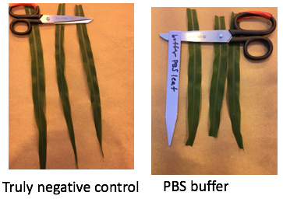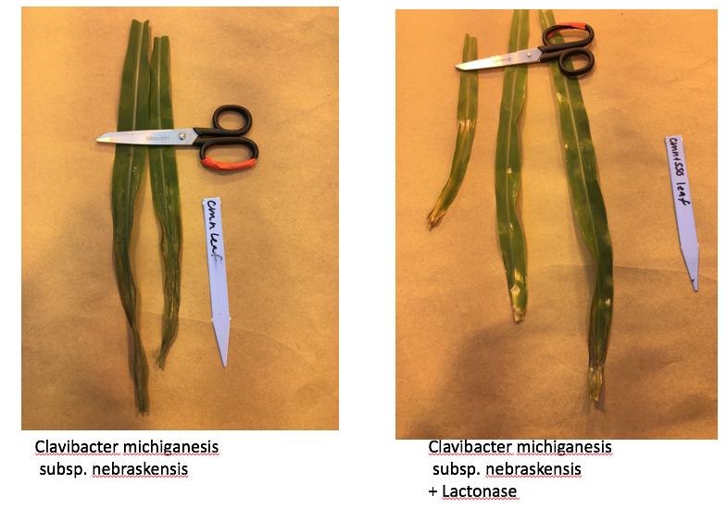

In vivo pathogenicity assay of wheat and barley by Xanthomanas translucens.
We also tested the ability of the SsoPoX lactonase to inhibit other plant diseases on other crops. Among the first tested was Xanthomanas translucens on wheat and barley.

Bacteria working solution

Two strains of Xanthomas translucens were prepared. Briefly, Xanthomanas translucens pv translucens and Xanthomanas translucens pv undulosa were suspended dissolved into 0.85% NaCl and diluted to OD₅₄₀=0.1 (~10⁸ cells/ml), which were then inoculated on barley and wheat, respectively.

Infection assays
Compared to plants that did not receive spraying with SsoPox, disease symptoms were observed on the leaves of wheat and barley. When sprayed with SsoPox, disease was prevented and healthy leaves were maintained on both plants.

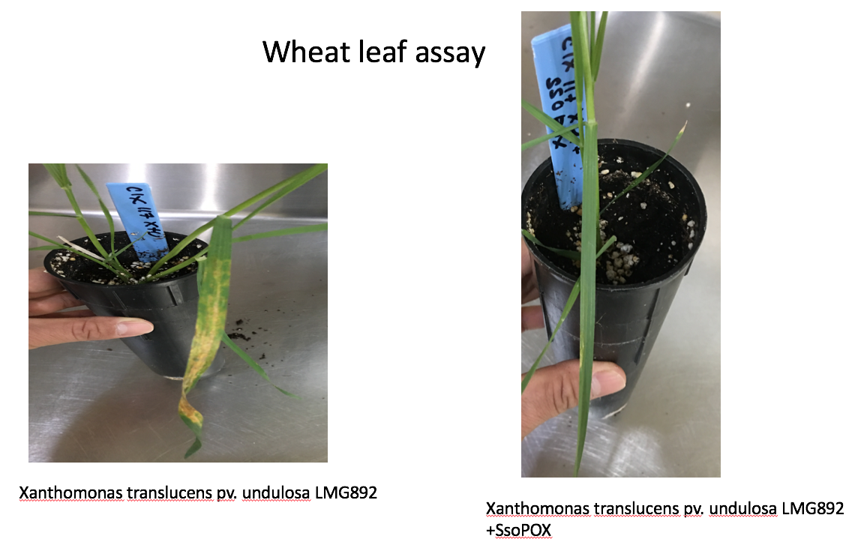

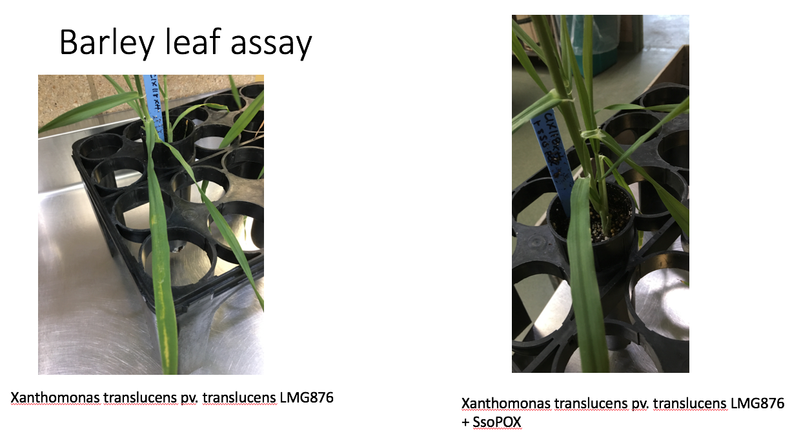

Taken together, we are very excited about the ability of SsoPoX to inhibit bacterial diseases on Corn and other agricultural crops. We look forward to examining other pathogens in the near future and do determine the minimal concentration of enzyme required to inhibit the pathogens at several doses. We are also very excited to report that we can inhibit bacterial leaf streak (BLS) caused by Xanthomonas translucens pv. undulosa, and serious emerging pathogen of wheat.

References:
Bergonzi C, Schwab M, Elias M (2016). The quorum-quenching lactonase from Geobacillus caldoxylosilyticus: purification, characterization, crystallization and crystallographic analysis. Acta Crystallogr F Struct Biol Commun 72: 681-686.

Remy B, Plener L, Poirier L, Elias M, Daude D, Chabriere E (2016). Harnessing hyperthermostable lactonase from Sulfolobus solfataricus for biotechnological applications. Scientific reports 6: 37780.

2.) IDENTIFY ANY SIGNIFICANT FINDINGS AND RESULTS OF THE PROJECT TO DATE.

We have just started to evaluate plant model infection assays. See above

3.) CHALLENGES ENCOUNTERED. (Describe any challenges that you encountered related to project progress specific to goals, objectives, and deliverables identified in the project workplan.)
We have now received permission to obtain and use pathgens in our lab and facilties.

4.) FINANCIAL INFORMATION (Describe any budget challenges and provide specific reasons for deviations from the projected project spending.)

We just started spending on the project June 1, 2017 with hiring of our postdoc. There are no budget challenges.

5.) EDUCATION AND OUTREACH ACTIVITES. (Describe any conferences, workshops, field days, etc attended, number of contacts at each event, and/or publications developed to disseminate project results.)

None yet. We just started.

