Innovation Grant Final Report

PROJECT TITLE: Evaluating optimum interseeding dates for soil health and weed control
REPORTING PERIOD: Final Report and Invoice due by Feb 28, 2018
FARMER INNOVATOR: Matt Alford
COLLABORATING ORGANIZATION/PERSON:
PHONE NUMBER: 402-760-0263
EMAIL: alfordma@hotmail.com

- PROJECT ACTIVITIES COMPLETED DURING THE REPORTING PERIOD. (Describe project progress specific to goals, objectives, and deliverables identified in your project proposal.)
Yield numbers as well as stalk nitrate and soil nitrate samples were all collected and analyzed. These numbers were all included in the previous report.

- IDENTIFY ANY SIGNIFICANT FINDINGS AND RESULTS OF THE PROJECT. (This could include photo documentation of the project at various stages if you haven’t already provided these as well as final relevant images of the project at completion. Any data analysis (especially Level 3 Grants), graphics or record of observations throughout the growing season or during the field day event are also anticipated.)

The final average yield numbers for each treatment are as follows:
V3-217.55bu
V5-222.42bu
Control-215.52bu
The mean yield of the interseeded treatments was 219.98bu vs 215.52 in the control portions. This is a 4.46bu advantage. The price of corn at $3.50 would equal a $15.61/acre advantage to the interseeded treatments. The price of the post-emerge chemical program used in the control was 2.5oz Status and 24oz Roundup with a $7 application fee totaling $19.68/acre. This gives the interseeded treatments an advantage of $35.29/acre. The seed mix cost was $20.50 so the net benefit of the interseeded portions was $14.79/acre. In addition we also received all the additional soil health benefits of the cover crops.

This project shows one way cover crops can potentially pay on a year to year basis. Even though very little of the covers in the trial did not survive the canopy they increased yield as well as provided more than adequate weed control. The V3 portion had a greater amount of growth before canopy than the V5 portion did. I think going forward targeting V3-V5 is the ideal time as weather and machinery logistics allow.

The following pictures will illustrate the various growth between the V3 and V5 seeding. V3 seedings were done on 6/5/18 and V5 was done on 6/14/18. Very little of the interseeded cover crops survived the shade of hybrid I used for my trial. I also seeded into another hybrid for comparison. Those pictures are included as well for a reference.
Picutres From Trials
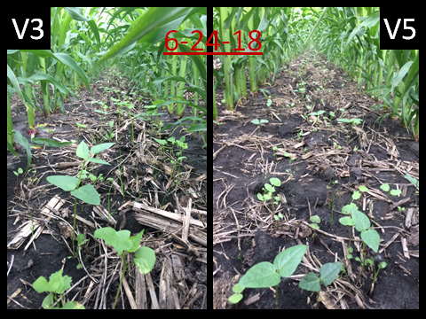

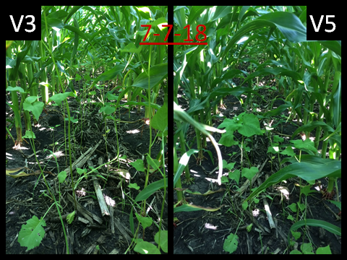
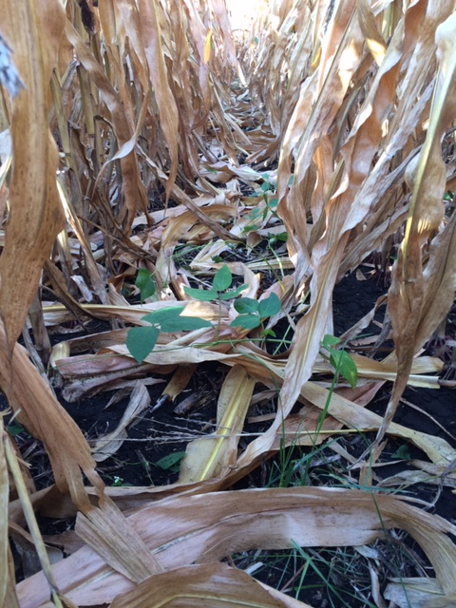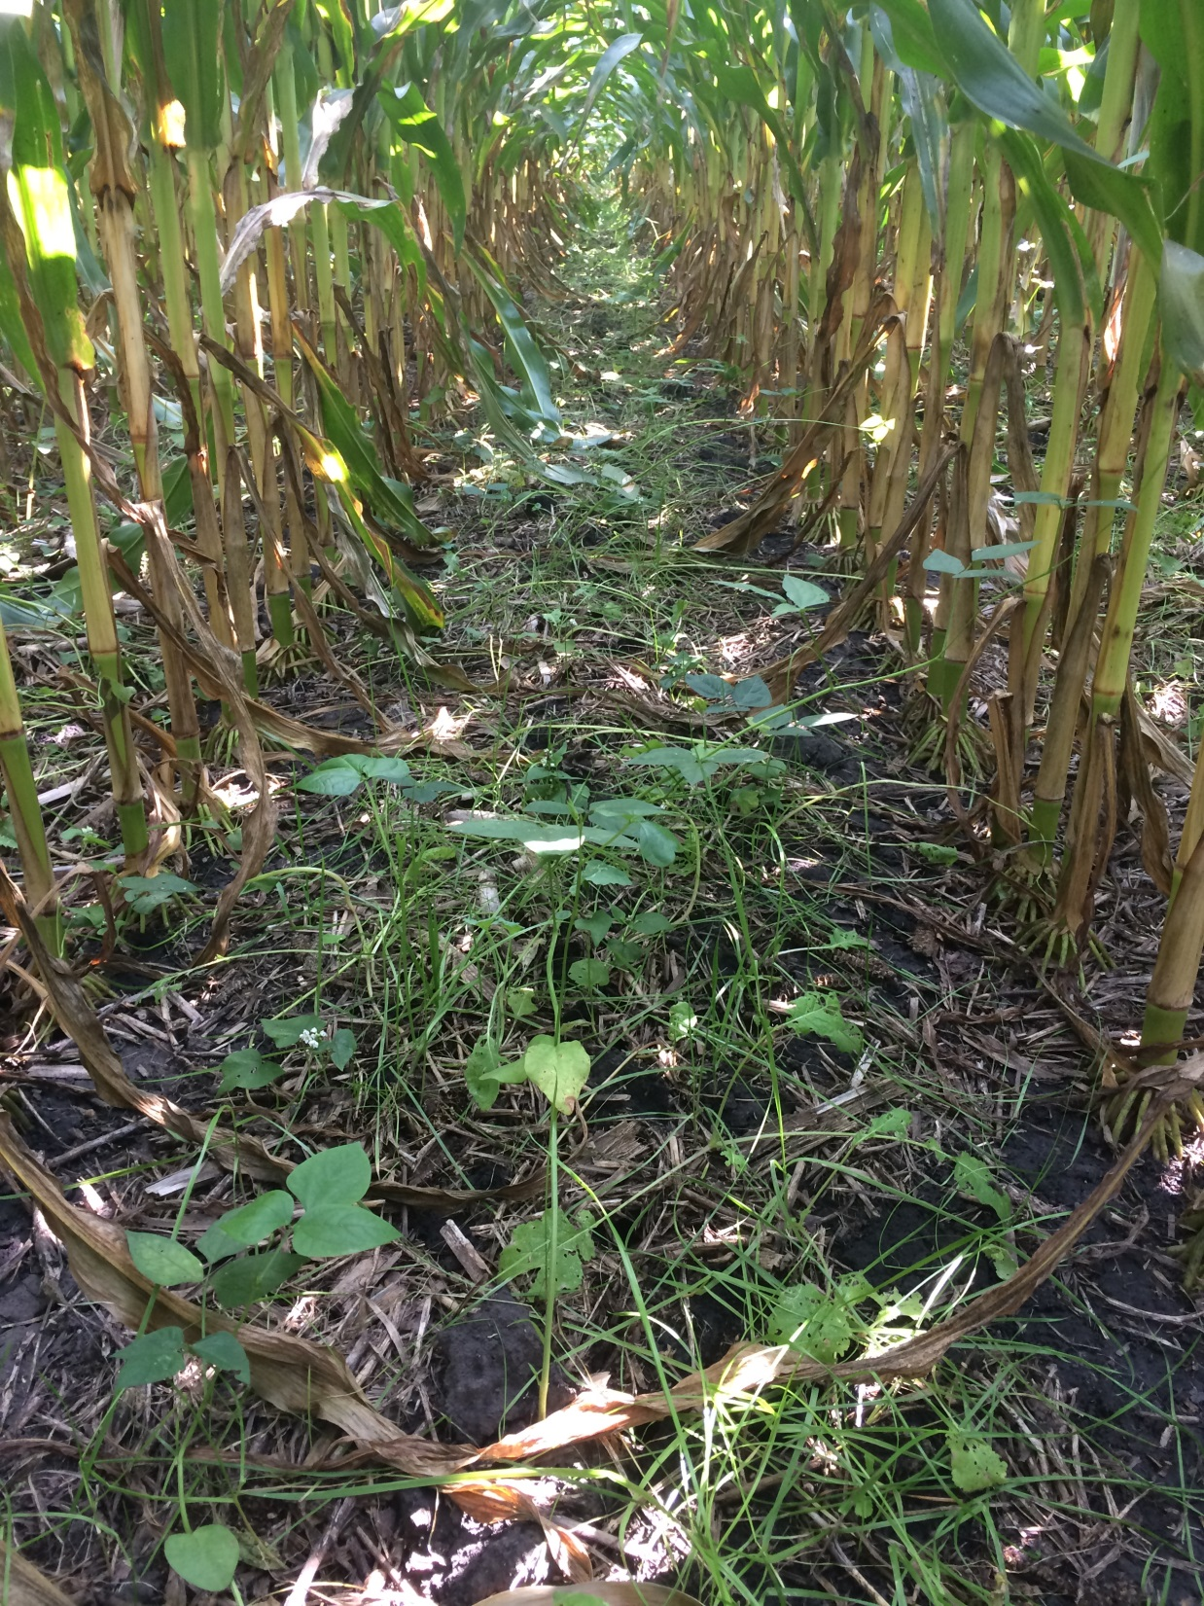
Remaining growth from trial on 9/18/18 Cover Crops persisting under the canopy in
A different hybrid on 8/24/18

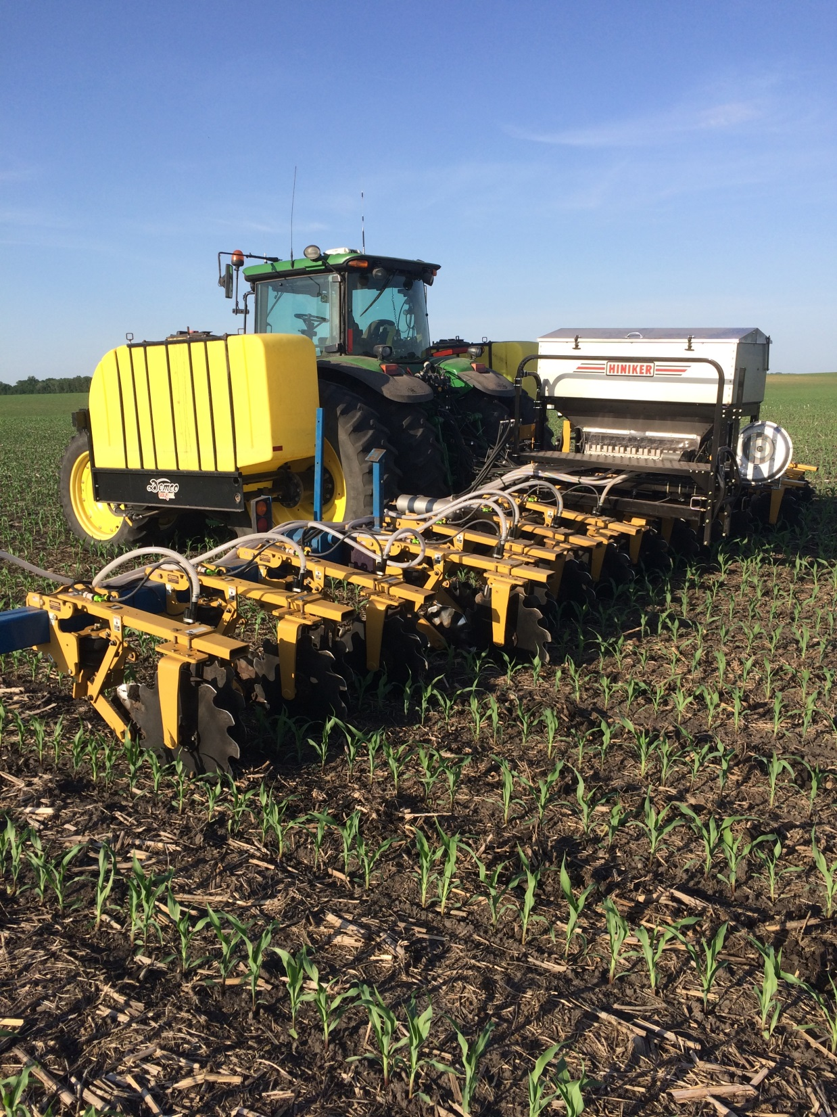
Interseeder/Sidedress Unit
- CHALLENGES ENCOUNTERED. (Describe any challenges that you encountered related to project progress specific to goals, objectives, and deliverables identified in the project proposal.)

The extremely wet weather and large rainfall events made it a challenge to get in the field at times. This is one of the reasons it is very hard to target an exact time frame to interseed. I believe that V3-V5 is ideal and anywhere in that range will give good results.

4.) EDUCATION AND OUTREACH ACTIVITES. (Describe any opportunities to engage with farmers, influencers or the media about your project.)

I was recently part of a farm panel at a Land Stewardship meeting in Faribault where I shared my observations and results from this year’s trial.

5.) HOW CAN WE HELP? (Please let us know how we can improve the experience for the next generation of projects.)

