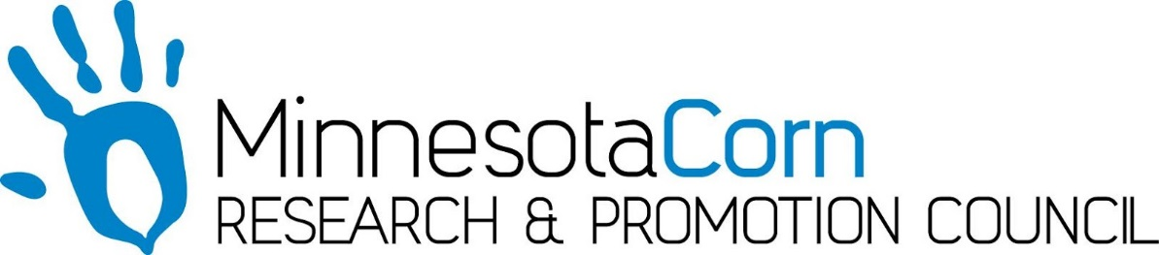

Innovation Grant Progress Report

PROJECT TITLE: VRN Study
REPORTING PERIOD:
FARMER INNOVATOR: Les Anderson
COLLABORATING ORGANIZATION/PERSON: Todd Anderson
PHONE NUMBER: 507.298.0150
EMAIL: lesanderson79@gmail.com

1.) PROJECT ACTIVITIES COMPLETED DURING THE REPORTING PERIOD. (Describe project progress specific to goals, objectives, and deliverables identified in your project proposal.)
80# of N as Urea was applied preplant and incorporated on 4/30/18. Dekalb 5356 was planted on 5/6/18 in 80 foot strips. The Inner 40 feet was planted at a static 35.000 and the outer 40 feet was planted at a variable rate. The Soil tests at a one foot depth were pulled and tested for N on the entire plot on 6/4/2018. Field Prescription was written and then urea was sidedressed on 6/15/2018, 4 days later we had 2.3 inches of rain.

2.) IDENTIFY ANY SIGNIFICANT FINDINGS AND RESULTS OF THE PROJECT TO DATE. (There may be none to report at some stages of the project)
Not too many results or observations yet, Most surprising was the amount of variability in the N tests and the amount of variation in some of the programs, with some areas calling for no additional N. Corn is off to a great start despite the later planting. Corn is approximately 6 ft.

3.) CHALLENGES ENCOUNTERED. (Describe any challenges that you encountered related to project progress specific to goals, objectives, and deliverables identified in the project proposal.) No Major challenges, fairly straightforward process. Writing the prescription was probably the most time consuming part of the study.

4.) EDUCATION AND OUTREACH ACTIVITES. (Describe any opportunities to engage with farmers, influencers or the media about your project.) Jonathan Eisenthal came out the 6/15/18, the same day we were sidedressing and worked on a report for Mn Corn. Started a Facebook Page to act as diary and as a way to give up to date reports to the Team and possibly as way to show the general public on how we are working on being more efficient with N.

5.) HOW CAN WE HELP? (Please let us know how we can improve the experience or assist in your project if possible.)

