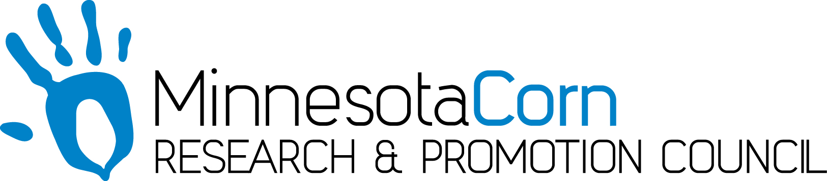

Innovation Grant Progress Report

PROJECT TITLE: Measuring Crop Response to Timing of Split Nitrogen Application with Recommendations Based on Multiple Nitrogen Management Tools
REPORTING PERIOD: October 31st, 2017
FARMER INNOVATOR: Ahrens Farms (Brian Ahrens)
COLLABORATING ORGANIZATION/PERSON: Central Advantage GS – Kate Stenzel
PHONE NUMBER: 507-456-6987
EMAIL: blahrens80@gmail.com

1.) PROJECT ACTIVITIES COMPLETED DURING THE REPORTING PERIOD. (Describe project progress specific to goals, objectives, and deliverables identified in your project proposal.)
The combine monitor used for this project was calibrated before corn harvest began with a weigh wagon and moisture tester. The field was harvested in completion on 10/29/17. This raw data has not yet been collected by Central Advantage to be analyzed.

2.) IDENTIFY ANY SIGNIFICANT FINDINGS AND RESULTS OF THE PROJECT TO DATE. (There may be none to report at some stages of the project)
There were noticeable differences going across the field. Some variability was expected from farm history, but there were also some noticeable differences based on treatments. While the actual treatment map was not available to reference at the time of harvesting, it was visible on the harvest map displayed on the monitor some of the treatment splits.

3.) CHALLENGES ENCOUNTERED. (Describe any challenges that you encountered related to project progress specific to goals, objectives, and deliverables identified in the project proposal.)
The biggest challenges and frustration has been the delay in harvest due to weather and soil conditions. The corn was left in the field and dried down more than had been planned. Some shelling on the combine head was observed due to the average moisture running approximately at 22%.

4.) EDUCATION AND OUTREACH ACTIVITES. (Describe any opportunities to engage with farmers, influencers or the media about your project.)
No specific activities at this time. With the observations noticed in the harvest map, it will be very interesting to see what information Central Advantage is able to analyze for this trial.

5.) HOW CAN WE HELP? (Please let us know how we can improve the experience or assist in your project if possible.)
None at this time.

