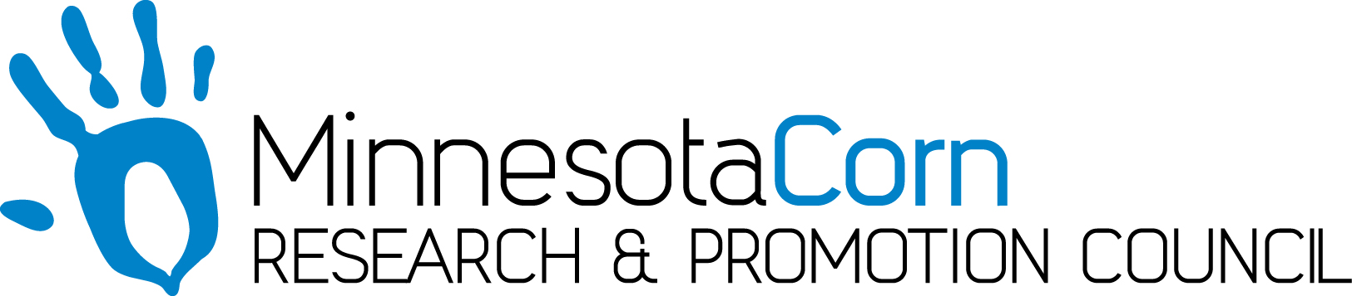

Innovation Grant Progress Report

PROJECT TITLE: Drip Irrigation and Nitrogen Management
REPORTING PERIOD: July 17th 2017
FARMER INNOVATOR: Brian Velde
COLLABORATING ORGANIZATION/PERSON:
PHONE NUMBER: 320-295-2670
EMAIL: bvelde@centrol.com

1.) PROJECT ACTIVITIES COMPLETED DURING THE REPORTING PERIOD. The first week of April we were fortunate to capture a decent weather period that allowed us to install the drip tape and finalize the “In field” plumbing. Below is a youtube video of the process, this is not our field but it is the same installer that installed ours and a very similar process.
https://www.youtube.com/watch?v=A3SSepvNQaM

We plowed in the drip tape every 60” at a depth ranging from 14-16” using RTK. The 58 acre field was spilt into 6 different zones (9.5 acres per zone). The different zones can be operated independently or 2 zones can be operated at once. Throughout the test site we left three 60 foot checks that would allow us to quantify the data. Dr. Jeff Strock and myself set up a protocol that will allow us to quantify yield responses with the treated and untreated areas. The field was planted on May 5th at a population of 38,000, when the crop emerged on May 13th we had a final stand of around 37,000. On June 5, the weather station was installed and 2 moisture probes were installed in both a sandy and clay loam soil type. 6 NIR sensors were also installed throughout the site. On June 5th tissue tests were taken and analyzed. On June 7th we took 12” PSNT nitrate samples in 5 different soil types on V4 corn. After receiving the Nitrate results on June 9th showing nitrogen levels were adequate, we have not injected any 28% into the system yet. On Monday June 5th we started the system and on June 8th the system was operational and working as planned.
Below is another YouTube link that gives some insight on how the system works and results that have been obtained by others.
https://www.youtube.com/watch?v=A3SSepvNQaM

2.) IDENTIFY ANY SIGNIFICANT FINDINGS AND RESULTS OF THE PROJECT TO DATE. The final results will be collected with the yield monitor and then analyzed but attached is a picture that shows the difference between the irrigated and non-irrigated areas.

3.) CHALLENGES ENCOUNTERED. The biggest challenge was preparing the field with spring tillage after a fairly intensive installation had been done a few weeks earlier.

4.) EDUCATION AND OUTREACH ACTIVITES. A lot of area farmers have been inquiring about the progress of the project. An August 22nd field day has been scheduled to provide an outreach and knowledge exchange.

5.) HOW CAN WE HELP? I’m hoping the MN corn growers will be able to have some people attend the field day on August 22nd. It would be nice to have an informational booth on site for the field day and maybe a person to do a short presentation on the different innovation grants the MN corn growers have helped provide funding for and the value of the program.

