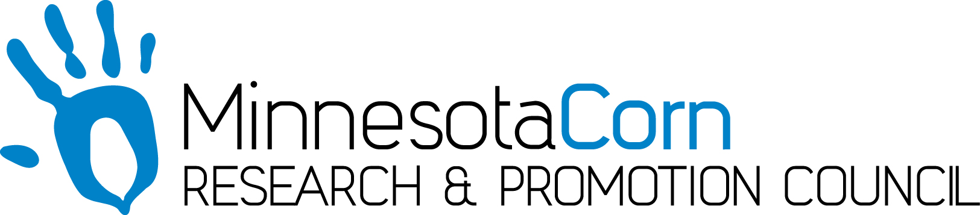

Innovation Grant Progress Report

PROJECT TITLE: Integrating Swine Manure Application with strip tillage into a single pass system
REPORTING PERIOD: August 31,2018
FARMER INNOVATOR: Lee Thompson
COLLABORATING ORGANIZATION/PERSON: Dan Coffman
PHONE NUMBER: 507-508-6556
EMAIL: dan.coffman55@gmail.com

- PROJECT ACTIVITIES COMPLETED DURING THE REPORTING PERIOD. (Describe project progress specific to goals, objectives, and deliverables identified in your project proposal.)
The main activity has been getting the machine ready to display at our field day on September 13

- IDENTIFY ANY SIGNIFICANT FINDINGS AND RESULTS OF THE PROJECT TO DATE. (There may be none to report at some stages of the project)
None at this time

3.) CHALLENGES ENCOUNTERED. (Describe any challenges that you encountered related to project progress specific to goals, objectives, and deliverables identified in the project proposal.)
So far so good, I’m expecting the biggest challenges when we get the machine to the field for a trial run

- EDUCATION AND OUTREACH ACTIVITES. (Describe any opportunities to engage with farmers, influencers or the media about your project.)
I’ve been working with Eric Miller from the Nicollet SWCD on hosting a field day on September 13. We are hoping that a lot of local farmers will attend, especially since there are quite a few hog farmers in the county as well.

- HOW CAN WE HELP? (Please let us know how we can improve the experience or assist in your project if possible.)
You guys are doing great!, keep the innovation grant program going. Always appreciate the reminders for due dates on reports, etc.

