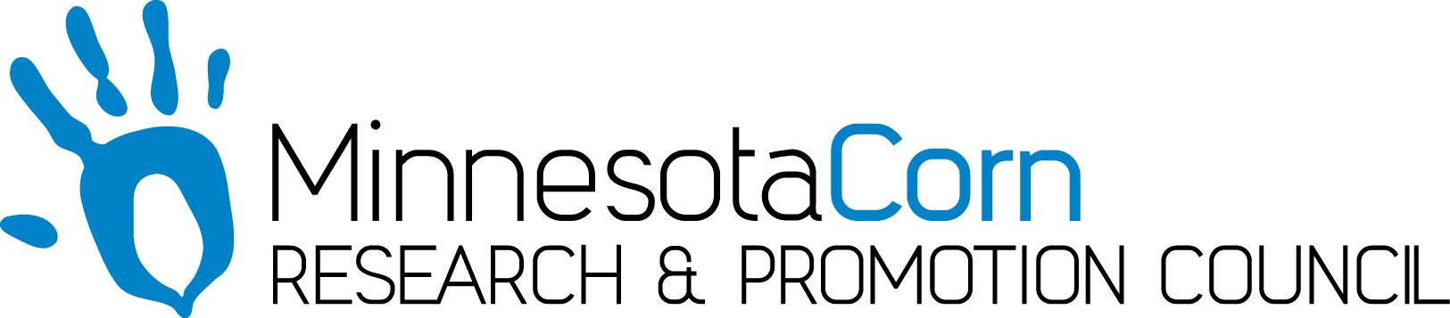

Innovation Grant Progress Report

PROJECT TITLE: Interseedng Cover Crops into V6 Corn While Side-Dressing Nitrogen
REPORTING PERIOD: July-August 2018
FARMER INNOVATOR: Keith Hartmann
COLLABORATING ORGANIZATION/PERSON: Nate Firle-CCA, AgRevival
PHONE NUMBER: 507-276-0573
EMAIL: keith.hartmann88@gmail.com

1.) PROJECT ACTIVITIES COMPLETED DURING THE REPORTING PERIOD. (Describe project progress specific to goals, objectives, and deliverables identified in your project proposal.)
After all the June rains, I found a window to interseed and side-dress the corn on June 30th. The corn was at V6 and I was able to interseed and incorporate as planned vs a broadcast application like I had thought in the last report. I seeded a 15lb/A mix of Annual Ryegrass and Kale while applying 20 gallons/A of 28% UAN.

2.) IDENTIFY ANY SIGNIFICANT FINDINGS AND RESULTS OF THE PROJECT TO DATE. (There may be none to report at some stages of the project)
With the abundance of soil moisture, the cover crop germinated quickly and grew 6” before the corn canopy closed. The Annual Ryegrass and Kale are long, pale and stringy looking, but still alive. That is consistent from previous years and exactly what I want to happen. That means it isn’t competing with the corn for nutrients or water. In a couple weeks when the corn leaves start to drop, more sunlight will reach the ground and the cover crop will start to grow once again.

3.) CHALLENGES ENCOUNTERED. (Describe any challenges that you encountered related to project progress specific to goals, objectives, and deliverables identified in the project proposal.)
The rains and finding a window to seed was a continued challenge. One deliverable from this is even though the corn canopy was lush and closing fast, the cover crop still grew enough in a short amount of time to remain viable.

4.) EDUCATION AND OUTREACH ACTIVITIES. (Describe any opportunities to engage with farmers, influencers or the media about your project.)
On August 6th, 2018, I recorded a radio spot with Mark Dorenkamp for the MN Corn Growers discussing my Innovation Grant Project and past results.

5.) HOW CAN WE HELP? (Please let us know how we can improve the experience or assist in your project if possible.)
A social media post about my plot day, partnered with AgRevival, on September 13th discussing my Innovation Grant project would be excellent. I will attach an Invite to this email. Thanks!

