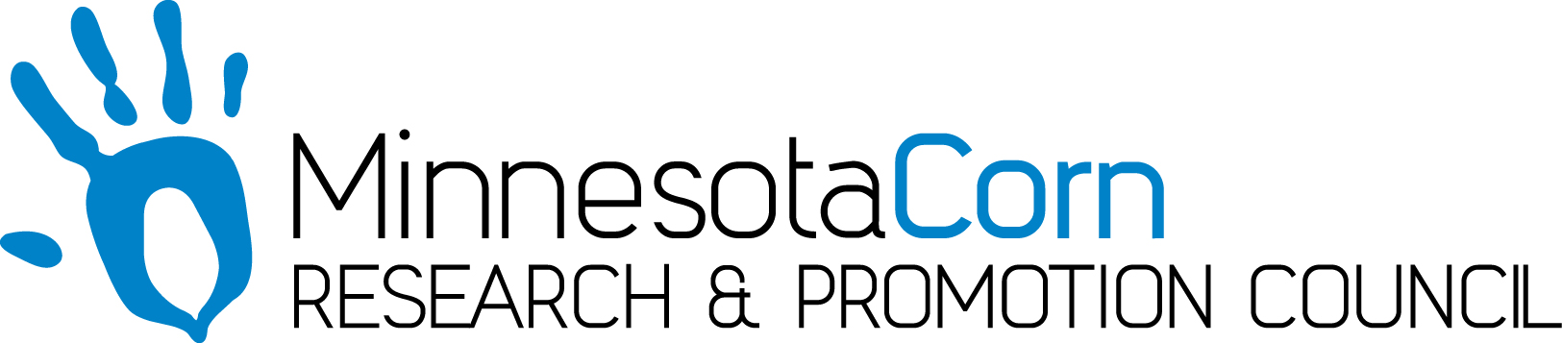

Innovation Grant Progress Report

PROJECT TITLE: Nitrogen Management on Fall Manure Applied Fields Using Intensive Grid Nitrate Sampling and Nitrogen Modeling
REPORTING PERIOD: October 31st, 2017
FARMER INNOVATOR: Jason Gillis
COLLABORATING ORGANIZATION/PERSON: Central Advantage GS – Kate Stenzel
PHONE NUMBER: 507-456-9258
EMAIL: gillis189@gmail.com

1.) PROJECT ACTIVITIES COMPLETED DURING THE REPORTING PERIOD. (Describe project progress specific to goals, objectives, and deliverables identified in your project proposal.)
Little change in the has occurred with the research field since the last report. The combine monitor has been calibrated for the corn crop, both grain weight and moisture. The field used in this research project has not yet been harvested.

2.) IDENTIFY ANY SIGNIFICANT FINDINGS AND RESULTS OF THE PROJECT TO DATE. (There may be none to report at some stages of the project)
There were some interesting differences observed when looking at NDVI in season imagery within the field. We are curious to see if those translate into yield differences when the field is harvested. There were some visual differences when looking at the field as well throughout the growing season.

3.) CHALLENGES ENCOUNTERED. (Describe any challenges that you encountered related to project progress specific to goals, objectives, and deliverables identified in the project proposal.)
It has been a challenging crop year. Operations continue to be delayed. The corn continues to stand well at this time, but with the strong winds and the stalks so dry, lodging could become an issue which may affect harvest data.

4.) EDUCATION AND OUTREACH ACTIVITES. (Describe any opportunities to engage with farmers, influencers or the media about your project.)
I can’t think of any education or outreach activities that could be done from this report period.

5.) HOW CAN WE HELP? (Please let us know how we can improve the experience or assist in your project if possible.)
No help is currently needed.

