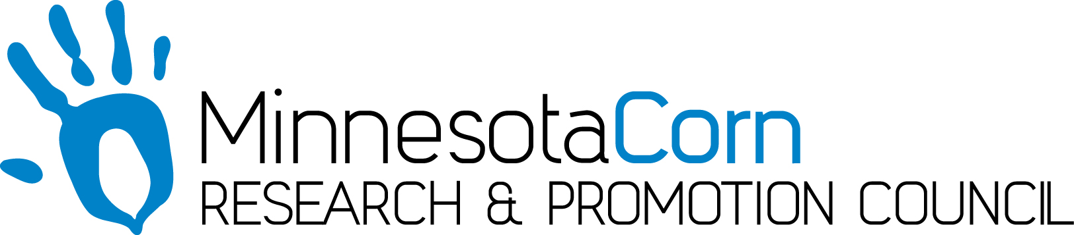

Innovation Grant Progress Report

PROJECT TITLE:
REPORTING PERIOD: July 19, 2017
FARMER INNOVATOR: Hicks Family, Brian, Michelle, Jake, Adam, Mallorie
COLLABORATING ORGANIZATION/PERSON: Michelle or Jake Hicks
PHONE NUMBER: 507-626-0701
EMAIL: mhicks@rrcnet.org

- PROJECT ACTIVITIES COMPLETED DURING THE REPORTING PERIOD. (Describe project progress specific to goals, objectives, and deliverables identified in your project proposal.) All of the soil samples have been collected. Field scouting opportunitites have been taken weekly. 252 soil tests have been completed. There are 14 Humus tests left. We plan repeat the test with other methods to see if results vary.

2.) IDENTIFY ANY SIGNIFICANT FINDINGS AND RESULTS OF THE PROJECT TO DATE. (There may be none to report at some stages of the project) The results so far have been quite varied. It appears we have high calcium levels across the board. The Nitrogen levels are more varied. Phosphorus appears to be in good levels in most fields. pH levels are varied. I was surprised at some of the high carbonation levels in the soils. The tops of some samples blew off when making extractions. I’m super excited to see the final results. We are using some higher sophisticated equipment to measure the pH levels and compare them with the pH levels I obtained by running chemical tests. The tests are not super complicated. I was able to teach some of my children how to run them with me simultaneously.

3.) CHALLENGES ENCOUNTERED. (Describe any challenges that you encountered related to project progress specific to goals, objectives, and deliverables identified in the project proposal.) The Potassium lab test results were very difficult to read. I made a lot of calls to the testing company trying to figure out how to get the best results. I believe eventually I would like to make videos how to correctly do each test to help other farmers. But I want to get the data back from the professional testing facilities to compare with my data to be sure I have the correct results. I want to make sure my data correlates and that I am doing the test correctly before I post any videos.

4.) EDUCATION AND OUTREACH ACTIVITES. (Describe any opportunities to engage with farmers, influencers or the media about your project.) We met with the Headlight Herald reporter, Per Peterson. He came out and toured our farm and took photos. The project will be featured in the next Agricultural Edition. Our homeschool group is super interested in watching demonstrations on our project. I have several families that want their kids to see how to run soil tests. I plan to do this this fall when school is up and running. My daughter Mallorie is doing a 4-H project on soil testing for the Lyon County Fair this summer. She thinks doing this project is awesome!

5.) HOW CAN WE HELP? (Please let us know how we can improve the experience or assist in your project if possible.) I cant think of anything at this point. Well maybe, are there any conferences or classes you would recommend that we attend?Thanks for all you do!\
Michelle

Would you like some photos at this point? Otherwise we will save them for the presentation at the end.

