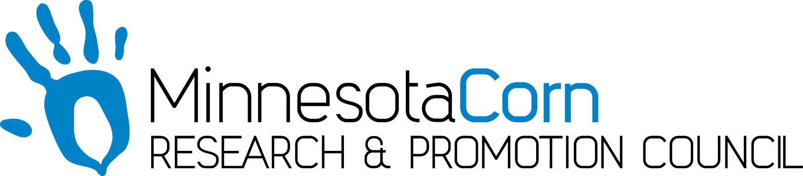

Innovation Grant Progress Report

PROJECT TITLE: Eliminating soil erosion using a three crop rotation and extensive cover crops.
REPORTING PERIOD: First Quarter
FARMER INNOVATOR: Brock Olson
COLLABORATING ORGANIZATION/PERSON: SWCD Goodhue County, Tom Steger
PHONE NUMBER: 651-206-3897
EMAIL: brockolson@gmail.com

1.) PROJECT ACTIVITIES COMPLETED DURING THE REPORTING PERIOD. (Describe project progress specific to goals, objectives, and deliverables identified in your project proposal.)
Water infiltration tests were conducted the morning after a 0.1” overnight rain. Times listed are what it took for the first 2” of water, second 2” of water, and third 2” of water to infiltrate.
2.) IDENTIFY ANY SIGNIFICANT FINDINGS AND RESULTS OF THE PROJECT TO DATE. (There may be none to report at some stages of the project)
 | Water Infiltration Rate May 1st | Water Infiltration Rate July 1st | Water Infiltration Rate Sept. 1st | Organic Matter
No Till Winter Rye | 2:00, 10:00, 10:00 |  |  | 1.9%
No Till Corn | 1:30, 2:00, 2:50 |  |  | 3.5%
Full Tillage Corn | 3:40, 3:50, 4:20 |  |  | 2.7%

3.) CHALLENGES ENCOUNTERED. (Describe any challenges that you encountered related to project progress specific to goals, objectives, and deliverables identified in the project proposal.)
The winter rye planted October 2017 did not emerge because of very cold fall temperatures. The rye did germinate in the fall, but this delayed overall rye growth. Erosion has been non existent on this field despite a couple 2” rains this spring.

4.) EDUCATION AND OUTREACH ACTIVITES. (Describe any opportunities to engage with farmers, influencers or the media about your project.)
I have participated in two phone interviews with the corn growers association, which ultimately ended up on public radio.

5.) HOW CAN WE HELP? (Please let us know how we can improve the experience or assist in your project if possible.)
No additional help is needed at this time.

