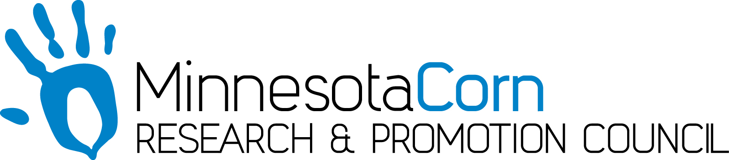

Innovation Grant Progress Report

PROJECT TITLE: Economic Benefit of Variable Rate Nitrogen Programs
REPORTING PERIOD: August 28, 2018 – December 12, 2018
FARMER INNOVATOR: Sam Peterson
COLLABORATING ORGANIZATION/PERSON: Central Advantage GS, Winfield Solutions, Encirca, 3P Farms LLC
PHONE NUMBER: 507-649-1582
EMAIL: sam.peterson140@gmail.com

1.) PROJECT ACTIVITIES COMPLETED DURING THE REPORTING PERIOD. (Describe project progress specific to goals, objectives, and deliverables identified in your project proposal.)
The main goals of this recording period were to harvest the test area and analyze the yield data collected during harvest. The field was harvested on two separate days due to weather constraints. Rain, cold, snowfall, and tough harvest conditions lead to the field needing to be harvested in two separate dates. Harvest started on November 3rd but the majority was completed on the 11th of November. Harvest data has been compiled and is in the process of being analyzed. The analyzation of the results will be done in the final report.

2.) IDENTIFY ANY SIGNIFICANT FINDINGS AND RESULTS OF THE PROJECT TO DATE. (There may be none to report at some stages of the project)
The yield map shows no visual indication of yield difference between the trials. Although, no change in yield across treatments would cause a significant revenue difference between treatments due to the difference in applied nitrogen. After the data is analyzed more closely using computer software, yield averages may show different results for each treatment.

3.) CHALLENGES ENCOUNTERED. (Describe any challenges that you encountered related to project progress specific to goals, objectives, and deliverables identified in the project proposal.)
Unfortunately on September 20TH, high winds from a storm broke off a lot of the corn plants. This made harvest of the corn very difficult. A crop reel was added to the corn head to help feed in the down plants. The combine had to back up many times due to plugging which may have influenced the results on part of the field. To combat this issue, many of the data points may have to be thrown out of the results.

4.) EDUCATION AND OUTREACH ACTIVITES. (Describe any opportunities to engage with farmers, influencers or the media about your project.)
During the month of September, I attended multiple corn plot meetings and spoke about the project. I emphasized the importance of nitrogen placement, especially in a growing season like we had in 2018. Heavy rainfalls caused nitrogen to be a limiting yield factor in many fields across southern Minnesota.

5.) HOW CAN WE HELP? (Please let us know how we can improve the experience or assist in your project if possible.)
Nothing to report.

