Innovation Grant Final Report

PROJECT TITLE: Economic Benefit of Variable Rate Nitrogen Programs
REPORTING PERIOD: Final Report and Invoice due by Feb 28, 2018
FARMER INNOVATOR: Sam Peterson
COLLABORATING ORGANIZATION/PERSON: Central Advantage GS, Winfield Solutions, Encirca, 3P Farms LLC
PHONE NUMBER: 507-649-1582
EMAIL: sam.peterson140@gmail.com

1.) PROJECT ACTIVITIES COMPLETED DURING THE REPORTING PERIOD. (Describe project progress specific to goals, objectives, and deliverables identified in your project proposal.)

During this reporting period, analysis of the harvest data was completed along with a financial comparison between treatments to answer the question of which variable rate treatment, if any, is most profitable when compared to a flat rate treatment.

2.) IDENTIFY ANY SIGNIFICANT FINDINGS AND RESULTS OF THE PROJECT. (This could include photo documentation of the project at various stages if you haven’t already provided these as well as final relevant images of the project at completion. Any data analysis (especially Level 3 Grants), graphics or record of observations throughout the growing season or during the field day event are also anticipated.)

Below is a table displaying the economic analysis of the trial. Yield averages from the five replications are compared with the average amount of urea applied within the same area. $3.65/bushel was used as a price of cash corn and $250/ton was used for the price of urea fertilizer. $450/ton was assigned for the pre-plant anhydrous to create a weighted average for total cost of nitrogen applied on the trial area. In summary, the final results of the trial show that Winfield’s R7 tool brought a 9 bushel increase in yield which lead to a $16.87 net profit per acre compared to the flat rate trial. The other two variable rate applications, Nitrate Now and Encirca, showed a net loss compared to the flat rate due to not producing enough yield to offset the extra cost of the program and the additional nitrogen applied. Another important result to note was the nitrogen efficiency for each trial. Even though R7 produced the most net profit, it had the weakest nitrogen use efficiency at .9953 compared to .8724 on the flat rate trial. This result tells me that the R7 tool is applying significantly higher amounts of nitrogen in areas where it is deficient or expected to use high amounts. Applying more nitrogen in only the areas where it is needed also produced more yield. According to Climate Corporation, there were 25.5 inches of rainfall between the planting and harvest date in 2018. A high amount of rainfall influenced the importance of nitrogen placement during the growing season. The corn hybrid planted, Croplan 3909STXRIB, also has a high response to nitrogen which may have had an influence on the yield results.

Flat Rate |  | AVERAGE | Weighted $/#N
# 46-0-0 Top Dress | 152.17
46-0-0 $/Ac | $ 19.02
Program $/Ac | $ -
Total $/Acre | $ 19.02 | $ 19.02
Yield | 196.00 | 196.00
Total # of N | 171.00 | 171.00 | $0.2733
Total # of N per bu | 0.8724 | 0.8724
R7 |  | AVERAGE
# 46-0-0 Top Dress | 224
46-0-0 $/Acre | $28.00
Program $/Ac | $7.00
Total $/Acre | $35.00 | $35.00
Yield | 205.00 | 205.00
Total # of N | 204.04 | 204.04 | $0.2731
Total # of N per bu | 0.9953 | 0.9953
NitrateNow |  | AVERAGE
# 46-0-0 Top Dress | 184.78
46-0-0 $/Acre | $23.10
Program $/Ac | $7.00
Total $/Acre | $30.10 | $30.10
Yield | 198.00 | 198.00
Total # of N | 186.00 | 186.00 | $0.2732
Total # of N per bu | 0.9394 | 0.9394
Encirca |  | AVERAGE
# 46-0-0 Top Dress | 184.78
46-0-0 $/Acre | $23.10
Program $/Ac | $10.00
Total $/Acre | $33.10 | $33.10
Yield | 198.00 | 198.00
Total # of N | 186.00 | 186.00 | $0.2732
Total # of N per bu | 0.9394 | 0.9394
Summary
 | Flat Rate | R7 | NitrateNow | Encirca
Average Top Dress $/Ac | $19.02 | $35.00 | $30.10 | $33.10
Average Yield bu/Ac | 196.00 | 205.00 | 198.00 | 198.00
Average Total #N/bu | 0.8724 | 0.9953 | 0.9394 | 0.9394
+/- bu/Ac vs Flat Rate |  | 9.00 | 2.00 | 2.00
+/- $/Ac vs Flat Rate |  | $15.98 | $11.08 | $14.08
+/- #'s N/bu Flat Rate |  | 0.12 | 0.07 | 0.07
Gross $/Ac Difference |  | $32.85 | $7.30 | $7.30
Net $/Ac Difference vs Flat Rate |  | $16.87 | -$3.78 | -$6.78

Below is an as-applied map showing the rates applied during the side-dress application of urea. The field is split by a driveway. Two replications of the trial were performed on the left of the driveway and three more were on the right side. All passes were placed, at random, within their respective replication.
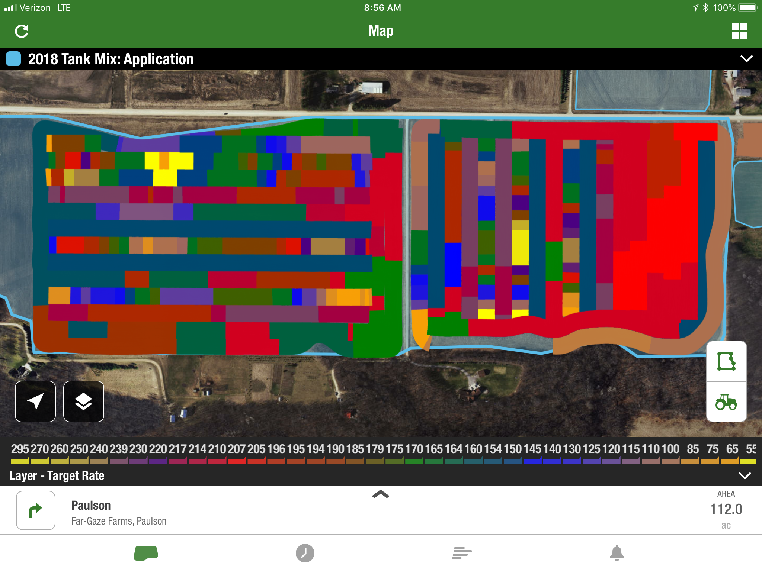

3.) CHALLENGES ENCOUNTERED. (Describe any challenges that you encountered related to project progress specific to goals, objectives, and deliverables identified in the project proposal.)

On September 20th, 2018, the research area experienced extremely high winds due to a tornado passing through nearby. This caused significant lodging to most plants in the field and resulted in an extremely difficult harvest. A corn reel was installed on the header of the combine to help decrease harvest loss by feeding the down plants into the harvest equipment (image 1 and 2 below). Even though the reel helped significantly, the harvest process was very slow and required the combine to stop many times. The harvest data needed to be combed over to make sure any outlying data was removed to ensure results were not skewed. Although this was a huge challenge for us, I stand behind the results as being accurate and unbiased. A special thanks to Brad Carlson at UMN Extension for helping make that happen.

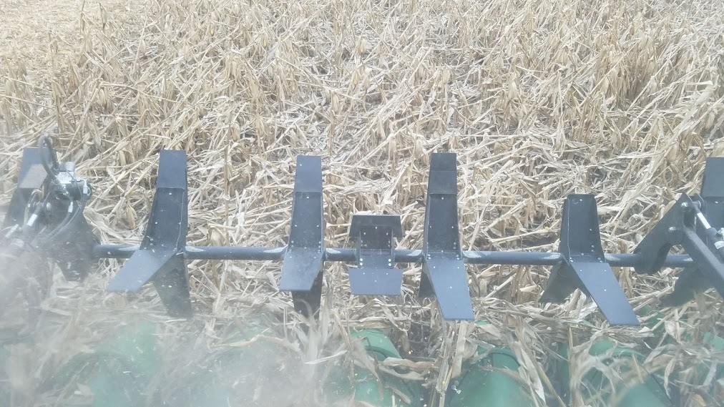
Image #1
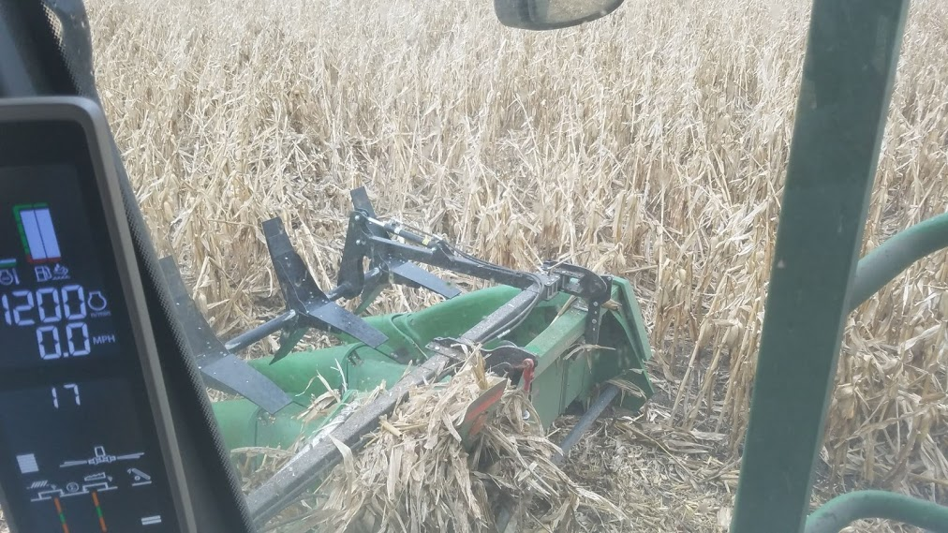
Image #2

4.) EDUCATION AND OUTREACH ACTIVITES. (Describe any opportunities to engage with farmers, influencers or the media about your project.)

During this reporting period I had a chance to meet with multiple growers in my area to talk one-on-one about split application of fertilizer and how this trial has influenced my thinking on how these variable rate nitrogen programs work. I also like talking about different experiments growers are trying on their own farms.

5.) HOW CAN WE HELP? (Please let us know how we can improve the experience for the next generation of projects.)

My experience has been great. I have no suggestions at this time.

