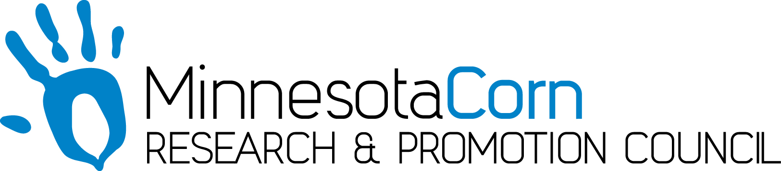

Innovation Grant Progress Report

PROJECT TITLE: Teralytic Soil Probe
REPORTING PERIOD: July 2019
FARMER INNOVATOR: Brian Velde
COLLABORATING ORGANIZATION/PERSON: Brian Velde and Centrol Crop Consulting
PHONE NUMBER: 320-295-2670
EMAIL: bvelde@centrol.com

1.) PROJECT ACTIVITIES COMPLETED DURING THE REPORTING PERIOD. (Describe project progress specific to goals, objectives, and deliverables identified in your project proposal.)
The Teralytic Soil probe can not only measure soil moisture but also the movement of nutrients, most importantly nitrogen. The goal of the project is to track the accuracy of this technology compared to the typical soil sampling methods. If this technology can accurately track Nitrogen movement and mineralization this will revolutionize agriculture and nitrogen management.

2.) IDENTIFY ANY SIGNIFICANT FINDINGS AND RESULTS OF THE PROJECT TO DATE. (There may be none to report at some stages of the project)
Currently we are still waiting to receive the probes.

3.) CHALLENGES ENCOUNTERED. (Describe any challenges that you encountered related to project progress specific to goals, objectives, and deliverables identified in the project proposal.)
PRODUCTION. We are still waiting to receive the probes that were scheduled to be delivered in April. After visiting with the CEO it appears they haven’t shipped any probes yet as they are still fine tuning one of the sensors. A September shipping date is proposed and I would like to postpone this project to 2020 for obvious reasons. I am very frustrated with the delay but if the product isn’t accurately working it’s probably best to wait for an operational product to test.

4.) EDUCATION AND OUTREACH ACTIVITES. (Describe any opportunities to engage with farmers, influencers or the media about your project.)
NA

5.) HOW CAN WE HELP? (Please let us know how we can improve the experience or assist in your project if possible.)
I would like the board to consider this project for 2020 as I feel it’s a very innovative concept. Financially the $5000 lease for the probes will be extended for the 2020 season from Teralytic.

