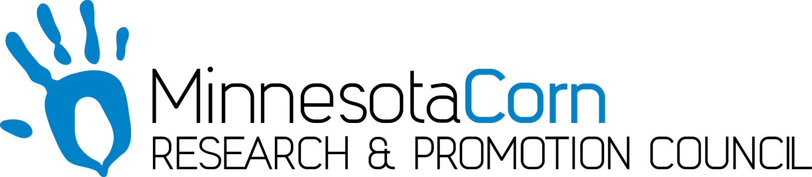

Progress Report

PROJECT TITLE: Quantifying hydrologic impacts of drainage under corn production systems in the upper Midwest
PROJECT NUMBER: 4116-14SP
REPORTING PERIOD: October 1, 2016 to December 31, 2017
PRINCIPAL INVESTIGATOR: Jeff Strock
ORGANIZATION: University of Minnesota
PHONE NUMBER: 507-752-7768
EMAIL: jstrock@umn.edu

1.) PROJECT ACTIVITIES COMPLETED DURING THE REPORTING PERIOD. (Describe project progress specific to goals, objectives, and deliverables identified in the project workplan.)
Objective 1: Determine how the presence of subsurface drainage changes the comprehensive water budget of corn production systems.

Task 1. Physical quantification of soil water balance. Minnesota: Drain flow has been continuously monitored and during 2017, flow was nearly continuous once flow began after soils thawed in spring. Water samples for water quality have been analyzed. Soil water potential sensors (Tensiometers and 229 matric potential sensors or MPS-6 sensors) have been continuously monitored. Climate data are being continuously downloaded from both sites. Root samples were collected from the two Minnesota sites and have been scanned and analyzed. Corn was planted at the Tracy and Waseca sites in 2017. Yield data was collected from the management zones at the Tracy site as well as the Waseca site however the raw data have not been completely processed at this time. South Dakota: Drain flow has continuously been monitored every 15 minutes based on flow over V-notch weirs in drainage control structures. Water table depth at 5-ft midway between drain lines in the middle of each plot was also been measured and logged every 60 minutes. Soil water content was collected every 15 minutes at 6, 18, 30, and 42 inch depths. Micrometeorological data (temperature, relative humidity, wind speed and direction, solar radiation, and precipitation) were also collected continuously from the South Dakota Mesonet station, located on the research farm near Beresford that and operated by the South Dakota State Climate Office. We continue to collect annually crop yield data for soybean-corn rotation. Soybean was planted in odd years and corn in even years.

Task 2. Source, flow path and residence time of root zone water and shallow ground water. Minnesota: Deep and shallow wells along with suction cup lysimeters were monitored during 2017. Precipitation, drainage water, well water and soil pore water was collected monthly, during frost-free periods for isotopic analysis. Samples have been delivered for isotopic analysis. Water table elevation was continuously monitored during 2017 in the deep wells. South Dakota: Well and water table data were collected every 60 minutes. The well is an artesian well with continuous flowing water. Isotope samples have been collected two to three times per year.

Objective 2: Quantify how the different components of field-scale water budgets may influence watershed-scale hydrology and predict how these systems may change under scenarios of variable weather and changing climate.
Task 1. Computer simulation modeling using the SWAT model. South Dakota: A SWAT model of the Vermillion River Watershed has been built and hydrologic calibration was completed. Additional notable progress with modeling efforts are centered on developing methods to partition daily modeled flow values into their respective source components (e.g., surface water vs. ground water). We are now able to visualize water yields for individual flow components on a daily basis to determine how various sources of water are combining to make up total flow from a watershed. This is an important advancement for evaluating the simulated hydrology data against measured water age values to assess whether or not the watershed model is doing a realistic job of simulating key components of the watershed hydrologic budget. Information gained from this analysis of model results (and complemented by field observations) will lead to a more robust understanding of the relative importance of different water sources during various watershed conditions.

2.) IDENTIFY ANY SIGNIFICANT FINDINGS AND RESULTS OF THE PROJECT TO DATE.
Considerable work has been done in synthesizing data collected since the beginning of the project. This data was presented at the Minnesota Water Resources Conference and the ASA-CSSA-SSSA annual meeting in Tampa, FL.

Our whole team has met and are working on the final report. The final report will contain five chapters. Chapter 1 will be an overview of the project. Chapter 2 will be focused on the water balance from drained and undrained cropland from out field research in South Dakota and Minnesota. Chapter 3 will focus on the impact of water management on roots from field research conducted in Minnesota. Chapter 4 will be focused on the isotopic analysis and ground water aging. The focus of Chapter 5 will be on extending the field research to the watershed scale.

3.) CHALLENGES ENCOUNTERED. (Describe any challenges that you encountered related to project progress specific to goals, objectives, and deliverables identified in the project workplan.)
We continued to have delays in isotope analysis during 2017. In order to complete the isotope analysis for the project an alternative laboratory was identified and samples submitted for analysis. In addition, the lead PI from SDSU left the institution for another position. Todd Trooien assumed the PI role. Before leaving SDSU, the former PI, Lauren Ahaiblame, along with contributions from Todd Trooien, wrote a draft of the South Dakota contribution to Chapter 2.

4.) FINANCIAL INFORMATION (Describe any budget challenges and provide specific reasons for deviations from the projected project spending.)
Spending has been progressing as expected.

5.) EDUCATION AND OUTREACH ACTIVITES. (Describe any conferences, workshops, field days, etc attended, number of contacts at each event, and/or publications developed to disseminate project results.)

- Minnesota Water Resources Conference – September 17-18, 2017. St. Paul, MN. Topic: Impacts of subsurface drainage strategies on the fate of water in the upper Midwest. Number of participants: 112.
- Minnesota Water Resources Conference – September 17-18, 2017. St. Paul, MN. Topic: Isotope uses in a drained agricultural landscape water budget. Number of participants: 97.
- Minnesota Water Resources Conference – September 17-18, 2017. St. Paul, MN. Topic: Simulating watershed-scale hydrologic response to farm-level changes in water management. Number of participants: 103.
- Soil Science Society of America Annual Meeting. 23 October, 2017. Tampa, FL. Topic: Effect of drainage water management strategy on corn and soybean roots. Number of participants: 32.

Personal contacts with some attendees after the presentations were strongly positive about the project.

