

Progress Report

PROJECT TITLE: Maximizing Soil Warming and Health under Different Tillage Practices in a Corn-Soybean Rotation (no-cost extension)
PROJECT NUMBER: 4143-18SP
REPORTING PERIOD: Oct 31 to Jan 31, 2020
PRINCIPAL INVESTIGATOR(S): Jodi DeJong-Hughes
ORGANIZATION: University of Minnesota Regents
PHONE NUMBER: 320-235-0726 x 2006
EMAIL: dejon003@umn.edu

- PROJECT ACTIVITIES COMPLETED DURING THE REPORTING PERIOD. (Describe project progress specific to goals, objectives, and deliverables identified in the project work plan.)
- Conservation Tillage Conference (CTC ) – The CTC was held on Dec 17-18 in St. Cloud. There were 275 participants, speakers, and exhibitors at the conference. The evaluation results will be summarized in the next 2 weeks.
- Life in the Pits field day – see below.

2.) IDENTIFY ANY SIGNIFICANT FINDINGS AND RESULTS OF THE PROJECT TO DATE.
- CTC - we will hold the CTC in Mankato next year if we can find a favorable location.
- Life in the Pits - see below.

3.) CHALLENGES ENCOUNTERED. (Describe any challenges that you encountered related to project progress specific to goals, objectives, and deliverables identified in the project workplan.)
- No issues this quarter.

4.) FINANCIAL INFORMATION (Describe any budget challenges and provide specific reasons for deviations from the projected project spending.
- There were no budget challenges during this project period.

5.) EDUCATION AND OUTREACH ACTIVITES. (Describe any conferences, workshops, field days, etc attended, number of contacts at each event, and/or publications developed to disseminate project results.)

- CTC – Articles written by attending news media include:
  - https://www.agriculture.com/crops/conservation/why-the-2019-harvest-has-set-the-stage-for-field-compaction
  - https://www.agriculture.com/crops/conservation/soil-health-and-conservation-tillage-put-to-work
  - https://www.agupdate.com/minnesotafarmguide/news/crop/assessing-soil-health-at-this-year-s-conservation-tillage-conference/article_c166e950-2654-11ea-9ed3-670532bac604.html
  - https://www.rrfn.com/2019/12/19/conservation-tillage-conference-focuses-on-improving-soil-productivity/
  - YouTube https://www.youtube.com/watch?v=-ub6pTs24Vg&feature=emb_title
  - Does Conservation give farmers an edge in a wetter climate? Written by Jonathan Eisenthal
  - Two more articles will be coming from MN Farm Guide in the next few weeks.
  - More articles will be coming from Successful Farming in the next year.

Life in the Pits: A look at soil management and crop health

Life in the Pits: A look at soil management and crop health was a unique, small-group field day that equipped participants with the skills to identify different levels of soil structure and help them understand how tillage and crop management strategies affect the soil. It was held at Galen Skjefte's field on Sept 10th and 11th near Granite Falls.
Tillage has been implicated as a major contributor to soil degradation and erosion. It loosens the soil, making it prone to both wind and water erosion. The eroded soil also carries nutrients away from fields and into waterways, where soil can clog ditches and water structures with sediment. In Minnesota alone, wind and water erode over 8 tons of soil an acre each year, according to USDA.
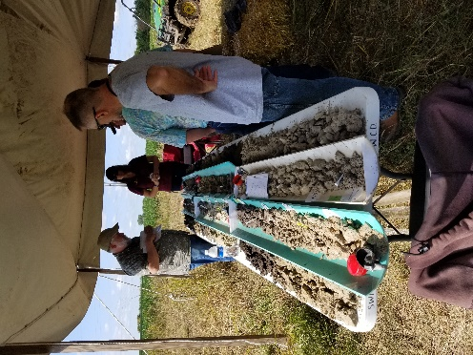
Using four soil pits, participants learned how soil texture, crop management, and topography influence a crop and soil quality. Each soil pit was a visual and textural reflection of management choices from the past 100 years. Understanding the importance of soil health and ultimately changing crop management practices will build soil aggregation, improve water infiltration and storage, and reduce soil erosion.
Most importantly, participants were able to connect the visual and physical impacts below ground to how it is treated above ground. Attendees were divided into groups to view three unique stations to further their understanding about soil structure and management techniques. Presenters included soil specialists from Minnesota, North Dakota, and Manitoba.
Figure 1. Dr. Jay Goos, NDSU, demonstrating the differences in ND/MN soils. Samples of salinity, compaction, and other problem soils.

Station 1
The first station included discussions of soil structure, the benefits of aggregated soils, and the habitat earthworms and microbes need to thrive. It also included a water infiltration demonstration and a discussion of problem soils (Figure 1.)

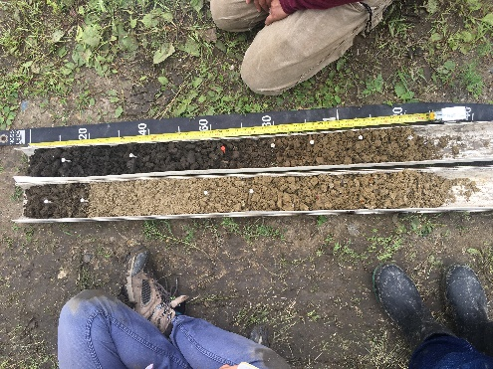
Station 2
The Erosion Soil pits (top of hill, bottom of hill) demonstrated the power of erosion to lower yield potential, add variability to the field, and degrade our water resources.

Station 3
The chisel plow field vs the grassed area looked at the effects of tillage on the soil structure, biology, and bulk density.
This hands-on, small group field day trained farmers on September 10. As a result of the field day, attendees should be able to take a shovel to any part of their field and have a better understanding of what they are seeing.
Figure 2. Two soil cores taken from the shoulder of a hill (L) and midway down the slope (R). Notice how the dark brown, high organic matter soil has eroded downslope.
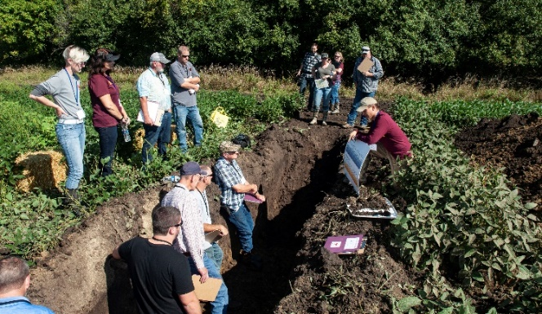
On September 11, SWCD, NRCS staff, and Minnesota West Ag students attended the field day. Training government agency staff to be able to identify soil erosion and cropping issues enables them to better make management recommendations to their clientele, Minnesota farmers.

Results
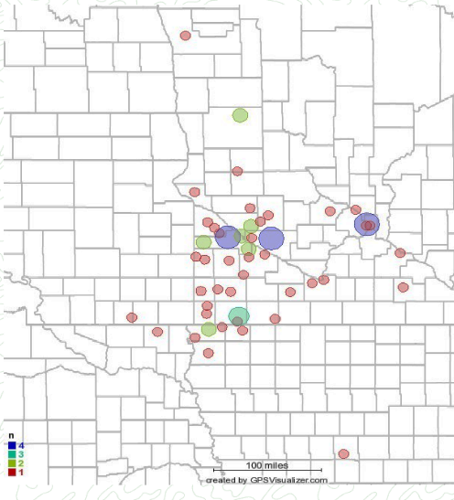
Twenty two farmers, 14 college students, 4 crop consultants, and 15 government agency personnel attended the field days. Figure 4 shows where the participants travel radius. The government people came from the following counties: Kandiyohi, Yellow Medicine, Renville, Ramsey, Rock, Pipestone, Redwood, Pope, and Otter Tail.
Figure 3. Participants at Life in the Pits.
An evaluation was emailed to participants with a 25% return rate. Of the respondents:
- 81% said they have a situation where they can use what they have learned at the field day.
- 86% said they will change at least one practice based on what they learned at the field day.
- 70% of the respondents are using reduced tillage practices.
Over 61,000 acres of crop land were either actively farmed or managed by the survey participants. This does not include the ag land that government staff can influence in their counties as well.
Figure 4. Map indicating participant addresses.
From the responses, 15% (representing 9,175 acres) will try and reduce a tillage pass this next season and 17% (representing 10,400 acres) will incorporate a cover crop into the rotation.
In addition, twelve UMN students used the soil pits to practice for the national soil judging competition.
Photos taken of the soil conditions in the soil pits will be used for future educational workshops and for Extension publications and blogs.
Partners: UMN Extension partnered with Renville, Yellow Medicine and Swift County Soil and Water Conservation Districts, MN Ag Services, Hawk Creek Watershed Project, MN Soil Health Coalition, Minnesota Corn Growers, and local farmers.

