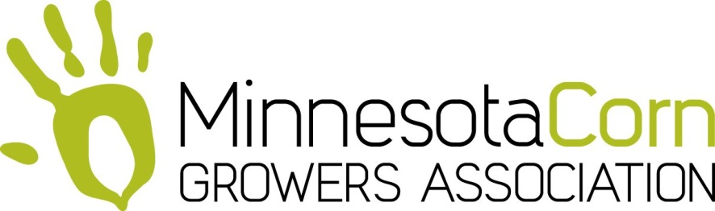

Pennington/Red Lake County Soybean/Corn Association

College Scholarship Application

All applications must be postmarked or received no later than March 15, 2018
THE PROGRAM
Pennington/Red Lake County Soybean/Corn Growers is offering four (4) $500 college scholarships to assist high school juniors and seniors who are working toward a degree in soybean/corn agronomy, soil science, soybean/corn genetics, food sciences, animal nutrition or large animal veterinary.
This scholarship program is administered by the directors of Pennington/Red Lake County from the Minnesota Soybean/Corn Research & Promotion Councils and the Minnesota Soybean-Corn Growers Associations. Awards are granted without regard to race, color, creed, religion, gender, disability or national origin.
ELIGIBILITY REQUIREMENTS
Applicants to the Minnesota Soybean/Corn Research & Promotion Council College Scholarship must be –
- A student of a Pennington/Red Lake County school or parents that are Pennington/Red Lake producers
- From a family who is active in agriculture
- A junior or senior in high school
- Pursuing an education in soybean agronomy, soil science, soybean genetics, large animal vet or animal nutrition
- Active in ag-related, campus and/or community activities
If you are unsure whether your degree qualifies, contact the NW MN Corn Office at 218-253-2074.
Send your application by March 15th to:
MN Corn Growers
c/o Marlene Dufault
2604 Wheat
Red Lake Falls, MN 56750
Phone – 218-253-2074

Supported by the Minnesota Corn Research & Promotion Council

