Innovation Grant Progress Report

PROJECT TITLE: Cover Crops ability to suppress weeds and reduce chemical input
REPORTING PERIOD: December 2019
FARMER INNOVATOR: Matt Alford
COLLABORATING ORGANIZATION/PERSON: Nate Carr-Faribault County Soil & Water Conservation District
PHONE NUMBER: 402-760-0263
EMAIL: alfordmja@gmail.com

1.) PROJECT ACTIVITIES COMPLETED DURING THE REPORTING PERIOD. (Describe project progress specific to goals, objectives, and deliverables identified in your project proposal.)

Harvest was completed and yield and moisture were collected using our calibrated Ag Leader yield monitor in our combine. Earlier in the year I used my quadrat to asses weed pressure in each treatment. I also had my father-in-law record his observations from the combine. After the corn was harvested I drove through the field and thoroughly inspected each treatment to assess weed escapes. I pulled soil cores at 0-6in and 12-16in in each treatment and sent them to a lab to be analyzed. The deeper samples I had analyzed for nitrate only and the shallow samples I had total analysis performed with both traditional soil tests as well as the Haney soil test. The nitrate tests were the only tests I had originally planned on performing when I applied for my innovation grant. I thought it would be interesting to see if there were any differences happening between the treatments that would show up on a soil test as well. I may include these analysis in the future as part of the plan.

2.) IDENTIFY ANY SIGNIFICANT FINDINGS AND RESULTS OF THE PROJECT TO DATE. (There may be none to report at some stages of the project)

Yield Results

Cover Crop 1 - 215.10
Control 1 - 214.53
Cover Crop 2 - 212.66
Control 2 - 212.71
Cover Crop 3 - 211.11
Control 3 - 210.54

Once again the cover crop had no negative effect on corn yield. In fact, it actually had a slightly positive impact on yield even seeded as early as V4; which is the case here.

Weed control was once again more than adequate. I found a few broadleaves that emerged late in one of the cover crop treatments. They had not had enough time to make seed because they had emerged so late. They should not have been able to contribute the weed seed “bank” because of this. I found a few spots where we had some corn that was drowned out and the cover crop completely took over those areas and smothered any potential would be weeds. I am really starting to believe that cover crops can be a real tool in reducing weed pressure. I have included a picture that shows one of the small drowned out areas. The brown woody looking stems you see remaining are what is left of the buckwheat that thrived with the extra sunlight. Virtually zero weed pressure in these areas. Normally in the absence of a cover crop these would be solid weeds that would go to seed.

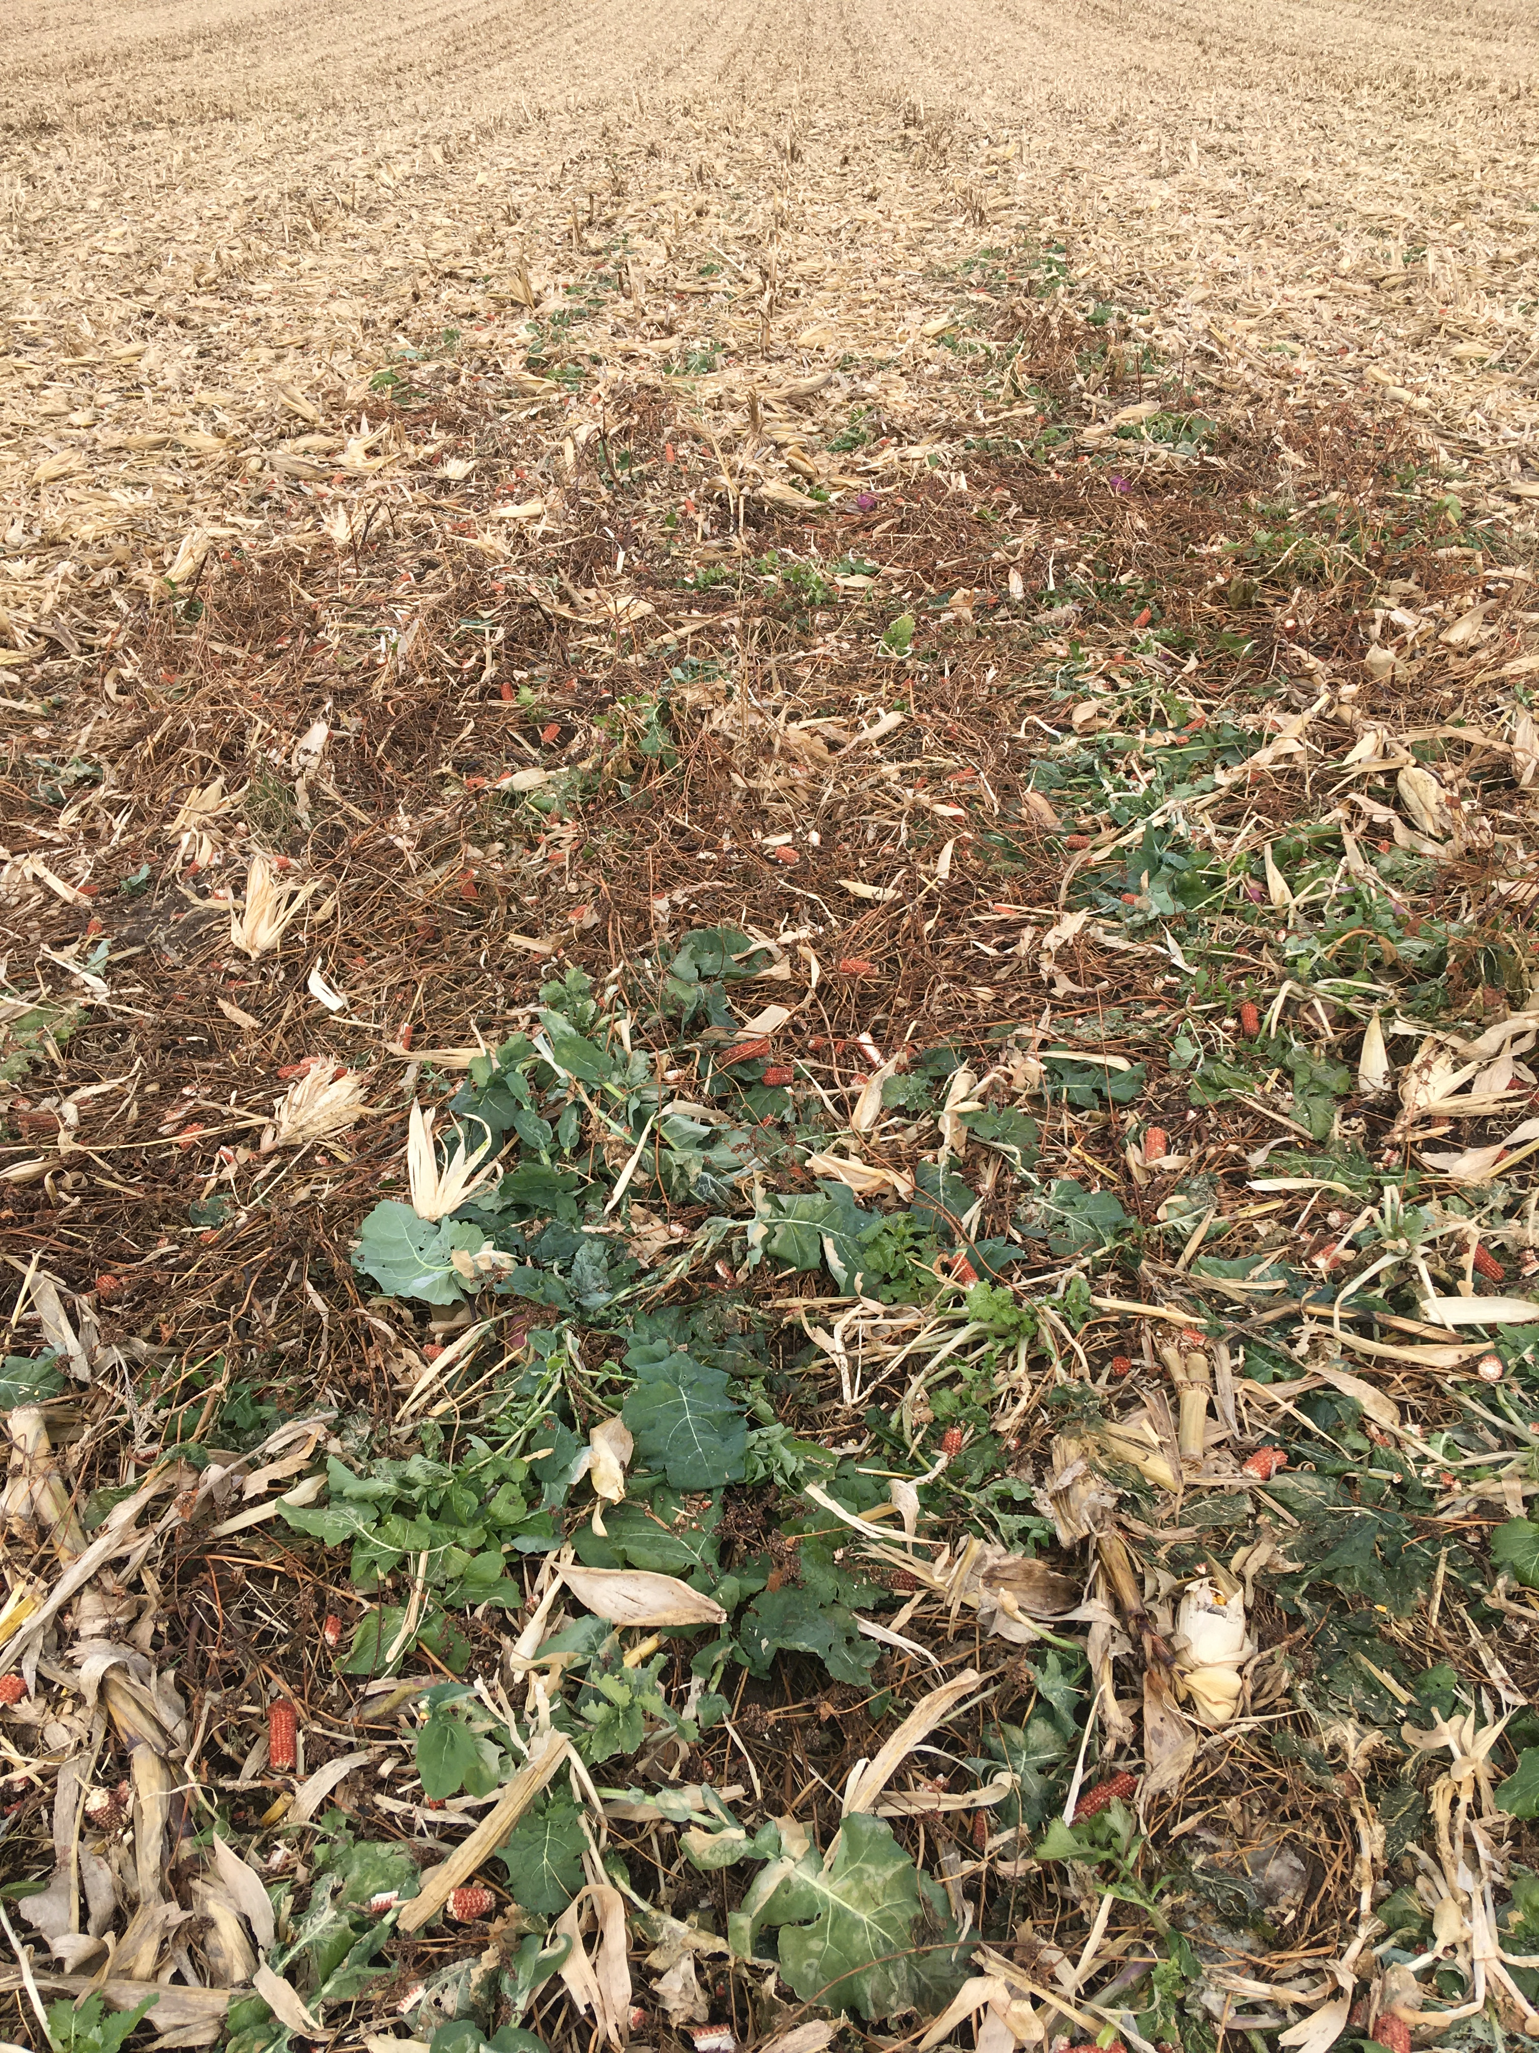

3.) CHALLENGES ENCOUNTERED. (Describe any challenges that you encountered related to project progress specific to goals, objectives, and deliverables identified in the project proposal.)

Harvest was late and we actually had to wait until the ground froze to harvest my plot area as well as the rest of this field due to very wet conditions.

4.) EDUCATION AND OUTREACH ACTIVITES. (Describe any opportunities to engage with farmers, influencers or the media about your project.)

Strip-Till Farmer had a small article that featured some of the things we are doing on our farm as well as some of the results I have gathered do in part to this project. I have also been asked to give a presentation at two locations for the I-90 soil health tour this winter. My findings from this project will be a large part of the information I present.

5.) HOW CAN WE HELP? (Please let us know how we can improve the experience or assist in your project if possible.)

My experience in this project and working with you has been very positive. Would definitely recommend it to anyone. The flexibility and understanding you have when it comes to deadlines and things of that nature are very much appreciated when we have long drawn out planting or harvests. Also reminders of upcoming dates are always very much apprecitated!

