

Innovation Grant Progress Report

PROJECT TITLE: Real-Time Liquid Manure Testing and Nutrient Management
REPORTING PERIOD: Q4 2019/Final Report
FARMER INNOVATOR: A.J. Krusemark
COLLABORATING ORGANIZATION/PERSON: Melissa Wilson
PHONE NUMBER: 928-925-8186
EMAIL: kruser02@gmail.com

1.) PROJECT ACTIVITIES COMPLETED DURING THE REPORTING PERIOD. (Describe project progress specific to goals, objectives, and deliverables identified in your project proposal.)
Fall 2019 provided another challenge for harvest and manure application. Before encountering frozen ground, we were able to apply approximately half of our manure. As a result, we will be applying some additional spring manure in 2020. Manure samples were collected on 60+ loads for nutrient analysis. Data for load by load testing & yield data was compiled and analyzed. This information will be used in conjunction with our management zones to create a true VRT application prescription for some spring 2020 manure application. Spring manure application will include a side by side of fall and spring applications from the same pit

2.) IDENTIFY ANY SIGNIFICANT FINDINGS AND RESULTS OF THE PROJECT TO DATE. (There may be none to report at some stages of the project)
Load to load variation in our hog manure in excess of 5% throughout the duration of pumping a pit. This is after several hours of agitation and with a Nuhn triple-port pump moving 6000+ GPM. This validates the opportunity to improve our application practices with real-time testing and variable rate application. The data displayed below is the result of testing two pits from the same 2400-hd Isowean barn that is in its 3rd year of use. I was surprised to find this level of discrepancy in the nutrient analysis. NOTE: The values for nitrogen, phosphorus and potassium are 1st year crop available (70% N, 80% P, 90% K) and are displayed in pounds/1000 gallons. The application rate was calculated using University of Minnesota phosphorus requirements for corn following soybean based on a crop removal of a 220 Bushel/Acre yield goal.

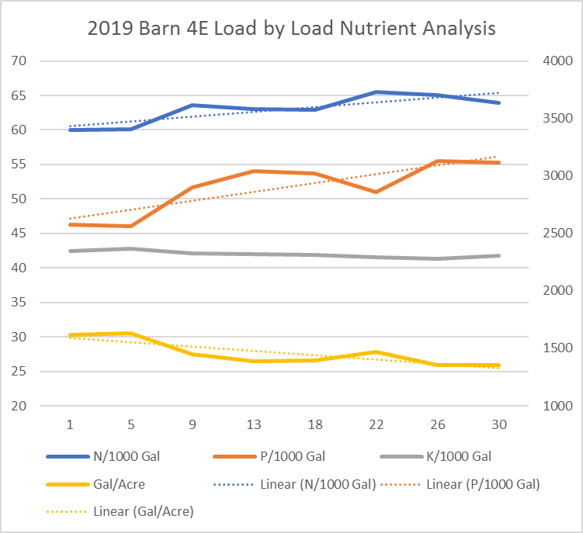
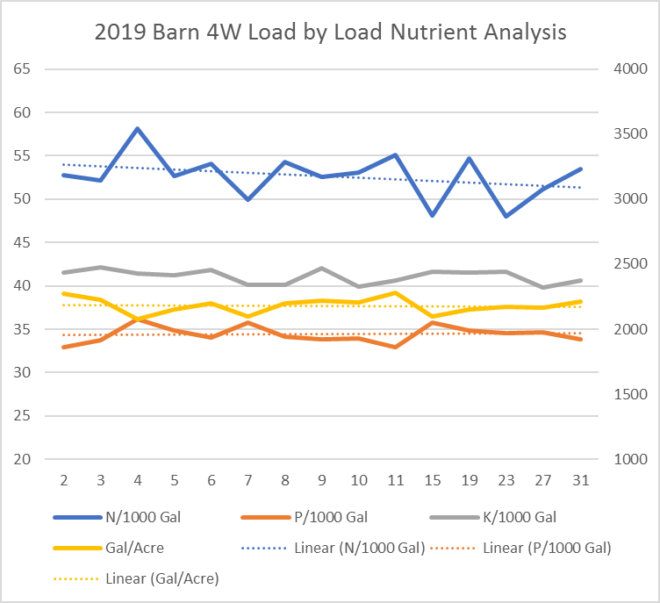

Yield Analysis
On average, in the wet growing season of 2019, hog manure application targeting phosphorus requirements of the corn crop had a slight yield advantage over commercial fertilizer. In both replications the balance of the nitrogen requirements for both manure and commercial fertilizer scenarios were split applied in-season with a combination of coulter side-dress at V5 and Y-Drop application pre-tassel. All fall nutrients (hog manure and VRT commercial) were applied using Soil Warrior X-row units and were not freshened in the spring. Planter is a DB44 equipped with Precision E-set row meters, DeltaForce, and Clean-Sweep.

Liquid Ratio Testing

The data displayed below was collected using a 1mm mesh to strain the solids out of several manure samples at the barn site while pumping the pit. They were correlated to a laboratory sample to verify accuracy.
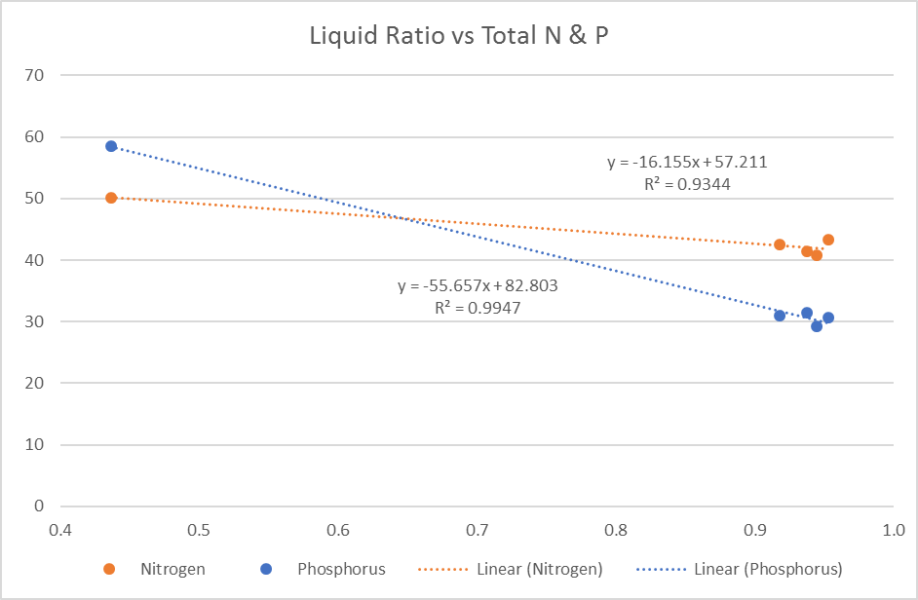

Application Accuracy

To recap information reported earlier this year, we have been able to fine-tune our application rig to perform repeatably at 95+% application accuracy, giving us confidence to apply a true variable rate application based on pit side load nutrient analysis. The left side of the field was applied while tweaking the application rig to achieve desired performance. The right side of the field was applied after achieving desired settings. Sub-optimum applications in this area are due to rolling hills and testing of application with a nearly empty tanker.

3.) CHALLENGES ENCOUNTERED. (Describe any challenges that you encountered related to project progress specific to goals, objectives, and deliverables identified in the project proposal.)
Snow and wet soil, coupled with early freezing. If the past 2 growing seasons have taught us nothing else, it is the value of a flexible farming system. Cover crop and strip-tillage practices have allowed our farm to adapt to a challenging moisture conditions without sacrificing yield.

4.) EDUCATION AND OUTREACH ACTIVITES. (Describe any opportunities to engage with farmers, influencers or the media about your project.)
I shared some of the results of this project as part of Melissa Wilson’s presentation at the Conservation Tillage Conference in St. Cloud. There were many more questions than we had time to answer during the session, sparking good lunch conversation.
I conducted a radio interview while at the Ag Expo in Mankato and also spent the day engaging with attendees who passed by our project posters, sharing information about findings and the Innovation Grant Program. I have used my poster as a talking point with account managers at our local coop and to challenge other local producers to think about increasing the precision of their manure applications.

I will be participating in a farmer panel at the Nutrient Management Conference in Mankato February 4th.

I continue to share a few tid bits on Twitter (@kruser02) and will continue to post progress pictures there.

5.) HOW CAN WE HELP? (Please let us know how we can improve the experience or assist in your project if possible.)
I am seeking a collaborating entity or individual with knowledge of real-time sensing and data processing. The goal of this collaboration would be to develop a solution to measure the liquid-ratio of manure samples to adjust the application at a minimum of each load from a pit.

