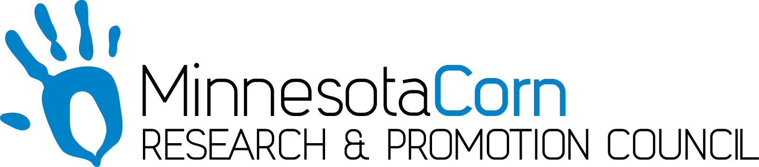

Innovation Grant Progress Report

PROJECT TITLE: Corn Response to Preplant and Pre-Sidedresss Nitrate Testing Utilizing Variable Rate Nitrogen Application and In-Season Imagery
REPORTING PERIOD: October 31st, 2017
FARMER INNOVATOR: Pat Smith
COLLABORATING ORGANIZATION/PERSON: Central Advantage GS – Kate Stenzel
PHONE NUMBER: 507-456-1571
EMAIL: psjd07@gmail.com

1.) PROJECT ACTIVITIES COMPLETED DURING THE REPORTING PERIOD. (Describe project progress specific to goals, objectives, and deliverables identified in your project proposal.)
Using the coop’s weigh wagon, the combine monitor was calibrated for moisture and weight as corn harvest began. The field used in this grant has not yet been harvested. Central Advantage has been working on collecting the application data from in season, as well as the imagery throughout the growing year.

2.) IDENTIFY ANY SIGNIFICANT FINDINGS AND RESULTS OF THE PROJECT TO DATE. (There may be none to report at some stages of the project)
None currently

3.) CHALLENGES ENCOUNTERED. (Describe any challenges that you encountered related to project progress specific to goals, objectives, and deliverables identified in the project proposal.)
The late planting of this field set it behind average pace from the beginning. Current weather field conditions have limited good days to be able to harvest. The grain may be drier than ideal, and standability could also become an issue if conditions remain poor.

4.) EDUCATION AND OUTREACH ACTIVITES. (Describe any opportunities to engage with farmers, influencers or the media about your project.)
No activities or opportunities currently present themselves. Once the field is harvested it will be interesting to see if there is a noticeable difference going across the field.

5.) HOW CAN WE HELP? (Please let us know how we can improve the experience or assist in your project if possible.)
No help is need at this time.

