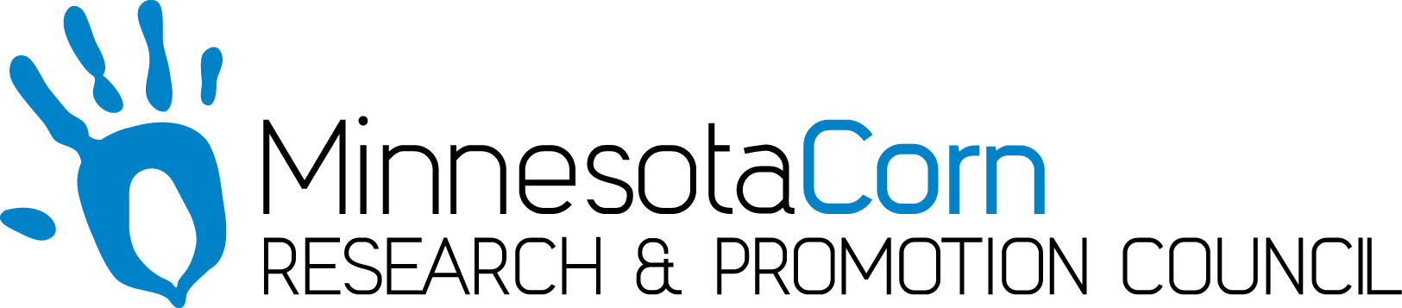

Innovation Grant Progress Report

PROJECT TITLE: Economic Benefit of Variable Rate Nitrogen Program
REPORTING PERIOD: 7/2/2019 – 12/15/2019
FARMER INNOVATOR: Sam Peterson
COLLABORATING ORGANIZATION/PERSON: Central Advantage GS, Encirca, Winfield R7,
3P Farms
PHONE NUMBER: 507-649-1582
EMAIL: sam.peterson140@gmail.com

1.) PROJECT ACTIVITIES COMPLETED DURING THE REPORTING PERIOD. (Describe project progress specific to goals, objectives, and deliverables identified in your project proposal.)
After the topdress was applied in June, observations were made on the field for the rest of the growing season. Observations included satellite images, drone pictures, and walking the field from the ground. Any significant changes between treatments were recorded. The objective of this time period was also to harvest the crop and collect the yield data. The yield data will then be analyzed. The center 12 rows out of 36 will be counted from each replication in the trial to prevent overlap of fertilizer or rows. All outlying data points will be removed and a set row length will be used for uniformity.

2.) IDENTIFY ANY SIGNIFICANT FINDINGS AND RESULTS OF THE PROJECT TO DATE. (There may be none to report at some stages of the project)
During this reporting period, observations showed significant yellowing and uneven growth of the plants in low areas because of excess moisture. This did not seem to be caused by either Nitrate Now, FFT, or Encirca. It was uniform across the trial but followed lower lying areas that lacked tile drainage needed this year. Harvest results showed that the entire field averaged 172 bushels per acre. The average yield on this trial was down compared to average because of heavy rainfall and lack of drainage in parts of the field. Standability at harvest was uniform among the trials though. The yield and fertilizer maps still need to be analyzed in depth to get data for the final results.

3.) CHALLENGES ENCOUNTERED. (Describe any challenges that you encountered related to project progress specific to goals, objectives, and deliverables identified in the project proposal.)
The biggest challenge with this year’s trial was rainfall. Excess moisture decreased the overall yield potential of the field. It was also harder to find days to spray, fertilize, scout, harvest, or fly over the field to take observations because of the adverse weather. Despite these challenges, all of the data was collected.

4.) EDUCATION AND OUTREACH ACTIVITES. (Describe any opportunities to engage with farmers, influencers or the media about your project.)
An interview I did with Jonathan Eisenthal was posted on the MNCorn website and sent to my local newspaper. This helped people understand what I was doing with my on-farm research and how it was beneficial. I had a lot of positive feedback as well as local farmers asking me more questions about the project and where they could find the results when they are posted.

5.) HOW CAN WE HELP? (Please let us know how we can improve the experience or assist in your project if possible.)
I think the poster idea at MN ag expo is a great idea. Help building one to showcase my research would be great.

