

Innovation Grant Final Report

PROJECT TITLE: BioElectroChemical Reactor for treating agricultural drainage water (4501-17SP)
REPORTING PERIOD: Final Report
FARMER INNOVATOR: NA
COLLABORATING ORGANIZATION/PERSON: University of Minnesota/Jeffrey Strock
PHONE NUMBER: 507-752-5064
EMAIL: jstrock@umn.edu

Prepared by Jeffrey Strock, Sebastian Behrens, Gary Feyereisen, Aaron Pauleon and Andry Ranaivoson.

Synopsis
The purpose of this project was to use MCRPC funds to initiate proof-of-concept research on electrocatalytic denitrification as a potential treatment option for removing nitrate from agricultural drainage water. This work was intended to build upon previous research done by the PI’s and collaborating scientists. Previous laboratory and field research on nitrogen reduction from drainage water was conducted using a vertical flow bioreactor system. The previous lab research was conducted under the direction of Dr. Gary Feyereisen and the previous field research was conducted under the direction of Dr. Jeff Strock as part of a Minnesota Department of Agriculture funded Clean Water Land and Legacy project. Additional research support was provided by the University of Minnesota Water Resources Center and the US Geological Survey to continue the lab and field effort.

The results of this research showed that modular, vertical flow bioreactors were capable of biological remediation of nitrate-laden tile drainage effluent. The key findings of this work were that biostimulation of bioreactors, dosing with a readily available carbon source (acetate), enhanced nitrate removal through denitrification. This work also demonstrated that biostimulation enhanced nitrate remediation at low temperatures (< 41°F) and that the hydraulic residence time (HRT) of the modular, vertical flow bioreactors, was decreased compared to other bioreactors. The HRT for the modular, vertical flow bioreactor was on the order of two to four hours in order to achieve greater than 30% nitrate reduction in comparison to horizontal flow bioreactors which have been shown to have HRT’s on the order of 12 to 24 hours to achieve similar nitrate reduction.

Introduction
In recent decades, electrocatalytic denitrification has emerged as a potential treatment option for removing nitrate from groundwater and industrial wastewater (Mook et al., 2012). This method is driven by electrical energy which produces electrons that act as a reducing agent combined with a metallic catalyst to promote the conversion of nitrate to harmless dinitrogen (N₂) gas. One of the advantages of this process is that the driving force, low amperage electricity, can be obtained from renewable sources such as solar.

Several studies have been conducted and have shown some success in this relatively new approach to denitrification. The range of nitrate concentrations considered in the studies can be divided into two groups: 1) low nitrate concentration (14 – 40 mg/L NO₃-N), and 2) industrial grade concentration (50 - 492 mg/L). Successful denitrification rate results were reported to range over 80% depending on current applied (order of mA), configuration of anode-cathode set (materials used -- metal or graphite -- and physical arrangement of electric poles), hydraulic residence time (hours), influent pH and influent nitrate concentration.

Islam and Suidan (1998) achieved a stable denitrification reduction efficiency of up to 85% over 2 years using a 20 mg NO₃-N /L, a cylindrical graphite cathode along the bioreactor wall and a graphite anode in the center, and a sustained 20 mA current. Prosnansky et al (2002) reported an enhancement of denitrification rate by 3-60 times higher than previous studies by using multiple porous cathodes (5 units) and a single anode design with a low residence time (0.33 hr/20 minutes) and incoming nitrate concentration between 15 and 40 mg/L. Concentric cathodes (8 units) and two anodes (2 units) helped Sakakibara and Nakayama (2001) achieve complete denitrification at hydraulic residence times between 2-6 hours with an influent nitrate concentration of 20 mg/L. Law et al. (2017) found that electrically enhanced woodchip bioreactors exhibited higher denitrification rates in an upflow laboratory column experiment.

In this experiment, it was hypothesized that using electrocatalytic denitrification methods may reduce or altogether eliminate the need for biostimulant external carbon source. Furthermore electrocatalytic denitrification may be as or more effective in remediating nitrate from subsurface drainage as other methods and more cost effective. The original objective of this proposal was to evaluate several cathode-andode materials and configurations in a model bioreactor design in order to optimize denitrification of nitrate laden water at relatively short time scales between <1 to 6 hours. This objective was modified slightly once the project was initiated. The modified objective included the addition of biochar as an amendment to the bioreactors.

During pre-experiment meetings it was discovered that Drs. Sebastian Behrens and Jovan Popovic, both from the Department of Civil, Environmental and Geo- Engineering, were engaged in similar research concepts with similar materials but they did not have an application for their research. After consultation with Drs. Behrens and Popivic, they agreed to join our team. The contributions of Dr. Behrens and his associates cannot be overstated. They performed a brief literature review on the topic of bio-electrochemical denitrification. Ten key papers were identified in the literature review. They also set up a preliminary microcosim scale bio-electrochemical bioreactor experiment which was deemed successful enough to proceed to setting up a mesocosim scale set of bioreactors for evaluation. The mesocosim design is shown and briefly described below (Figure 1 and 2).

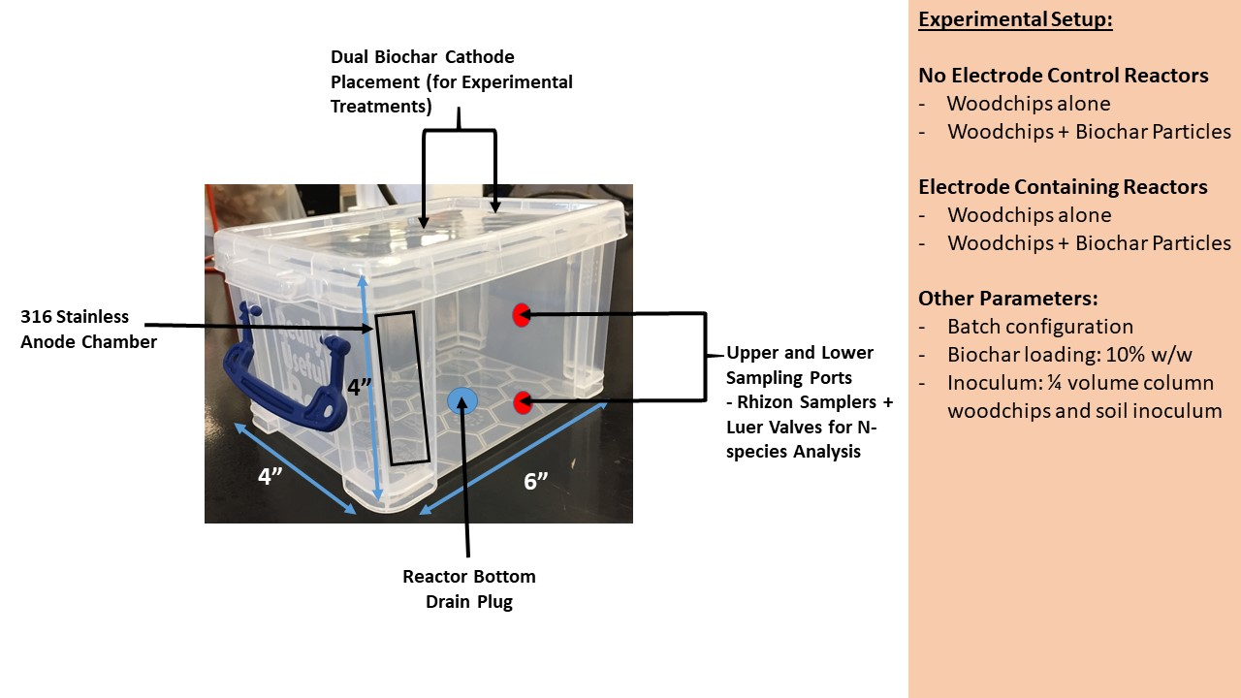
Figure 1. Bioreactor design and experimental set-up.

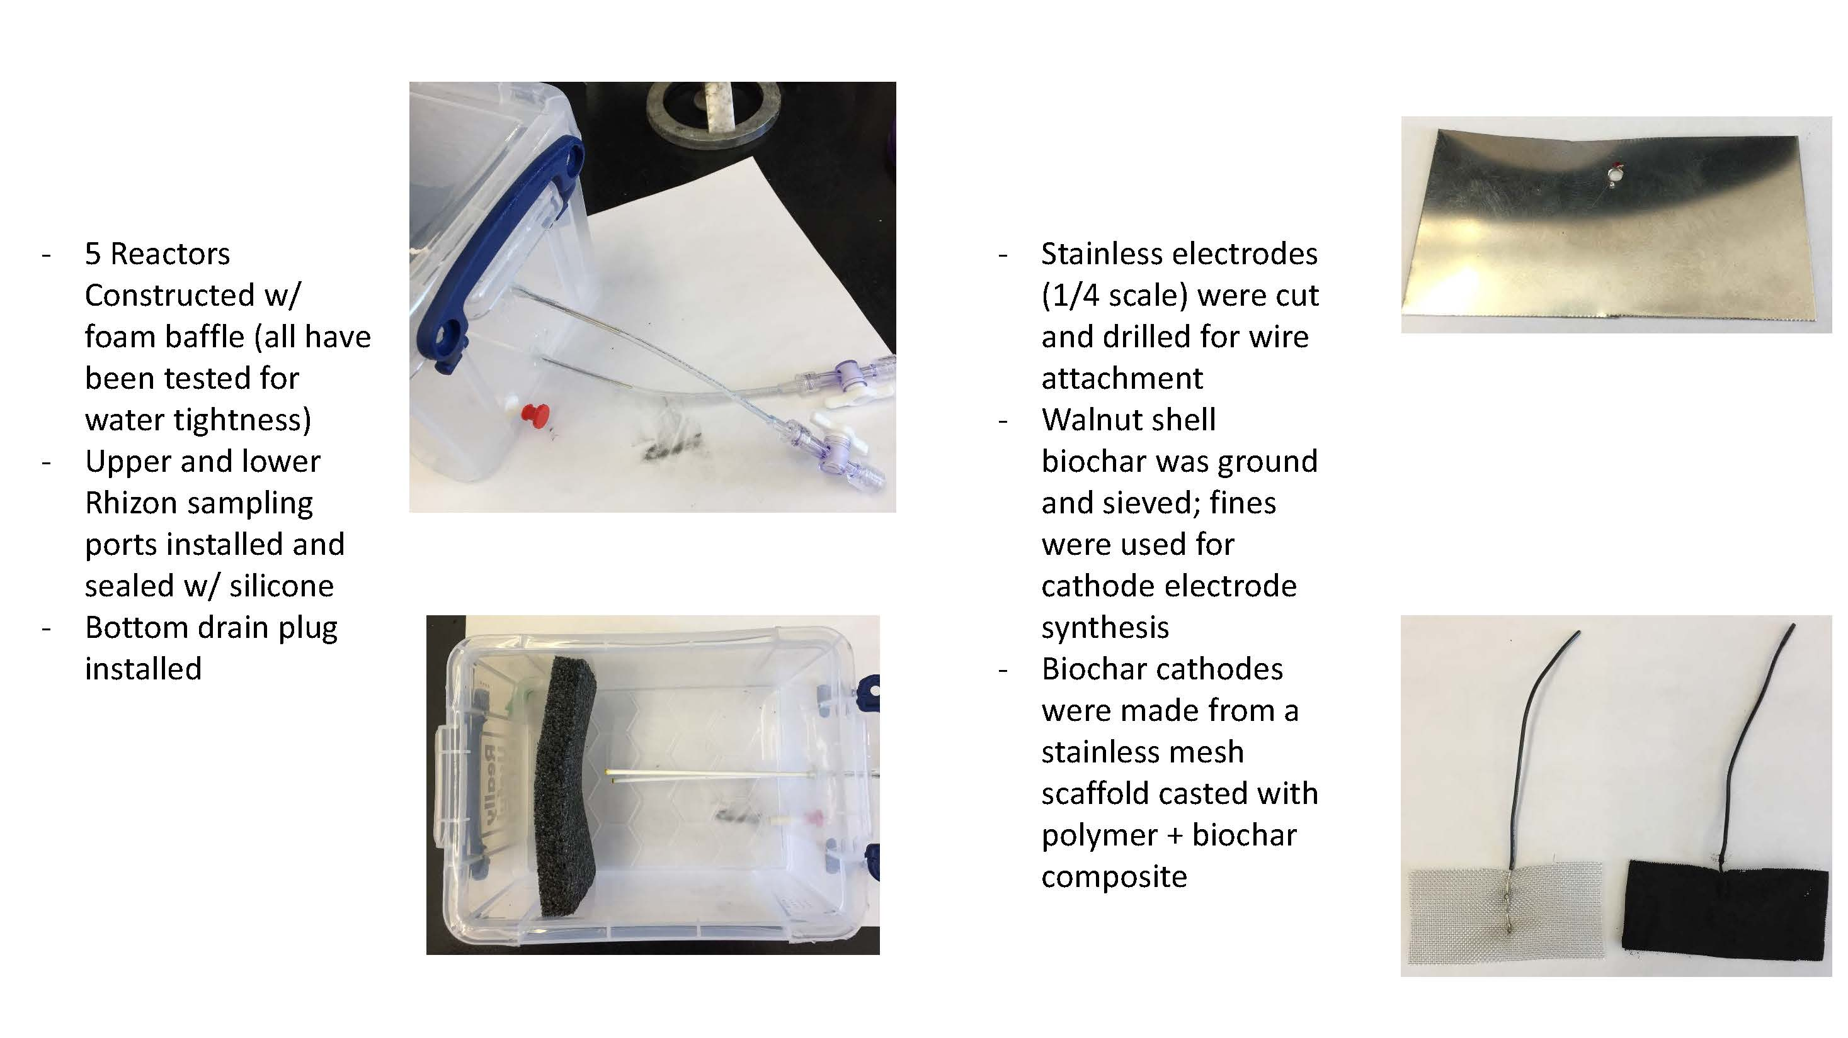
Figure 2. Bioreactor design details.

Upon completion of fabricating the mesocosim scale bioreactors, a graduate student from the College of Biological Sciences, Biotechnology Institute and under the direction of Dr. Behrens undertook experimentation. The details of the experiment including results, discussion and conclusions are included below.

Electrochemical stimulation of microbial denitrification in biochar amended woodchip bioreactor

Update: November 12, 2018
Author: Aaron Pauleon (MicE graduate student)
Advisor: Dr. Sebastian Behrens (Assoc. Prof CEGE/BTI)

Summary: Based on the reports of a manuscript from Law et al. 2018, this demonstration experiment included four batch reactors with varying treatments which were assessed for denitrification. These treatments included: a woodchip control, woodchips plus 10% by volume biochar, woodchips plus electric current, and woodchips plus biochar + electric current. Electrical current was applied through two graphite electrodes (cathodes) and a stainless-steel anode at a current area of 1.1 A/m² and eventually 1.93 A/m². Bioreactors were continuously operated for five months but only periodically amended with nitrate and only sampled for 24 hours following each nitrate addition. Based on first analysis of obtained data, the two reactors with electric current present exhibited less efficient NO₃/NO₂ removal within the first 8 hours of sampling compared to the other treatments (with near complete removal by 24 hours observed for every reactor). Nitrate removal ranged between 70 and 80% within 8 hours for every reactor until the current was increased. There was an unexpected difference in water coloration between the electrode and non-electrode reactors. The lack of replication limited statistical power, and the current method of surface dosing of nitrate solution resulted in inconsistencies for early sampling.

Results:
Nitrate concentration measurements at time zero (T0), immediately following nitrate addition, were highly variable due to diffusion limitations in the unstirred batch reactors (Figure 1). Differences in removal rate appear to be different between electrode, shown in gray and yellow, compared to non-electrode conditions, shown in orange and blue (Figure 1). Red arrows indicate dates (of nitrate addition. A vertical black dashed line arrow indicates the point in time, September, 21, when electrical current was increased from 5.5 mA (1.1 A/m²) to 9.5 mA (1.93 A/m²).

Figure 1. Nitrate concentrations in the four different woodchip bioreactors.

The two batch reactors with graphite electrodes (gray and yellow lines) appeared to have less denitrification reduction efficiency than the non-electrode- containing reactors (orange and blue lines) (Figure 2). The non-electrode reactors seemed to have had a more stable performance over the course of the summer, however fall sampling periods revealed large differences between the electrode and non-electrode operating conditions. Red arrows indicate dates of nitrate addition. A vertical black dashed line arrow indicates the time point when the current was increased from 5.5 mA (1.1 A/m²) to 9.5 mA (1.93 A/m²) (on 9/21). Concerning data analysis, if the nitrate concentration at time zero, T0 hours, was different between reactors due to mixing limitations, the nitrate concentration from hour two (T2) was used as the reference point for the calculation of percent nitrate removal. Four sampling points were missing between 8_6 and 10_27; they needed to be reanalyzed.

Figure 2. Percent NO_{x} (nitrate + nitrite) removal over time in woodchip bioreactors with and without electrochemical stimulation.

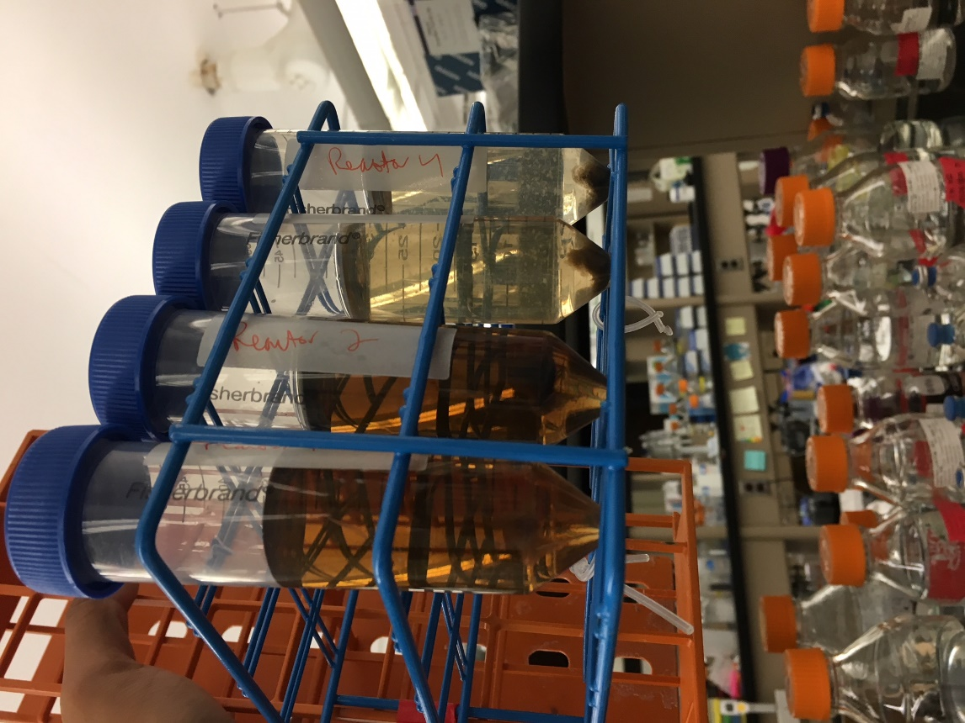
Figure 3. Change in reactor water coloration.

The water samples shown were drawn from top of each respective reactor (Figure 3). Each water sample was centrifuged, resulting in biomass pellets of variable sizes (visibly larger for the electrode reactors). The water from the non-electrode reactors (two tubes on the left) appeared brown/amber in color, while the water sampled from the electrode containing reactors (two tubes to the right) appeared “yellowish” clear. The pH of each reactor water sample was recorded as follows: from left to right, WC: 6.9, WC+BC: 6.85, WC+E: 6.42 and WC+BC+E: 6.98.

Data discussion and Conclusions
Due to experimental limitations, we could not determine differences in treatments through robust statistics for any treatments in this project. The purpose of the project was a proof-of-concept, thus of limited scope, demonstration of the feasibility of electrocatalytic denitrification to reduce nitrate from agricultural runoff compared to simpler systems designed for denitrification. Under the conditions and configuration used in this demonstration electrocatalytic denitrification did not appear to be advantageous for reducing nitrate. Woodchips alone appeared to perform as well or better than other treatments. Biochar had no discernable effect on the efficiency of nitrate removal. Following a voltage increase, the electrode containing reactors decreased in nitrate removal efficiency compared to the start of the experiment. Differences in reactor water coloration were found in the presence and absence of electric current that warrant further investigation. An alternative reactor design (specifically considering the electrode to reactor depth and volume) may increase the effect of electrolysis within the media beyond what was previously reported (Law et al., 2018); increasing dissolved oxygen access and preventing stable anoxic conditions. Another design modification that may improve performance would be the use of flow-through reactors.

Background

Reactor Specifications
- Container: “Really Useful Box”
  - 2L measured interior volume
  - 11.3x12x15.9cm
- Woodchips:
  - Cut to .25 to .5-inch pieces from old field-scale woodchip reactor
  - Submerged and inoculated 3 days with soil prior to placement in reactors
- 1L of reactor volume occupied by woodchips/biochar (biochar occupies 100ml of +biochar reactors)
- Biochar
  - Walnut shell biochar
  - Size: passing size 10 sieve, captured by size 60 sieve
- 800 mL of DI water into each reactor.
- Anode: stainless steel sheet
  - Dimensions: 10 x 0.005 x 3.52cm
  - Surface area: 70.54 cm² (49.3 submerged)
  - Insulated tin wire soldered to the top
- Cathodes (2): graphite cylinders
  - Dimensions: 10 cm x 0.5cm radius
  - Surface area: 32.99cm² (25.13 submerged)
  - Small hole drilled into the top
  - Insulated tin wire placed within the small hole
  - Silicone sealant applied to protect the graphite/wire junction
- Cathodes placed 6.5 cm away from each other and 9 cm away from the Anode

Power Supply
- Fisher Scientific FB300
- Current Applied
  - 5.5mA, 1.1 A/m² (before 9/17)
  - 9.5mA, 1.93 A/m² (after 9/21)
- Power would be applied continuously for at least 2-3 days at a time, with 6-8 hours of downtime if the power supply lost power (this would happen regularly)
- The applied current was increased on 9/21, as measurement by multimeter revealed the power supply was applying the current in parallel. A near 2 A/m² was initially desired and was attained with this increase.
Dosing and Sampling
- Bring reactors to 22.21 mg/L NO₃⁻ and 0.33 mg/L PO₄²⁻
  - 100x solution delivered via syringe into top of reactor media. Shake slightly.
  - This was done every 2-3 days regardless of sampling schedule
- Sample 1.5 mL of each reactor immediately before and after Nitrate/Phosphate dosing.
  - Using separate 3 mL syringes
  - Repeat for 2,4,6,8, and 24 hours.
  - Samples centrifuged and stored -20ºC
Sample Analysis
- SEAL Flow Analyzer AA3
  - Used to process water samples for Nitrate and Nitrite (NO₃/NO₂) or Ammonium
  - Reduces all Nitrate to Nitrite prior to colorimetric detection
  - XY-2 Sampler draws from open air cups
  - 550 nm Lamp

References
Islam, S. and M.T. Suidan. 1998. Electrolytic denitrification: long term performance and effect of current intensity. Water Research. 32:528-536.

Law, J., M.L. Soupir, D.R. Raman, and T.B. Moorman. 2018. Exploring multiple operating scenarios to identify low-cost, high nitrate removal strategies for electrically-stimulated woodchip bioreactors. Ecol. Eng. 120:146-153.

Law, J., M.L. Soupir, D.R. Raman, T.B. Moorman, and S.K. Ong. 2017. Electrical stimulation for enhanced denitrification in woodchip bioreactor: Opportunities and challenges. Ecol. Eng. 110:38-47.

Mook, W.T., M.H. Chakrabarti, M.K. Aroua, G.M.A. Khan, B.S. Ali, M.S. Islam and M.A. Hassan. 2012. Removal of total ammonia nitrogen (TAN), nitrate and total organic carbon (TOC) from aquaculture wastewater using electrochemical technology: A review. Desalination. 285:1-13.

Prosnansky, M. Y. Sakakibara and M. Kuroda. 2002. High-rate denitrification and SS rejection by biofilm-electrode reactor (BER) combined with microfiltration. Water Research. 36: 4801-4810.

Sakakibara, Y. and T. Nakayama. 2001. A novel multi-electrode system for electrolytic and biological water treatments: electric charge transfer and application to denitrification. Water Research. 35:768-778.

