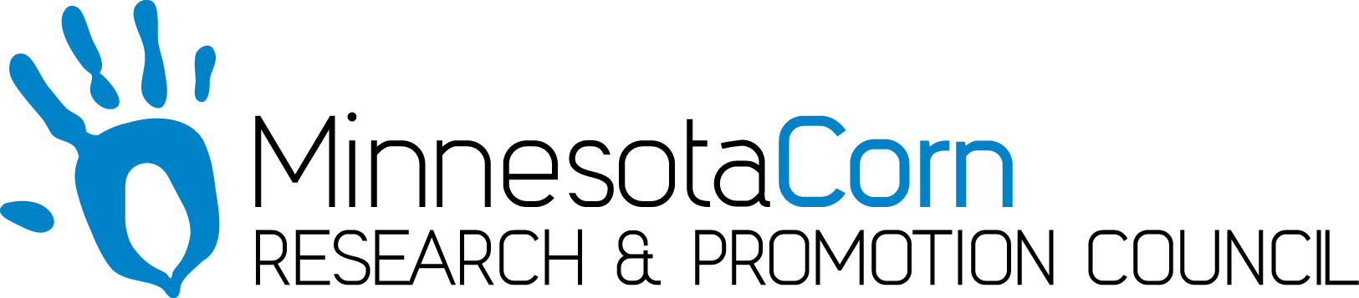

Innovation Grant Progress Report

PROJECT TITLE: Sub surface Drip Irrigation and Nitrogen Management
REPORTING PERIOD: December 2019
FARMER INNOVATOR: Brian Velde
COLLABORATING ORGANIZATION/PERSON: Brian Velde
PHONE NUMBER: 320-295-2670
EMAIL: bvelde@centrol.com

1.) PROJECT ACTIVITIES COMPLETED DURING THE REPORTING PERIOD. (Describe project progress specific to goals, objectives, and deliverables identified in your project proposal.) The system was installed and operation in April 2017. On May 14th 2019 the field was planted and the subsurface irrigation system was operational for the first fertigation application on July 11th. Weekly tissue tests have been taken in both the irrigated acres on checks to track nutrient trends. The goal of the project is to quantify the yield differences in using a subsurface drip irrigation system for both irrigation and fertigation compared to the typical dry land farming practices. This growing season has been very wet so the need for irrigation hasn’t been required but having the ability to run Nitrogen through the system has provided a nice “spoon feeding” approach. Currently this project is on track to provide the deliverables of quantifing yield differences in subsurface drip irrigation versus dry land farming practices.

2.) IDENTIFY ANY SIGNIFICANT FINDINGS AND RESULTS OF THE PROJECT TO DATE. (There may be none to report at some stages of the project)
In 2019 yield response from sub-surface drip irrigation and Nitrogen management showed a 26 bushel response on the lightest soils and a 4-11 bushel increase on the heavier soil types. The historic 5 year dryland yields prior to irrigation have averaged 174 bpa, the last 3 years (2017,2018,2019) dryland yields average 230.1 bpa while the irrigated yields have averaged 241.2 bpa. Every year the lightest irrigated soils have yielded the highest. The last 3 years irrigation has been minimal due to excessive moisture but Nitrogen management with fertigation has been implemented.

3.) CHALLENGES ENCOUNTERED. (Describe any challenges that you encountered related to project progress specific to goals, objectives, and deliverables identified in the project proposal.)
When demonstrating a new innovative sub-surface drip irrigation system throughout 3 years of ample/excessive annual rain fall has definitely been a challenge.

4.) EDUCATION AND OUTREACH ACTIVITES. (Describe any opportunities to engage with farmers, influencers or the media about your project.)
In October of 2019 we hosted the US Grain council with visitors from the middle east and Africa regions. Throughout the year the project has been highlighted in several local newspapers. I’ve advocated the project and the MN corn growers innovation grant program at many field days including the Commodity Classic in Orlando, FL last February, Hefty field day in Baltic, SD in July, and several grower conversations.

5.) HOW CAN WE HELP? (Please let us know how we can improve the experience or assist in your project if possible.)
I feel that throughout the last 3 years the MN corn growers has done a great job in assisting with the project.

