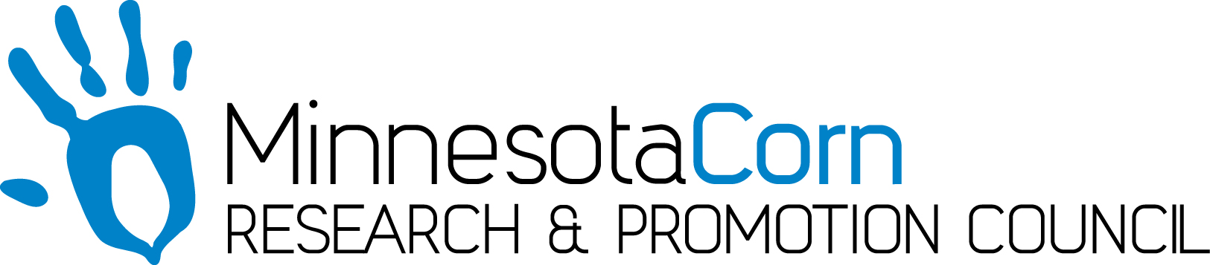

Innovation Grant Progress Report

PROJECT TITLE: Subsurface Drip Irrigation and Nitrogen Management
REPORTING PERIOD: July 2019
FARMER INNOVATOR: Brian Velde
COLLABORATING ORGANIZATION/PERSON: Brian Velde
PHONE NUMBER: 320-295-2670
EMAIL: bvelde@centrol.com

1.) PROJECT ACTIVITIES COMPLETED DURING THE REPORTING PERIOD. (Describe project progress specific to goals, objectives, and deliverables identified in your project proposal.) The system was installed and operation in April 2017. On May 14th 2019 the field was planted and the subsurface irrigation system was operational for the first fertigation application on July 11th. Weekly tissue tests have been taken in both the irrigated acres on checks to track nutrient trends. The goal of the project is to quantify the yield differences in using a subsurface drip irrigation system for both irrigation and fertigation compared to the typical dry land farming practices. This spring has been very wet so the need for irrigation hasn’t been required but having the ability to run Nitrogen through the system has provided a nice “spoon feeding” approach. Currently this project is on track to provide the deliverables of quantifing yield differences in subsurface drip irrigation versus dry land farming practices.

2.) IDENTIFY ANY SIGNIFICANT FINDINGS AND RESULTS OF THE PROJECT TO DATE. (There may be none to report at some stages of the project)
Last Monday’s set of tissue tests was interesting in that the corn in the drip irrigation had sufficient nitrogen levels while the dryland corn (40 feet away) indicated a deficiency. My hypothesis is that because we are spoon feeding the nitrogen at key growth stages, we are able to keep levels sufficient. The dryland nitrogen was applied prior to planting and with the excessive spring rains a portion of the nitrogen is not in the root system causing the plant to exhibit deficiency symptoms.

3.) CHALLENGES ENCOUNTERED. (Describe any challenges that you encountered related to project progress specific to goals, objectives, and deliverables identified in the project proposal.)
The biggest challenge was the wet conditions this spring caused delayed planting and a portion of the field was unable to be planted. The unplanted area will not compromise the statistical analysis at the end of the year.

4.) EDUCATION AND OUTREACH ACTIVITES. (Describe any opportunities to engage with farmers, influencers or the media about your project.)

I’ve had several farmers call from around the United States inquiring about this project as they read about it in many publications and farm magazines. Our biggest success was the field day and outreach we did in August of 2017 in which 250 farmers from MN, IA, WI, NE attended. Many MN corn grower board members attended and Paul Meints gave several promotional advocations for the innovation grants throughout the day. Over the last 3 years people from Zimbabwa, South Aftrica, Isreal and Canada have toured the project along with over 75 MN NRCS and Soil Conservation personal

5.) HOW CAN WE HELP? (Please let us know how we can improve the experience or assist in your project if possible.)
The MN corn growers has been very helpful when needed.

