Progress Report

PROJECT TITLE: Recovery and use of value-added corn functional ingredients
PROJECT NUMBER:
REPORTING PERIOD: July 31, 2019
PRINCIPAL INVESTIGATOR: Padu Krishnan
ORGANIZATION: South Dakota State University
PHONE NUMBER: 574-440-9215
EMAIL: Padmanaban.krishnan@sdstate.edu

1.) PROJECT ACTIVITIES COMPLETED DURING THE REPORTING PERIOD. (Describe project progress specific to goals, objectives, and deliverables identified in the project workplan.)

Current extraction techniques employed in SDSU have improved color and texture of DDG through controlled washing and milling.

Drying of wet DDG is now more efficient with the acquisition of a scientific freeze dryer. Recovery of 59.8% dry matter is now possible without losses. Wet DDG may have moisture levels of up to 70% and such high levels of moisture are an impediment physical and chemical extraction techniques. Freeze dried starting materials are more conducive to conducting mass balance studies as better control is achieved and solvent use is better managed.

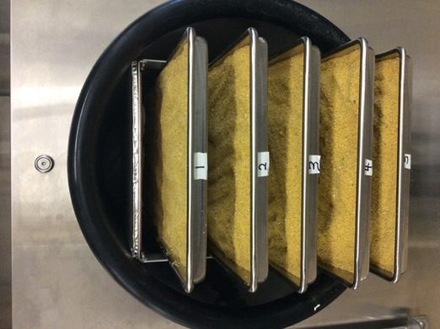

Fig. 1. Freeze-drying using Harvest Right Freeze Dryer (left), dried DDG (Center), and fine ground and coarse FDDG (right).

Brightness values (L) of FDDG have now reached 90 (on a scale of 1 to 100) with batch-to-batch reproducibility.

Particle size distribution of DDG ground using a 0.2mm and 0.5 mm mesh mill sieve is currently being investigated. Effects of particle size on bread dough rheology and food texture is being evaluated by MS Food Science Graduate student Patra Akaya. Effects of wheat flour blends fortified with up to 20% FDDG are being studied to establish moisture uptake, dough mixing properties and gas retention capabilities.

An automated Total Dietary Fiber Analyzer was acquired through a 2019 federal National Institute of Food and Agriculture Grant and matching support from General Mills Inc. This instrument measures the total dietary fiber content of food materials after a sequential multi-enzyme treatment, rinsing, precipitation using ethanol and filtration steps. FDDG has as much as 40% TDF on a dry weight basis. Fiber constituents are beneficial in human nutrition and health. This instrument is helpful in establishing TDF content of both DDG and DDG fortified foods developed in our labs.

Graduate student Tanvee Deshpande successfully defended her thesis involving food quality standards for Food Grade Distillers Grains in May, 2019.

Graduate student Kara Konst completed her MS research project involving FDDG enrichment of Instant Asian Noodles in May 2019.

One new area of fortification envisaged includes meat products where FDDG will serve as a fiber and protein ingredient as well as a texturizer.

2.) IDENTIFY ANY SIGNIFICANT FINDINGS AND RESULTS OF THE PROJECT TO DATE.

Table 1 below shows significant improvements in Instant Asian noodles fortified with 10% and 20% FDDG in relation to protein content, Fiber content (TDF%) as well as Total Phenolic Content (TPC%)

Table 1. Proximate composition of Asian noodles fortified with distillers grains and oat flour.
___________________________________________________________________________________
Constituent | Control  100W | 90W: 10OF | 80W: 20OF | 90W: 10D | 80W: 20D | 70W:10D:20OF | 70W:20D:10OF
Fat (%) | 0.55e | 0.76d | 0.89c | 0.59e | 0.83c | 1.12b | 1.47a
 | (±0.01) | (±0.03) | (±0.00) | (± 0.03) | (± 0.03) | (± 0.05) | (±0.01)
Protein (%) | 12.72g | 13.2f | 14.09e | 15.04d | 17.46b | 16.18c | 17.94a
 | (±0.05) | (±0.05) | (±0.07) | (±0.00) | (±0.02) | (±0.03) | (±0.01)
Ash (%) | 0.95c | 0.88d | 0.86de | 0.98c | 1.04b | 1.09a | 0.82e
 | (±0.02) | (±0.02) | (±0.01) | (±0.01) | (±0.03) | (±0.03) | (±0.01)
Moisture (%) | 6.95c | 8.16c | 7.13c | 6.27d | 6.17d | 8.85a | 8.82a
 | (±0.07) | (±0.13) | (±0.13) | (±0.13) | (±0.01) | (±0.09) | (±0.01)
TDF (%) | 3.38g | 5.12f | 6.95d | 5.92e | 12.77b | 8.02c | 14.39a
 | (±0.01) | (±0.2) | (±0.20) | (±0.49) | (±0.26) | (±0.24) | (±0.23)
Available CHO (%) | 75.46a | 71.88b | 72.00 | 71.20c | 61.72e | 64.73d | 56.56f
 | (±0.09) | (±0.04) | (±0.15) | (±0.56) | (±0.25) | (±0.29) | (±0.25)
Total Phenolic (μg/g) | 30.50d | 35.00d | 46.00c | 54.00c | 90.50a | 71.50b | 92.50a
 | (±3.53) | (±2.83) | (±2.83) | (±0.00) | (±2.12) | (±3.54) | (±6.36)
Calories (kcal/100g) | 357.66 | 347.20 | 354.44 | 350.23 | 324.23 | 333.76 | 311.19
Amt. ser. TA/50g Av CHO | 66.26 | 69.56 | 68.94 | 70.22 | 81.01 | 77.24 | 88.40
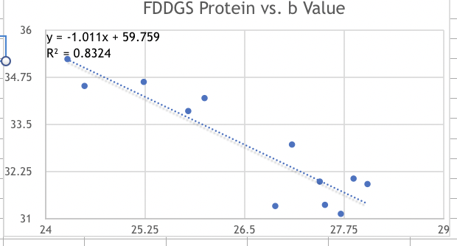

Figure 2. Plot showing interrelation ship of pigments and protein content in DDGS. Protein content in DDGS was inversely proportional to b values (pigments responsible for yellowness in corn).

The work of Graduate student Brady Bury relates processing techniques with the fate of bioactive constituents (Carotenoids, antioxidants, phenolic compounds, etc.). This information will assist in optimizing extraction, minimize solvent use, and minimize deleterious effects from unintended removal from the corn fraction. Understanding of inherent relationships of useful moieties within the DDG or DDGS matrix may help us to tailor processing techniques.

3.) CHALLENGES ENCOUNTERED. (Describe any challenges that you encountered related to project progress specific to goals, objectives, and deliverables identified in the project workplan.)

Work on standardizing and automating extraction protocols using the ACE solvent extractor is progressing well. Graduate student Brady Bury has made significant progress in his MS graduate research project.

4.) FINANCIAL INFORMATION (Describe any budget challenges and provide specific reasons for deviations from the projected project spending.)

There are no budget challenges.

5.) EDUCATION AND OUTREACH ACTIVITES. (Describe any conferences, workshops, field days, etc attended, number of contacts at each event, and/or publications developed to disseminate project results.)

Abstracts submitted to the American Association of Cereal Chemist International were accepted for scientifc presentation. Two of these dealt with standards and specification for a food grade DDG (FDDG) and the extraction of useful pigments and antioxidants form corn and corn fractions.

My research crew attended the DGTC Distillers Grains Technology Conference in Minneapolis in June 2019.

My research staff attended and presented three posters on corn utilization at the Institute of Food Technologists Conference in New Orleans, July, 2019.

A manuscript on Chinese Steamed bread fortification with food grade DDG was submitted to the Journal of Food Science and Nutrition. The paper is currently under peer review.

Several SDSU research scientists have begun collaboration with JB Meyers Industries, SD, on potential technologies for large-scale supercritical CO2 extraction of DDG for recovery of oils and other corn components.

A survey of the ethanol production industry is underway to determine the prospects and potential for value enhancement of corn in food, feed and pharmaceutical applications.

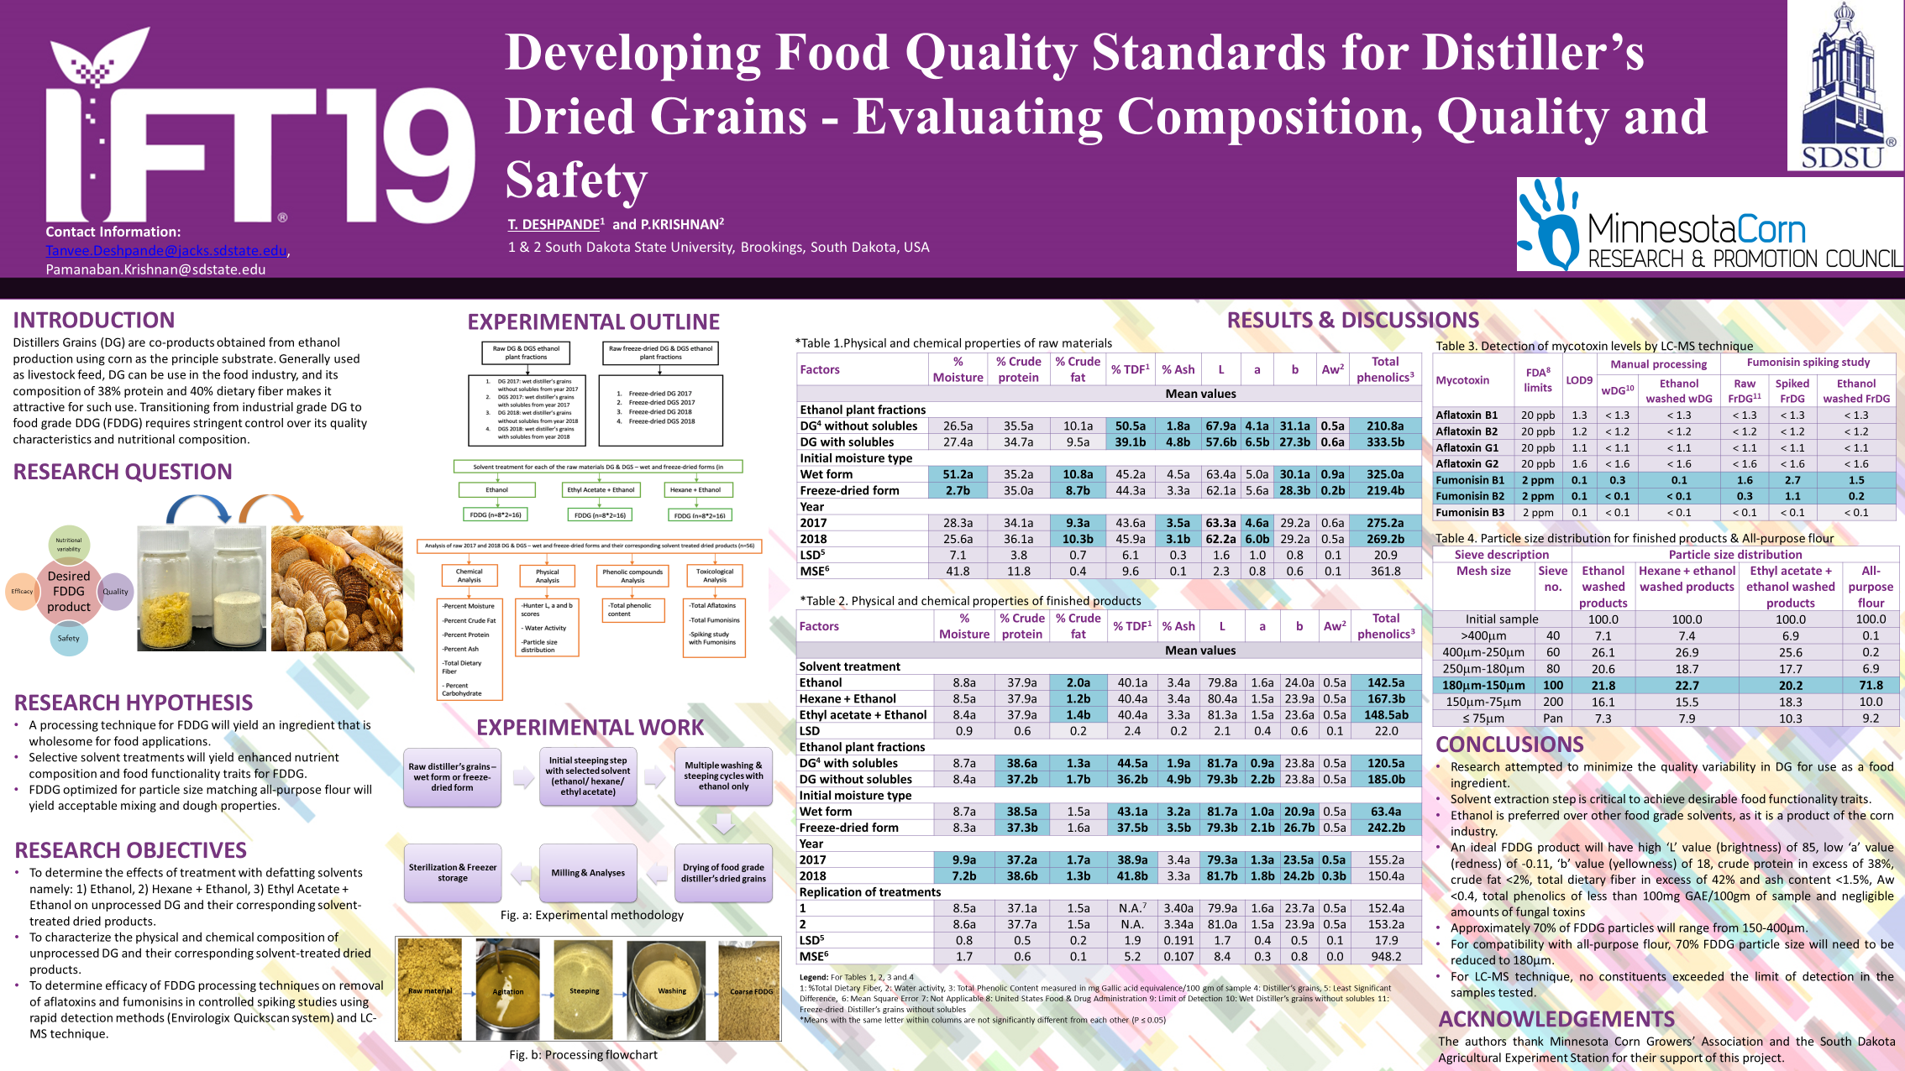
Figure 3. Poster on Food grade standard for Distillers Dried Grains.
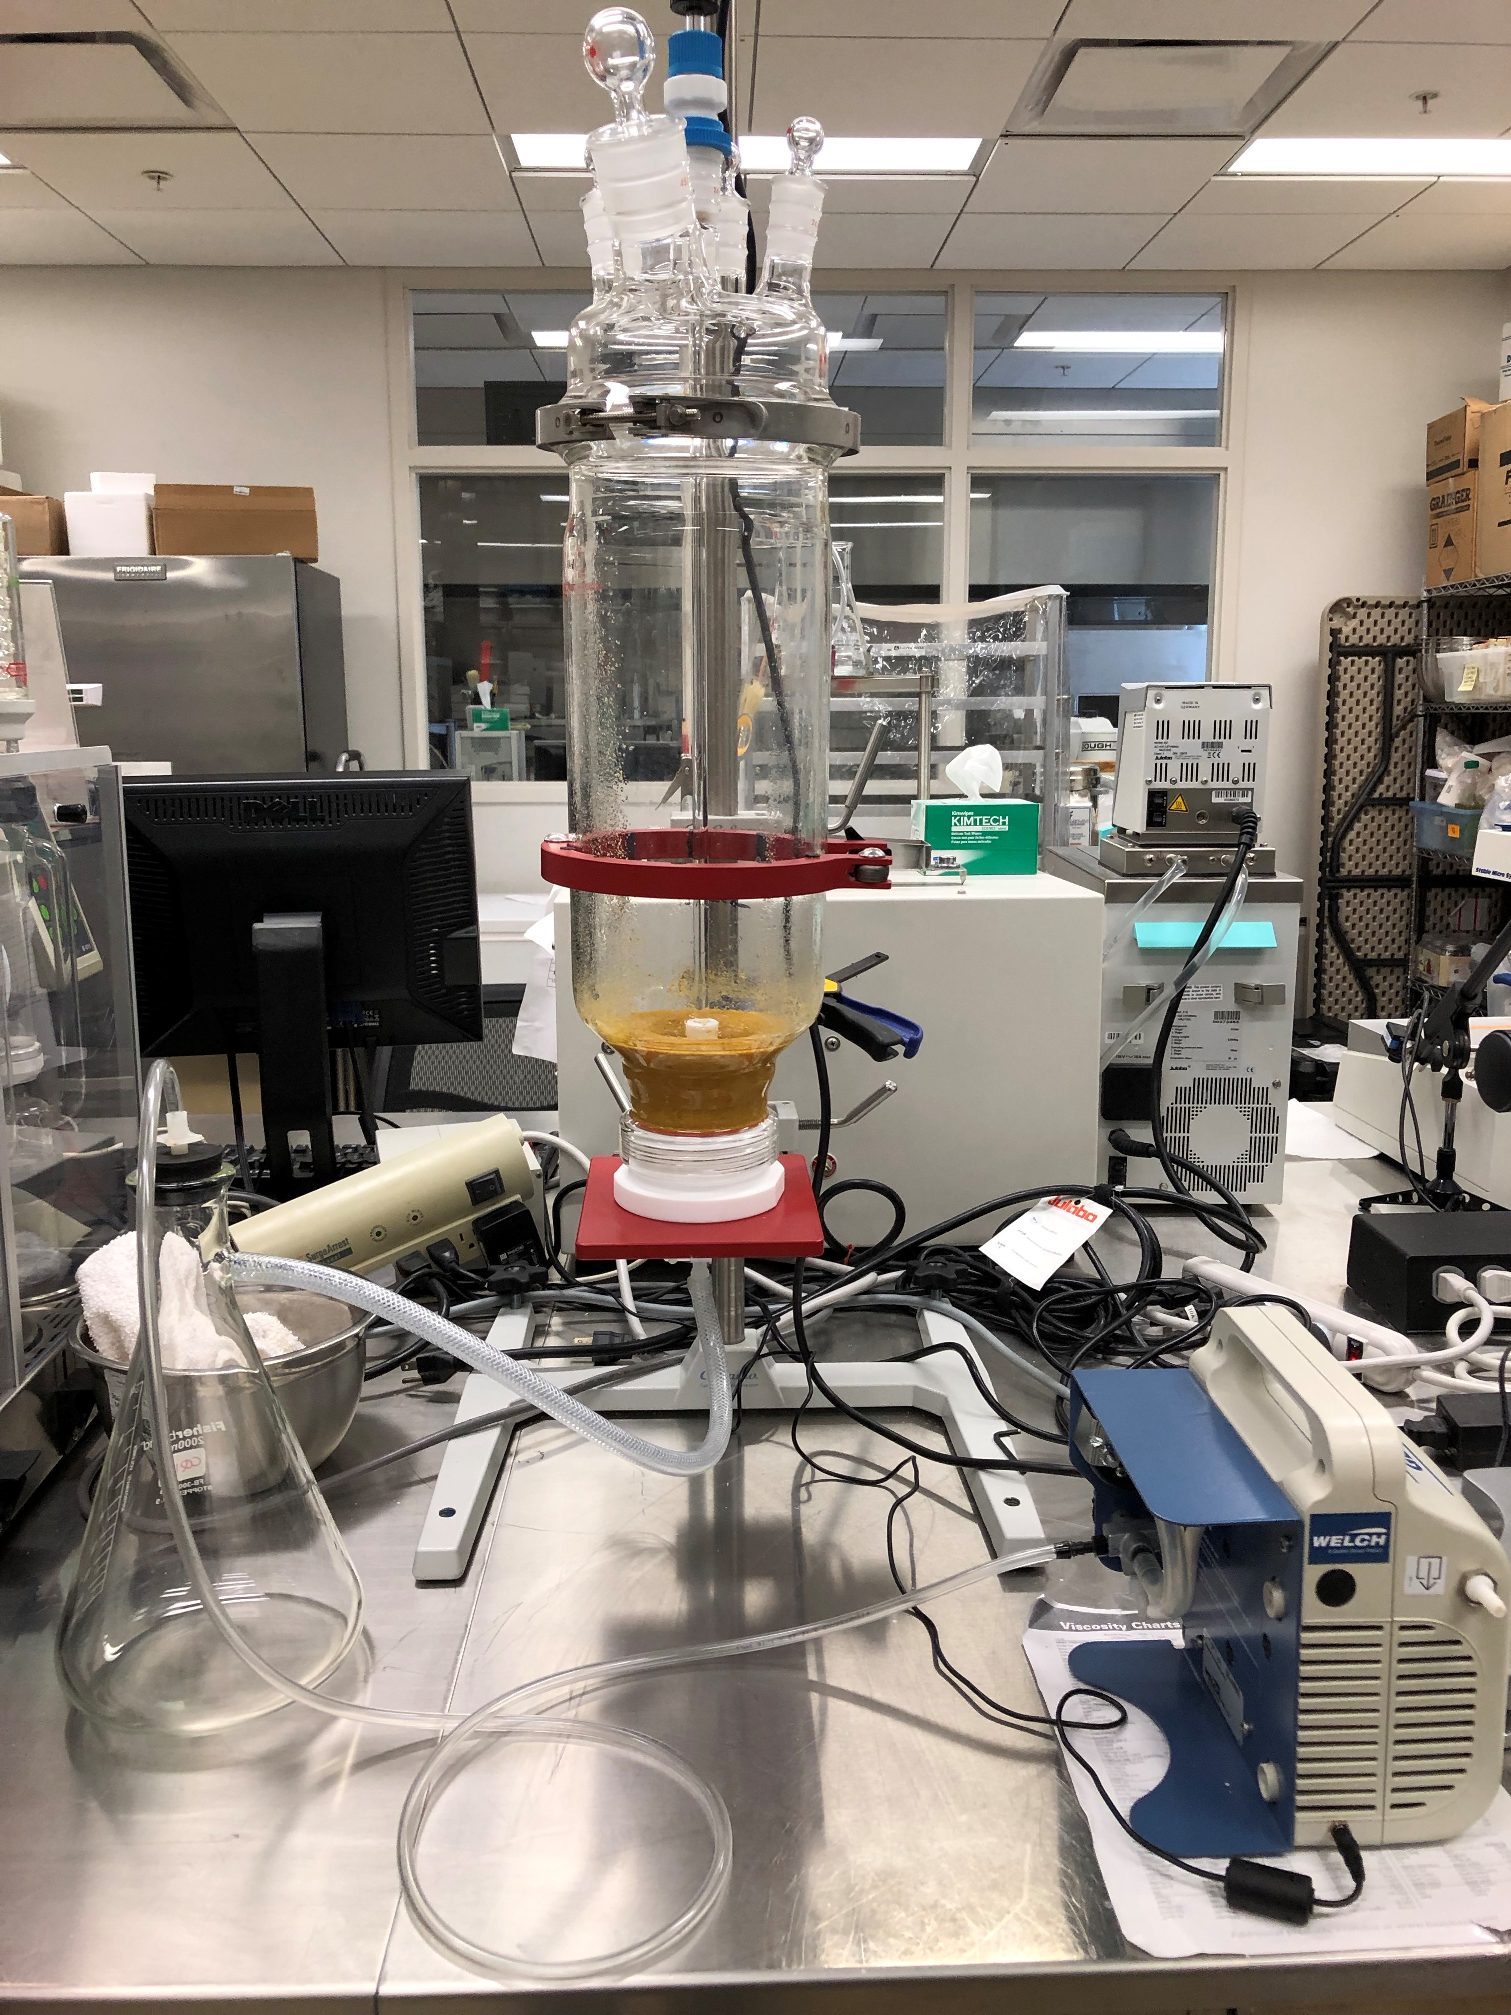
Figure 4. ACE apparatus for optimizing extraction and recover conditions for bioactive compounds from corn DDG.

Table 2. Color characteristics of raw materials and finished products
(L= brightness, a=redness & b=yellowness)

SAMPLE | L* | a* | b*
Wet DDG (Unwashed) | 80.27 | 5.17 | 37.64
 | 77.97 | 5.15 | 36.55
Freeze Dried DDG (Unwashed) | 77.00 | 4.65 | 37.64
 | 79.97 | 5.15 | 36.55
Coarse DDG - Freeze Dried (Washed) | 86.81 | 2.49 | 29.17
 | 86.44 | 2.58 | 29.28
0.2mm Sieve DDG (Washed) | 93.08 | 1.64 | 28.65
 | 94.05 | 1.38 | 28.59
0.5 mm Sieve DDG (Washed) | 90.84 | 1.55 | 28.59
 | 93.67 | 1.89 | 29.82
Super Critical Extracted DDG – Coarse (Un-milled) | 81.69 | 5.29 | 29.10
 | 82.11 | 5.42 | 29.57
Super Critical Extracted DDGS (Un-milled) | 60.17 | 9.81 | 29.91
 | 62.90 | 9.88 | 31.71
Super Critical Extracted DDG (Milled – 0.5mm sieve) | 90.12 | 4.67 | 32.02
 | 88.53 | 4.47 | 31.42
Super Critical Extracted DDGS (Milled – 0.5mm sieve | 77.80 | 6.56 | 35.59
 | 77.99 | 6.25 | 35.07

Table 3. Proximate composition of raw material and commercial Supercritical Extracted DDG showing modest fat reduction and protein content increase.

Sample | Crude Protein | Moisture  W/W% | Crude Fat  W/W% | Ash  W/W% | NDF  W/W% | TDF  W/W%
DDG | 37.49 | 5.69 | 3.38 | 5.04 | 30.67 | 40.02
 | 37.59 | 5.71 | 3.27 | 5.05 | 30.03 | 39.86
DDGS | 34.26 | 8.65 | 8.15 | 4.78 | 32.08 | 42.33
 | 34.36 | 8.66 | 8.23 | 4.76 | 32.39 | 42.56

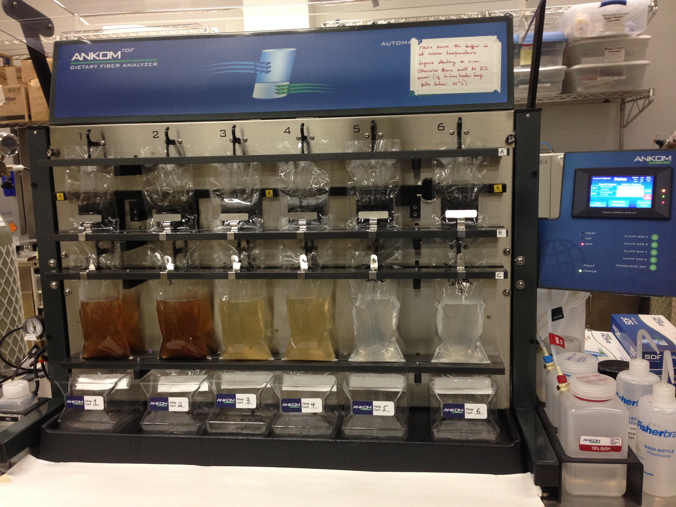
Figure 5. Automated Total Dietary Fiber Analysis system for fiber measurement in cereal-based products.

