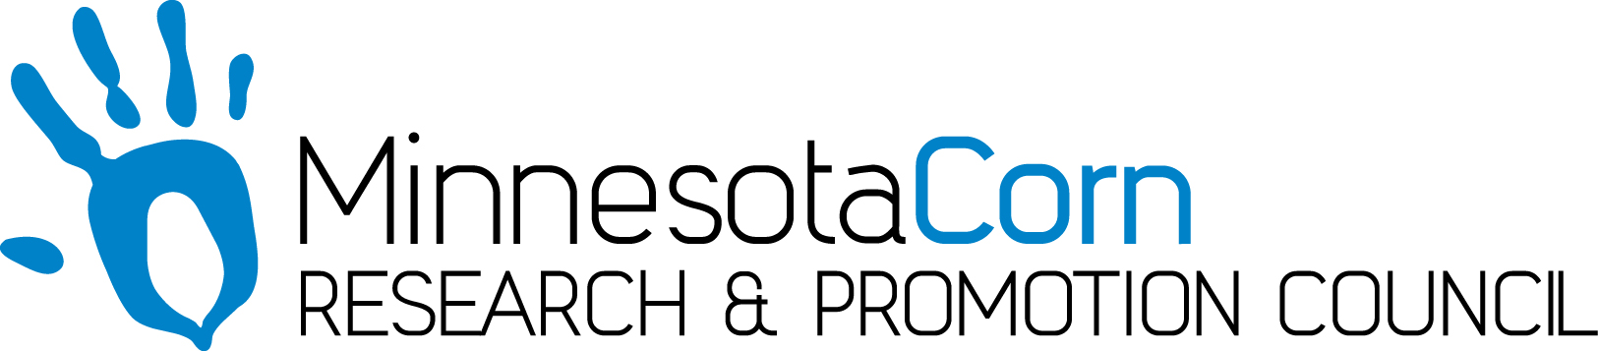

Progress Report

PROJECT TITLE: Pushing the Limits on Nitrate Removal: A Watershed-scale Bioreactor
PROJECT NUMBER:
REPORTING PERIOD: July 2019 quarterly Report
PRINCIPAL INVESTIGATOR: Michele Stindtman
ORGANIZATION: Faribault County Soil and Water Conservation District
PHONE NUMBER: 507-526-3872
EMAIL: michele.stindtman@co.faribault.mn.us

1.) PROJECT ACTIVITIES COMPLETED DURING THE REPORTING PERIOD. (Describe project progress specific to goals, objectives, and deliverables identified in the project workplan.)

During this quarter, equipment has been installed at the bioreactor system inlet, which essentially is the outlet of county tile main CD62, to measure nitrate-N concentration and turbidity at 5-minute intervals. All instruments at the inlet site, including flow, water temperature, electroconductivity, and raingauge are connected to one datalogger. We installed a new 4G telephone modem to which project personnel can connect via a cell phone. We demonstrated the ease of access and the showed the available information to a group of producers and stakeholders on June 27th, which is a large step toward meeting Objective 2/Deliverable 1, “to make weather, flow, and water quality data available online.” The meeting on June 27th, organized by Faribault County SWCD and held at their facility, included two key producers in the watershed. We explained the goal of working toward identifying practices in the watershed that may reduce nutrient and sediment delivery. Thus, progress toward fulfilling project deliverables this quarter was substantial.

2.) IDENTIFY ANY SIGNIFICANT FINDINGS AND RESULTS OF THE PROJECT TO DATE.

Dr. Feyereisen is in the process of summarizing the bioreactor system performance for the initial water years. Flow was restricted through beds 2 and 3 because of poor quality woodchips used in them. Otherwise, the bioreactor beds performed as expected.

3.) CHALLENGES ENCOUNTERED. (Describe any challenges that you encountered related to project progress specific to goals, objectives, and deliverables identified in the project workplan.)

A large storm in June 2018 damaged the bioreactor system, restricting flow due to sediment. Faribault County is working through the process of obtaining FEMA funds to recharge the bioreactor.

4.) FINANCIAL INFORMATION (Describe any budget challenges and provide specific reasons for deviations from the projected project spending.)
Project spending is on target.

5.) EDUCATION AND OUTREACH ACTIVITES. (Describe any conferences, workshops, field days, etc attended, number of contacts at each event, and/or publications developed to disseminate project results.)

A “Lunch and Learn” meeting focused on updating the landowners in the watershed and other project stakeholders was organized by the Faribault County SWCD and held on June 27, 2019. There were 15 people in attendance, which included 2 key landowners, and a local representative of the Corn Growers.

Dr. Feyereisen presented preliminary findings at the stakeholder meeting, at an international land use/water quality conference in Denmark, LuWQ 2019, (50), and at the Annual Meeting of the Agricultural and Biological Engineers (30).

Local staff discussed the sampling collection process. ISG presented the plan for the future tweaks to the site, landowner questions were answered, and a preview of the digital data was presented.

