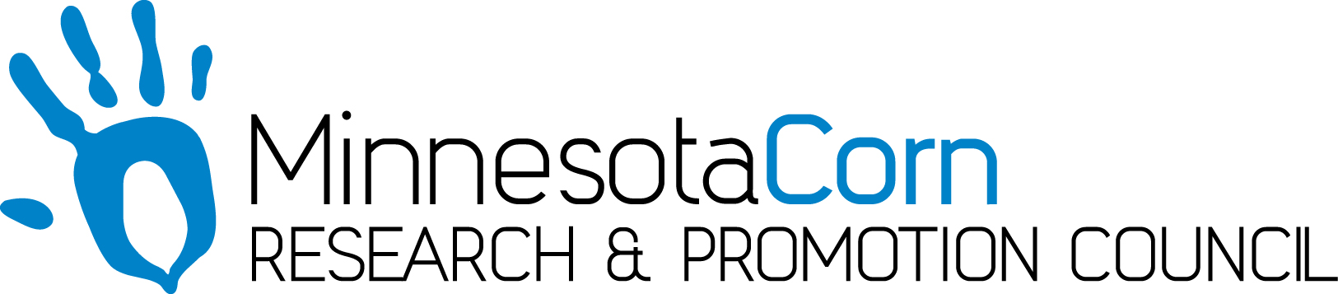

Progress Report

PROJECT TITLE: Assessment of Minnesota’s Soil Mineralogy and Impacts on Fertilizer Guidelines
PROJECT NUMBER:4156-19SP (U of M CON000000077750)
REPORTING PERIOD: Oct. 1 – Dec 31, 2019
PRINCIPAL INVESTIGATOR: Daniel Kaiser
ORGANIZATION: Regents of the University of Minnesota
PHONE NUMBER: 612-624-3482
EMAIL: dekaiser@umn.edu

1.) PROJECT ACTIVITIES COMPLETED DURING THE REPORTING PERIOD. (Describe project progress specific to goals, objectives, and deliverables identified in the project workplan.)

We were busy collecting soil samples from various locations for the lab studies. We have collected four sets of soils which we will use for the study to look at the impact of pH on CEC and K retention on sandy soils. The collection locations were at Lamberton, Becker, Cambridge, and one site in Big Stone County. The soils have been dried and processed and the pH adjustments for the soil will start in February 2020, which is on schedule. We also have collected soil for the K weathering trials from roughly 10 locations. We were planning on colleting soils from additional locations but the cold fall temperatures froze many sites where we could not collect soil. We will finish up soil collecting in spring and early summer of 2020 in order to start the weathering trials sometime in summer 2020. We are following up on the field trial near Mentor to obtain yield data from the site. We have as applied data which will be evaluated to determine how accurate the treatments were applied. We have been busy lining up new trials for 2020. Currently we have 6 locations planned (some sites were applied in fall 2019 and some will be applied in spring). I have been trying to identify additional locations. My target is 12-15 locations for 2020.

2.) IDENTIFY ANY SIGNIFICANT FINDINGS AND RESULTS OF THE PROJECT TO DATE.

Spring 2019 was an establishment year for the study so we have not gathered any data at this time. Soil samples were collected from the trial near Mentor, MN and we have the data back from the lab. We have been busy processing soil samples and prepping for the start of some of the lab work and creating prescription maps to establish field trials for 2020. We should start to get data back from soil samples in Spring 2020.

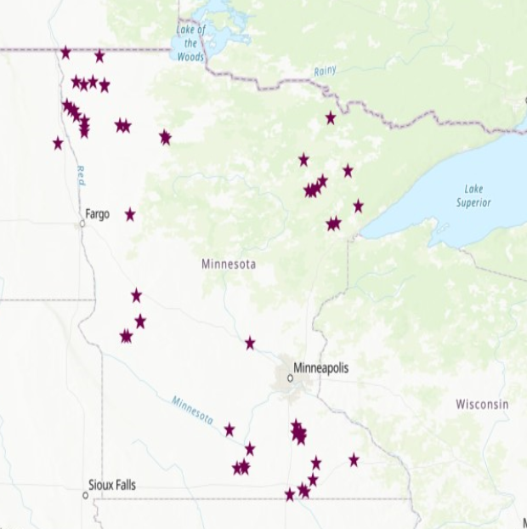
Figure 1. Locations where soil samples were collected and give some data with clay species.

3.) CHALLENGES ENCOUNTERED. (Describe any challenges that you encountered related to project progress specific to goals, objectives, and deliverables identified in the project workplan.)

We have had issues locating field trials. We have 6 in place but I have a few contacts to follow up with made at winter meetings thus far. I would anticipate at least 10 sites at this point based on contacts and site already in place for 2020 which was the original plan. I do have funding for additional sites so we will include as many locations as possible for 2020 beyond the 10 sites planned.

4.) FINANCIAL INFORMATION (Describe any budget challenges and provide specific reasons for deviations from the projected project spending.)

Samples were submitted to ActLabs in Canada for mineralogical analysis. I requested an extension and re-budgeting for the 2019-2020 grant to move funds from labor which I did not need over to sample analysis. With the current rebudget and the 2020-21 request I am hoping to be able to complete some of the work not related to field studies in the second funding year. Figure 1 should information available to use from web soil survey but we are finding the data is lacking in detail for what is needed to map clay species. It is likely we will have to go back through the data and determine where we may need to collect soil samples to fill in gaps where we do not have field trials in order to get the information we need to build the GIS maps. The survey would should be able to be completed in Summer/Fall 2020 with the funding request made for year 2.

5.) EDUCATION AND OUTREACH ACTIVITES. (Describe any conferences, workshops, field days, etc attended, number of contacts at each event, and/or publications developed to disseminate project results.)

I presented past data and spoke about the current K trial at the Crop input seminar in Hutchinson to about 50 farmers and ag professionals.

I also utilized information from this project in the following crop e-news articles.

https://blog-crop-news.extension.umn.edu/2019/10/corn-and-soybean-potassium-fertilizer.html

https://blog-crop-news.extension.umn.edu/2019/10/fall-fertilizer-economics-what-to-know.html

https://blog-crop-news.extension.umn.edu/2019/11/precision-agriculture-and-nutrient.html

