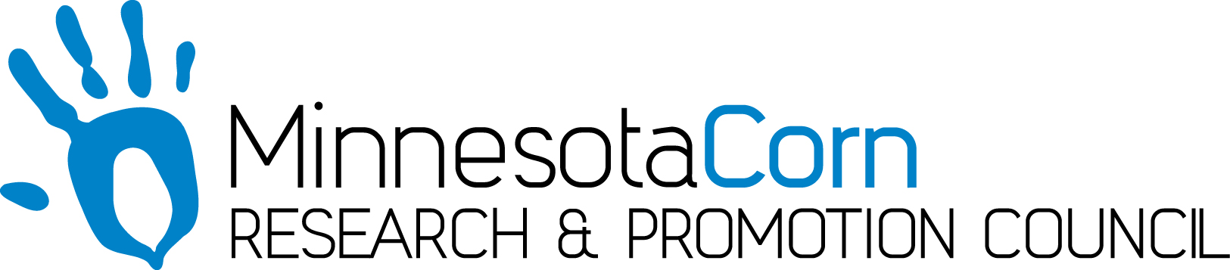

Progress Report

PROJECT TITLE: Assessment of Minnesota’s Soil Mineralogy and Impacts on Fertilizer Guidelines
PROJECT NUMBER:4156-19SP (U of M CON000000077750)
REPORTING PERIOD: July 1 – Sept 30, 2019
PRINCIPAL INVESTIGATOR: Daniel Kaiser
ORGANIZATION: Regents of the University of Minnesota
PHONE NUMBER: 612-624-3482
EMAIL: dekaiser@umn.edu

1.) PROJECT ACTIVITIES COMPLETED DURING THE REPORTING PERIOD. (Describe project progress specific to goals, objectives, and deliverables identified in the project workplan.)

For the field trial established, we collected soil samples which will be processed over the winter. I was able to take on a Ph.D. student for the project, Leanna Leverich, whom previously completed a M.S. program with me. Leanna has been working on locating sites and establishing yield maps to send out to cooperators for Fall fertilizer application. We also started locating soils for the lab portion of the study. We have targeted 3, possibly 4 soils for portion of the study related to the impact of pH on CEC and K holding capacity. We need to start incubations to modify the soil pH over the winter in order to keep with the trial objectives. We also identified locations for the second lab study focused on weathering of K from sands. We have a plan in place to start collecting soil for the weathering study fall 2019 but will likely not have this work finished until summer 2020 which is in line with the work plan for the study. Leanna also has been in contact with Matt Wiebers about the possibility of sharing some of his K data from his on-farm work to combine with this project to extend the number of locations where K response data are collected. Matt’s project is slightly different in that he does not have multiple K rates in place but the yield data can be utilized with soil data to compare K response with soil chemical properties. We also have identified projects with archived soil samples to send out to ACT labs. We will be sending those samples out after fall field work ends.

2.) IDENTIFY ANY SIGNIFICANT FINDINGS AND RESULTS OF THE PROJECT TO DATE.

Spring 2019 was an establishment year for the study so we have not gathered any data at this time. Soil samples were collected from the trial near Mentor, MN. Leanna went through data available on the web soil survey. The attached image shows points where clay data are available. We wanted to see if any information was available and utilize that data along with data collected to try to lessen the need for future soil samples. Some of the data available may be used but other data will likely not be usable. The map shows significant gaps in data particularly in west central and southwest Minnesota which is a primary target area for our research.

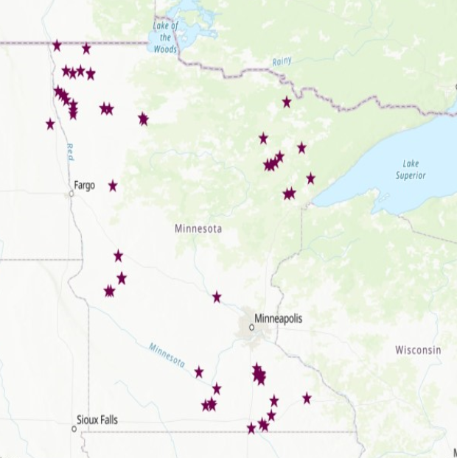
Figure 1. Locations where soil samples were collected and give some data with clay species.

3.) CHALLENGES ENCOUNTERED. (Describe any challenges that you encountered related to project progress specific to goals, objectives, and deliverables identified in the project workplan.)

We are encountering some similar issues with sites for the field trials. With the difficulties harvesting getting growers to agree to field trials has been difficult. Leanna and I have been in contact with consultants about trials and have located roughly half the desired trials at this time. We will continue to work on getting locations to get the desired number of trials for the study.

4.) FINANCIAL INFORMATION (Describe any budget challenges and provide specific reasons for deviations from the projected project spending.)

I will have to request funds be moved from labor to lab analysis to cover costs of soil analysis at an outside lab. Leanna’s Ph.D position is partially funded thorugh a fellowship so I will need to cover around ¼ of her position instead of the planned 100%. There is flexibility in the budget with part of her position being covered to move funds to analysis and get soil clay analysis completed at ACT labs.

5.) EDUCATION AND OUTREACH ACTIVITES. (Describe any conferences, workshops, field days, etc attended, number of contacts at each event, and/or publications developed to disseminate project results.)

My primary method for outreach has been through posts on Minnesota Crop news. I have had several posts outlining past and current work related to K and the project funded by the MN corn growers.

https://blog-crop-news.extension.umn.edu/2019/10/corn-and-soybean-potassium-fertilizer.html

https://blog-crop-news.extension.umn.edu/2019/10/fall-fertilizer-economics-what-to-know.html

https://blog-crop-news.extension.umn.edu/2019/10/fall-fertilizer-economics.html

https://blog-crop-news.extension.umn.edu/2019/08/fall-fertilizer-applications-what.html

https://blog-crop-news.extension.umn.edu/2019/07/5-tips-for-cutting-phosphorus-potassium.html

