Progress Report

PROJECT TITLE: Irrigation management impacts on corn yield and nitrate leaching
PROJECT NUMBER: 00076241 (CON000000077775)
REPORTING PERIOD: April-June 2019
PRINCIPAL INVESTIGATOR: Vasudha Sharma
ORGANIZATION: University of Minnesota
PHONE NUMBER: 612-626-4986
EMAIL: vasudha@umn.edu

1.) PROJECT ACTIVITIES COMPLETED DURING THE REPORTING PERIOD. (Describe project progress specific to goals, objectives, and deliverables identified in the project workplan.)
- This project aims at evaluating the impact of 4 irrigation water management strategies on corn yield and nitrate leaching and to calculate the threshold trigger point for irrigation (comparing depletion in available soil water with soil matric potential) using Electric Resistance Sensors (watermark sensors) in coarse-textured soils. To accomplish these objectives, following activities were performed in this quarter:
  - Irrigation management assistant tool was expanded to Sherburne County for the purpose of this project.
  - Tillage and other seed bed preparation operations were performed at the research site.
  - Soil was sampled for soil texture determination.
  - Corn was planted on May 6th 2019.
  - 12 plots were established and maintained.
  - Suction cup lysimeters for collecting water samples below the root zone were prepared and installed in each plot. 2 lysimeters were installed per plot.
  - 12 Neutron access tubes were installed to measure soil moisture.
  - 28 watermark soil moisture sensors (data is accessed online) were installed in the plots to compare them with neutron moisture meter data to develop tension based irrigation threshold trigger points.
  - Weekly soil moisture data and water samples from lysimeters are collected.
  - Irrigation Uniformity test was performed. The irrigation system uniformity was in the acceptable range.
  - 40 lbs Nitrogen fertilizer was applied at planting. Then two split applications were done at V2 and V8 stage. V2 application was 80lb N/ac and V8 application was 120lb N/ac.
  - Plant samples were collected right before the V8 N application for nitrate analysis.
  - Irrigation in each plot is managed based on the irrigation management method of that plot.
  - So far, irrigation has been done three times. Soil moisture sensor plots received 2.7 inches of irrigation, irrigation management assistant plots received no irrigation, checkbook method received 1.7 inches irrigation and EPIC crop growth model 1.51 inches of irrigation.
  - Hired a graduate student in MS category. The student will start in Fall 2019
2.) IDENTIFY ANY SIGNIFICANT FINDINGS AND RESULTS OF THE PROJECT TO DATE.

  - We found that there is a difference between irrigation amounts and timing when different irrigation management strategies are used. Soil moisture sensor plots received 2.7 inches of irrigation, irrigation management assistant (IMA) plots received no irrigation, checkbook method received 1.7 inches irrigation and EPIC crop growth model 1.51 inches of irrigation.
  - We have not yet analyzed the results of weekly water samples and plant samples collected from the study.
  - The weekly soil moisture data collected from each treatment is shown in figure 1. An example of daily soil tension from one of the plots measured using watermark sensors is provided in figure 2. We found that even soil moisture in the rooting depth was so low according to soil moisture sensors (figure 2), checkbook method and IMA method did not call for irrigation. The impact of these differences would be clear from the yield data at the end of the study.
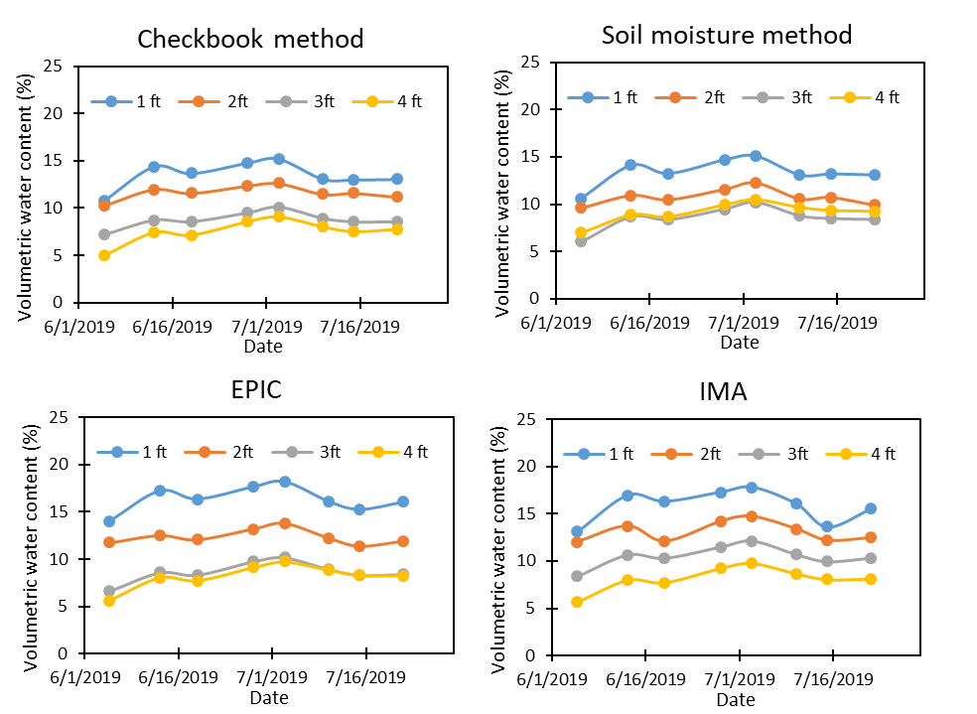
Figure 1. Weekly soil moisture data measured using neutron moisture meter.
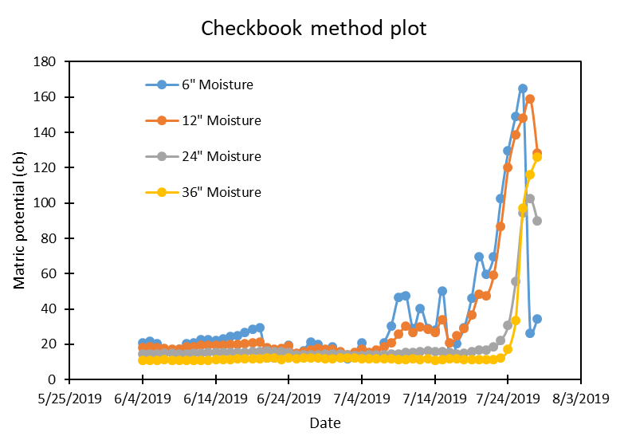
Figure 2. Soil matric potential measured using watermark sensor. Higher matric potential means lower soil moisture. Drop in matric potential means irrigation or rain due to which soil moisture increased.

3.) CHALLENGES ENCOUNTERED. (Describe any challenges that you encountered related to project progress specific to goals, objectives, and deliverables identified in the project workplan.)

No challenges encountered

4.) FINANCIAL INFORMATION (Describe any budget challenges and provide specific reasons for deviations from the projected project spending.)

- The initial plan was to hire a graduate student starting in summer 2019, but with challenges in finding an appropriate graduate student and paper work associated with graduate admissions, it took us more time than expected. The graduate student will start in fall 2019, so the salary of graduate student has not been used yet.

5.) EDUCATION AND OUTREACH ACTIVITES. (Describe any conferences, workshops, field days, etc attended, number of contacts at each event, and/or publications developed to disseminate project results.)

- Organizing the Irrigation and Nutrient management field day at the SPRF, Becker to be held on August 21st, 2019.
- Talked about irrigation systems and irrigation research at the Area II potato council field day at the Becker Sand Plain Research Farm. Becker, MN 16 July 2019 (25 attendees)

