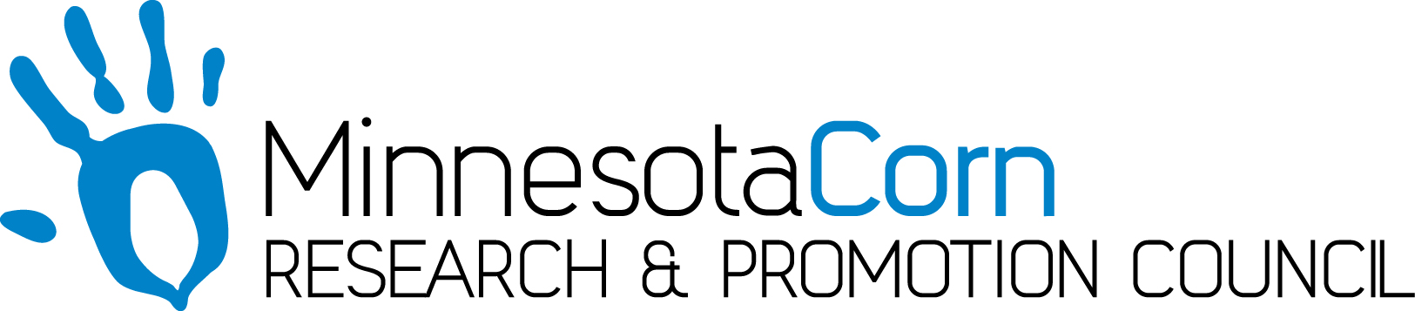

Innovation Grant Progress Report

PROJECT TITLE: Nitrates
REPORTING PERIOD: December
FARMER INNOVATOR: Jake Sharkey
COLLABORATING ORGANIZATION/PERSON: Dr. Jeff Strock
PHONE NUMBER: 507-476-0246
EMAIL: jsharkey@centrol.com

- PROJECT ACTIVITIES COMPLETED DURING THE REPORTING PERIOD. (Describe project progress specific to goals, objectives, and deliverables identified in your project proposal.)
  - Sampled the field according to 4.4ac grid
  - Sampled the field according to 20 acre strips
  - Sampled the field according to EC Zone Data
  - Collected Results and put together result maps

- IDENTIFY ANY SIGNIFICANT FINDINGS AND RESULTS OF THE PROJECT TO DATE. (There may be none to report at some stages of the project)
  - Nitrates this Fall were very low so seeing variation is small
  - 4.4 Acre strips by far showed the most variation – then EC Zone Samples – then 20 Acre Strips

- CHALLENGES ENCOUNTERED. (Describe any challenges that you encountered related to project progress specific to goals, objectives, and deliverables identified in the project proposal.)
  - Fall weather – cold, wet and tough going… but was able to get everything completed

- EDUCATION AND OUTREACH ACTIVITES. (Describe any opportunities to engage with farmers, influencers or the media about your project.)
  - Talked with a guy on the phone who writes blogs for MCGA and described the project

- HOW CAN WE HELP? (Please let us know how we can improve the experience or assist in your project if possible.)
  - Everything is good!

