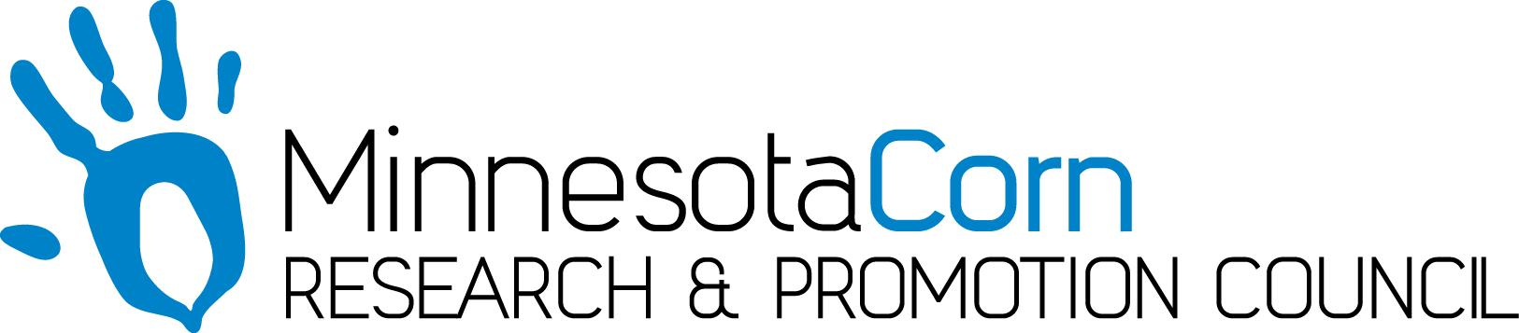

Innovation Grant Final Report

PROJECT TITLE: Evaluating Strip Tillage to increase soil quality and improve profitability
REPORTING PERIOD: 2019 Final Report
FARMER INNOVATOR: H & G Farms LLC, Harmon Wilts
COLLABORATING ORGANIZATION/PERSON: ETS Soil Warrior, Tanner Schultz
Centrol Crop Consulting, Dan Haubrich
John Deere, Tom Bouti and Ryan Peterson
Glacial Plains Coop, Shane Erickson/Joey Paulson
PHONE NUMBER: 320-894-5973
EMAIL: hgwilts92@gmail.com

1.) PROJECT ACTIVITIES COMPLETED DURING THE REPORTING PERIOD. (Describe project progress specific to goals, objectives, and deliverables identified in your project proposal.)

In year one the goal of establishing strips was accomplished even in this challenging fall. H & G Farms LLC, established three fields with three tillage systems in each, along with Appling fertilizer. We established approximately 25 acres of Conventional tillage systems with fall applied dry fertilizer, approximately 25 acres of Strip tillage utilizing the coulter system with dry fertilizer applied in a band with the strip till machine, then established approximately 25 acres of strip till utilizing the knife system in each field. The 2.5 acres grid soil samples were evaluated and based on 220 bushel corn yield goal to apply a constant rate across each of the three systems. The rates were; 17-80-80-10 of dry mix fertilizer. The Conventional tillage was broadcast and ripped in while the strip till was applied in the band as we built the strips. We will be applying the Nitrogen in the spring with the planter and the final pass with a side dress application in the summer of 2020. This is quite different; normally we apply all the nitrogen fertilizer in the fall as anhydrous. Fields look good and there are definitely differences. The strip till system is significantly different than the tillage we are used to completing. Thank you MN Corn Growers for the grant to help us try this system.

2.) IDENTIFY ANY SIGNIFICANT FINDINGS AND RESULTS OF THE PROJECT. (This could include photo documentation of the project at various stages if you haven’t already provided these as well as final relevant images of the project at completion. Any data analysis (especially Level 3 Grants), graphics or record of observations throughout the growing season or during the field day event are also anticipated.)

It definitely took some additional management to learn the new strip till tool and the newer tractor with RTK on both the tractor and strip till machine. We had great support/help from our partners in ETS and John Deere. There is also a new learning curve of working with retailer to apply our own fertilizer with the strip till machine. At this time it feels very good and rewarding to have implemented this projects in our fields. We’re really looking forward to more of this work and to plant and get the results next year.
In 2020 the data for the analysis of this research project will come from Climate Field View software, Spatial Data software, and yearly Nutrient Analysis tests. In addition to these sources of analysis, physical measurements will be analyzed including plant emergence, plant height, and the level of soil compaction. Additionally, the economic return per acre will be evaluated as well.

3.) CHALLENGES ENCOUNTERED. (Describe any challenges that you encountered related to project progress specific to goals, objectives, and deliverables identified in the project proposal.)

We were able to get our field’s project implemented in our soybean stubble going to corn next year in the 3 fields. After completing these fields, we want to add to the project and do additional fields of corn stalks going to soybeans. With almost 5 inches of rain in a week at the beginning of corn harvest we weren’t able to spend the time needed to complete the strip till in those fields. We will learn how to do this next year. Another large challenge was converting the strip till machine from the coulter system to the knife system. It took nearly 8 hours to complete this process with two guys however it is an important part of the learning to identify which system works best. Putting on all the nitrogen in the spring and summer is a large challenge with large volumes of Liquid 28 percent nitrogen.

4.) EDUCATION AND OUTREACH ACTIVITES. (Describe any opportunities to engage with farmers, influencers or the media about your project.)

In our first year just establishing the fields we were able to engage with farmers, partners, and media.
It was a great learning for our partners to work together with us to get the system established and learn what to do in the future. Main partners this summer and fall were; ETS, John Deere, Glacial Plains Coop, Centrol Crop Consulting, our farm team, and the media. Most of the partners were slightly questioning the system and how would it work. They asked a lot of questions and in some cases had to work together with each other to be successful. We did have a very nice article/write up in the West Central Tribune news paper this fall. They want to follow up with future stories. We are in the beginning stages to develop a field day for next summer to help other learn of the project.

5.) HOW CAN WE HELP? (Please let us know how we can improve the experience for the next generation of projects.)

Good questions, maybe we could have phone conference/meeting to show and explain the project to this point and to get any feedback from MN Corn. The other item would be help connect us with other potential partners to help the project be successful.

Great big thank you for the grant without it we may have waited. As I and our 3 daughters discuss we are really glad we moved forward on the project,

